FRUIT & VEGGIE HORSE PLAY
Basketball Instant Activity for Grades 2-6

Standards/Outcomes Addressed
Standard 1 [E17.4] Dribbling with hands in self-space, both hands, mature pattern.
Standard 3 [E6.5] Nutrition, analyzes impact of food choices relative to personal health.
Standard 4 [E4.4a-b] Praises performance of others more- and less-skilled. Accepts players of all skill levels into the physical activity.
Serving Up My Plate Objective [Level 3] Identify the 6 main nutrients and a variety of foods that contain them. Explain how nutrients help us grow and stay healthy.

Student Targets
- Skill: I will create a 5-dribble sequence during the game of Fruit & Veggie Horse Play.
- Cognitive: I will discuss 1 fact about a fruit or veggie during the lesson debrief.
- Personal & Social Responsibility: I will play Fruit & Veggie Horse Play with a partner, showing respect for different abilities by praising my partner at least 1 time.

Equipment/Resources Needed
- 1 basketball per pair [Recommended intermediate ball Voit XB 20 The Grip]
- Enough cones or markers to create activity grids
- 1 Food Fact Card

Activity Set-up
- Create enough grids to divide your class into pairs, each pair in a grid.
- Place 1 basketball in each grid.
- Post Food Fact Card at the entrance to the activity area.

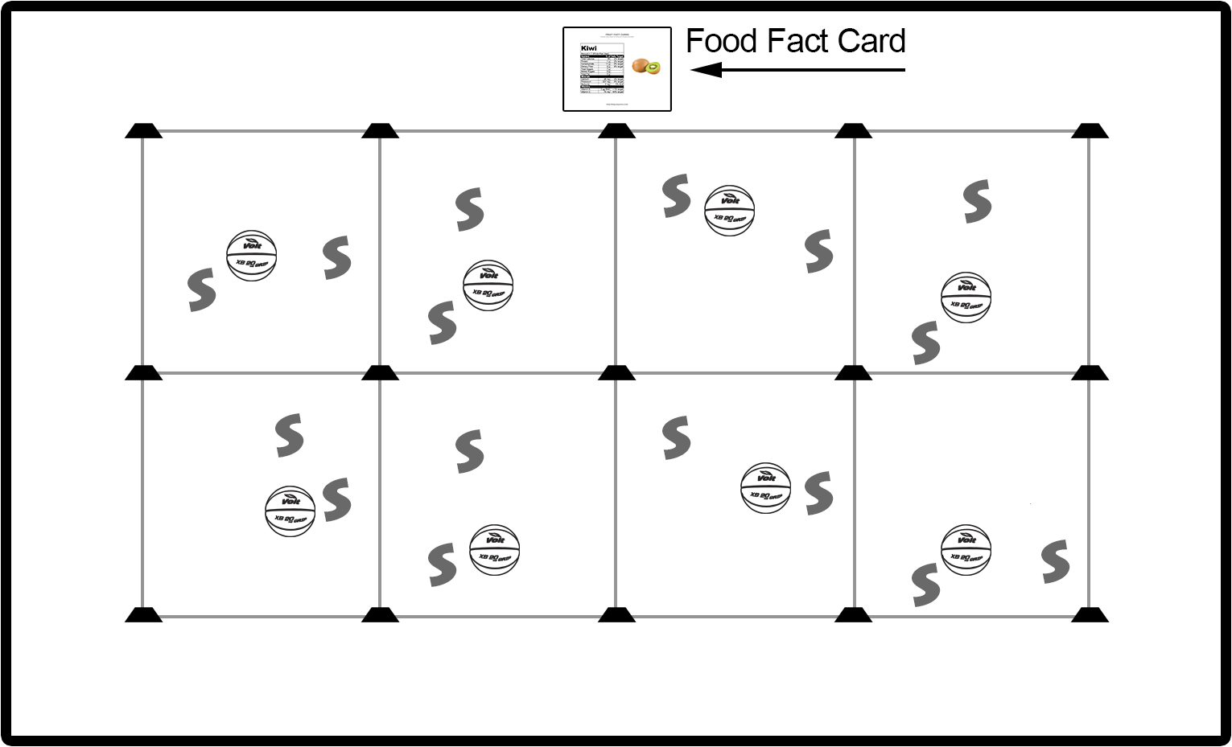

Activity Procedures
- There’s a Fruit or Veggie Fact Card posted near the entrance to the activity area. Use the name of the food that is posted as the word for your game of horse.
- Dribble Horse Play:
- Your goal is to create a 5-dribble sequence that your partner can’t complete without losing control of the basketball.
- When a player trying to recreate a sequence loses control of the ball, that person adds a letter to their score (for example: A for APPLE).
- The first person to spell the entire food name is eliminated and the game restarts.
- The shortest player in the group goes first.

Progressions
- Passing Horse Play: This is a 2 v 2 game. Pairs will create a 5-pass sequence for another pair to try and duplicate. No pass type can be made back to back. For example, pairs cannot make 2 bounce passes in a row.

Modifications
- Students v Teacher: Teacher creates a dribble sequence that all students must follow.

Debrief Questions
- Who will tell me what the 6 main nutrients are? [Carbohydrates, Proteins, Fats, Vitamins, Minerals, Water] Carbs, proteins, and fats give us energy to live, move, and grow, while vitamins, minerals, and water are needed for our bodies’ systems to work correctly.
- Let’s discuss the food we used in our game. What nutrients did our food have a lot of? What are some other types of foods that we could eat in order to get the nutrients that are missing?

Teacher Checks and Balances
- [As the teacher] I will focus on providing positive and corrective feedback to students during game play in order to guide them in the development of mature dribbling.
- I will also focus on facilitating a clear and concise debrief session, focused on reinforcing factual nutrition information.

