Challenge Card
Group Members: 1. _________________________ 2. _________________________

3. _________________________ 4. _________________________

Challenge #1  Eye of the Needle  How many tosses can you make through the hoop in 1 minute?  - Two Holders hold the hoop pointing up and down (opening facing the Tossers). Tosser-A tosses the beanbags through the hoop to the other side. When 4 beanbags are tossed, Tosser-A retrieves them all for Tosser-B. Continue alternating Tossers until you hear a stop signal. | 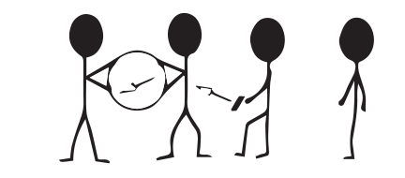  Trial 1 Result: _____________  Trial 2 Result: _____________  Circle the best performance.
Challenge #2  Eruption  How many tosses can you make through the hoop in 1 minute?  - Two Holders hold the hoop above their heads (opening facing the floor). Tosser-A tosses the beanbags up and out of the hoop. When 4 beanbags are tossed, Tosser-A retrieves them all for Tosser-B. Continue alternating Tossers until you hear a stop signal. | 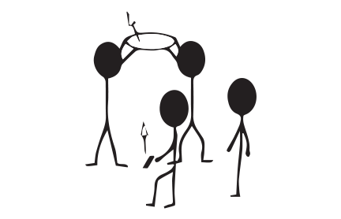  Trial 1 Result: _____________  Trial 2 Result: _____________  Circle the best performance.
Challenge #3  Moving Target  How many tosses can you make through the hoop in 1 minute?  - Two Holders stand 5 steps apart and roll the hoop back and forth between them. Tosser-A tosses the beanbags through the moving hoop. When 4 beanbags are tossed, Tosser-A retrieves them all for Tosser-B. Continue alternating Tossers until you hear a stop signal. | 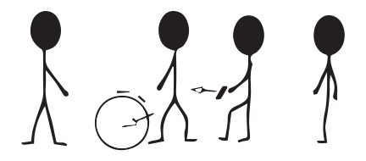  Trial 1 Result: _____________  Trial 2 Result: _____________  Circle the best performance.
Think About It – Answer the questions below on the back of this page.

- What does acceptance mean?

- Can you compare and contrast the benefits of working with others who are more skilled with the benefits of working with those who are less skilled? (HINT: Draw a Venn Diagram)

- How could we adapt or change one of our Triathlon challenges in order to help someone who is less skilled be more successful?

