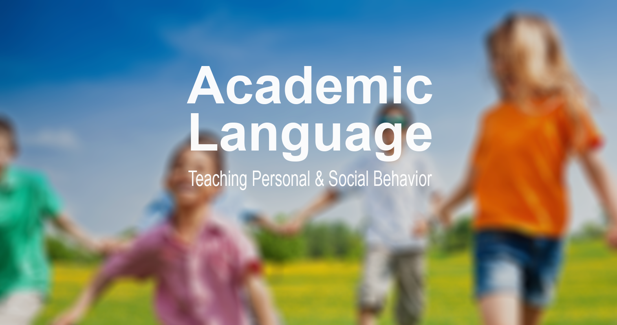

Aaron Hart with contributions from Nick Kline, Joey Feith, and Jim DeLine
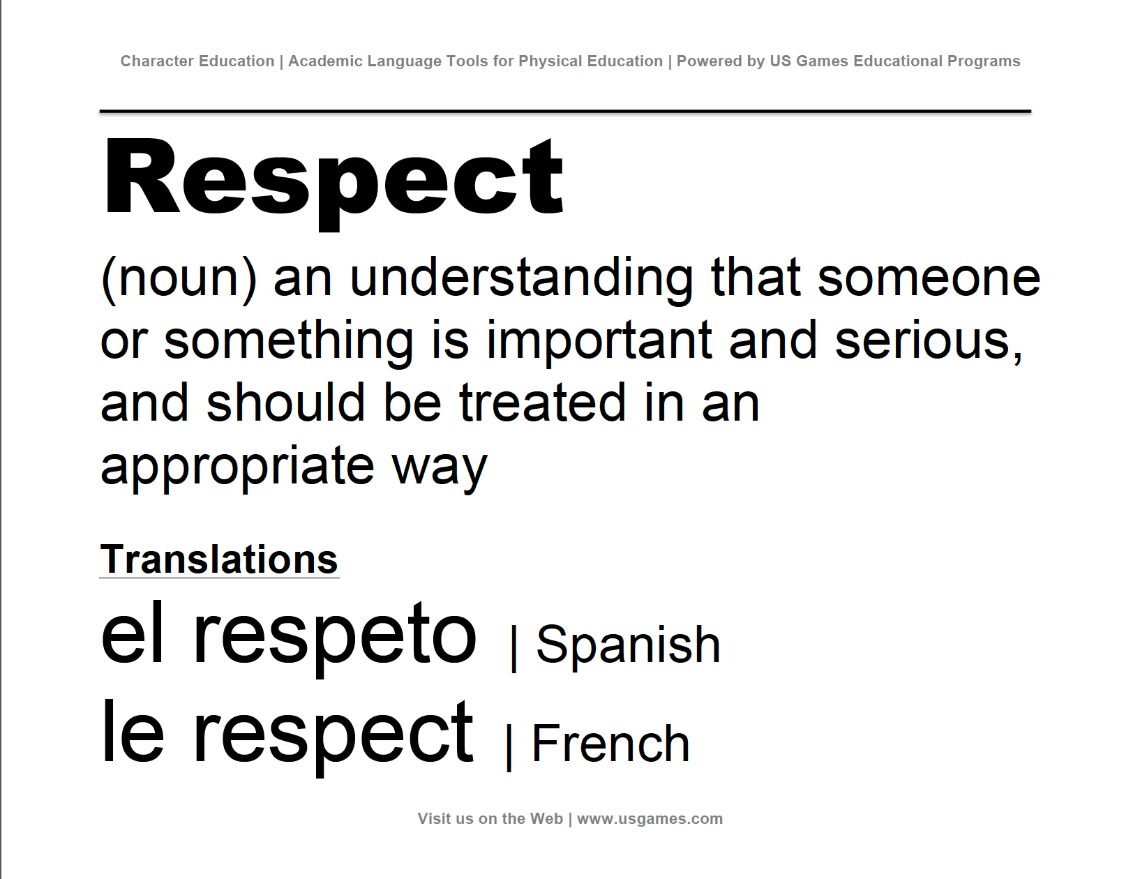  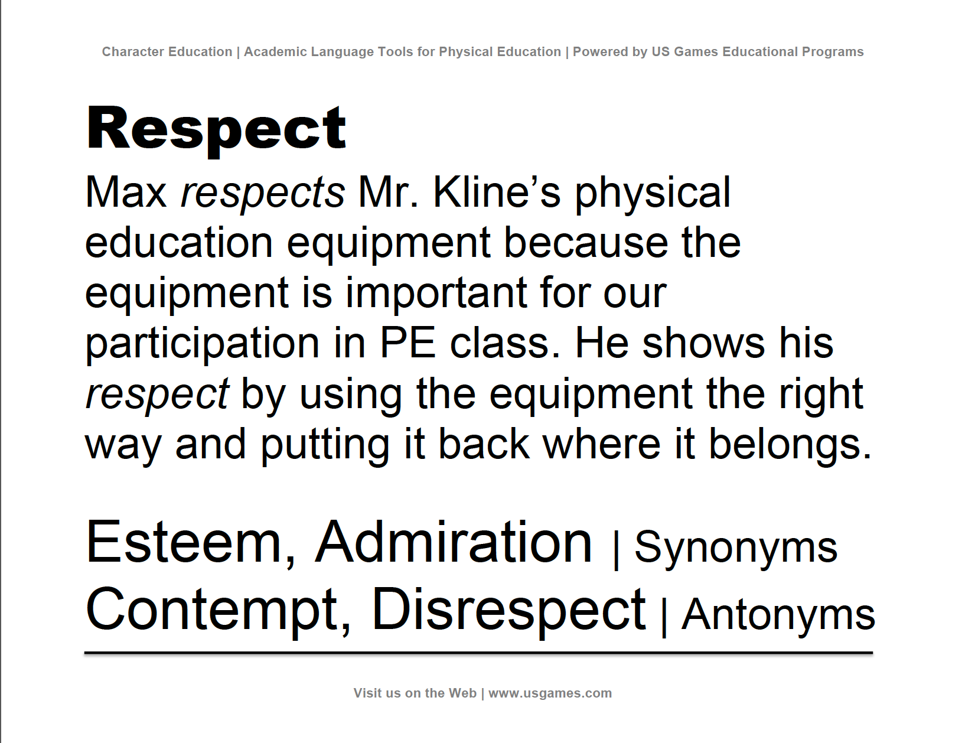 | What is Academic Language?  Academic language is the language students must acquire and master in order to demonstrate fluency in both general as well as domain-specific studies. It is essential for college and career readiness.  Academic language includes the vocabulary words, non-verbal signals, symbols, illustrations and graphics relevant to learning. Educators sometimes refer to two major types of academic language: instructional language and language of the discipline. Although physical educators must reinforce instructional language essential to all learning, the main focus of our academic language effort is on the language of the discipline of Phys. Ed.  What is a Word Quilt?  Word Quilts are designed to display both the syntax and vocabulary of academic language for students to see, study, discuss, and replicate. Teachers use Word Quilts to extend the traditional word wall in order to define key vocabulary words, prompt discussion, and place words in a context relevant to Phys. Ed.  How do I use Word Quilt Cards?  Print, post, and discuss. Here’s a real-world example:  Choose one word as a focus for your lesson and post that word’s quilt pages (there are two pages per word) in the activity area for students to see. Discuss the word and refer to the quilt pages throughout the lesson. At the end of the lesson move the quilt pages to a bulletin board or Word Quilt area and post the day’s word next to previously discussed Word Quilt pages. Repeat this process to create a quilt of words that fills your bulletin board or wall. Choose words that relate directly to your lesson objectives and desired outcomes. Tip: Add color by printing half of the words on one color paper and the other half on a second color.
References:
http://www.pelinks4u.org/articles/Toolkit%20for%20Academic%20Language%20in%20PhysicalEducation_Subm-1-19-14.pdf
http://www.edutopia.org/blog/8-strategies-teaching-academic-language-todd-finley

Why focus on Personal and Social Responsibility?
With respect to physical education outcomes, being physically fit and active for a lifetime requires personal responsibility. Further, successful and rewarding participation in physical activity oftentimes requires social responsibility.

With respect to college and career readiness, personal and social responsibilities are essential outcomes that underlie current and future success in nearly every core competency. Moreover, the personal and interpersonal skills that define personal and social responsibility outcomes are justifiably viewed as 21st Century Learning skills, fundamental to student success in a highly diverse and interconnected global community.

How did we choose the Academic Language of Personal and Social Responsibility?
The academic vocabulary words included in this resource were identified within Don Hellison’s Framework for Teaching Personal and Social Responsibility (TPSR). They appear as essential language within the components of the Five Levels of Responsibility:
1) Respecting the rights and feelings of others; 2) Effort and cooperation; 3) Self-direction; 4) Helping others and leadership; 5) Transfer outside of physical education class (Hellison, 2011). In his book Teaching Personal and Social Responsibility Through Physical Activity, Hellison states, “Although taking responsibility for one’s own development and well-being and for contributing to the well-being of others is the purpose of TPSR, the five levels (of responsibility) give students specific responsibilities, specific targets to shoot for, within the broader purpose.”

Personal and Social Responsibility as a part of a Comprehensive Anti-Bullying Framework
The U.S. Department of Health & Human Services has identified five components of a proactive Bullying Prevention program for schools. Teaching personal and social responsibility skills, concepts, and language is an essential part of each of the five components. The components include:
- Assess Bullying in Your School: Throughout an assessment process teachers and student leaders need to have a working understanding of personal and social responsibility.
- Engage Parents and Youth: As a part of the engagement process, all parties have an opportunity to explore, demonstrate and reward responsible personal and social behaviors.
- Create Policies and Rules: The core values sustained through personal and social responsibility must be a part of policy and rule creation as well as enforcement.
- Building a Safe Environment: Social and emotional boundaries and safety mechanisms, which are supported on a foundation of personal and social responsibility, allow students to feel comfortable with creative self-expression, developmentally appropriate risk taking, and academic exploration.
- Educate Students and School Staff: Effective and sustainable training efforts can only happen with a comprehensive working vocabulary focusing on personal and social responsibility.

References:
Hellison, D. R. (2011). Teaching personal and social responsibility through physical activity. Human Kinetics.
http://www.stopbullying.gov/prevention/at-school/index.html
Care
(noun) a feeling of kindness and concern for others

Translations
el cuidado | Spanish
le soin | French

Care
We care about our classmates and work to be kind and polite while learning and having fun.

Concern | Synonym
Inconsiderate | Antonym
Compassion
(noun) concern for the condition or misfortunes of others

Translations
la compasión | Spanish
la compassion | French

Compassion
Julius fell down during our game of tag and skinned his knee. James showed compassion by stopping and helping Julius get up and find our teacher.

Kindness, Empathy | Synonyms
Harsh, Cold | Antonyms
Cooperation
(noun) the process of working together for a common goal or outcome

Translations
la cooperación | Spanish
la coopération | French

Cooperation
Keeping our Phys. Ed. equipment in good condition takes cooperation. We all have to work together to use things the way they were meant to be used, and to put them back where they belong when class is over.

Collaboration | Synonym
Disunion | Antonym
Courage
(noun) the ability to overcome fear in order to accomplish a goal or complete a task

Translations
el coraje | Spanish
le courage | French
Courage
Phineas was afraid to try to play Pickleball because he had never used a racket before. He showed courage by trying his best to learn the new skills he needed. Now he loves to play Pickleball.

Bravery | Synonym
Fearful | Antonym
Effort
(noun) strenuous physical or mental exertion

Translations
el esfuerzo | Spanish
le effort | French

Effort
Learning new skills in physical education requires effort. New skills can be learned and mastered if you focus and try your best. If you make a mistake, learn from it and keep trying.

Work | Synonym
Laziness | Antonym
Feelings
(noun) emotional states or reactions

Translations
las emociones | Spanish
les sentiments | French

Feelings
Caitlin has positive feelings toward being active in physical education. Although sometimes she feels nervous when trying something new.

Emotion | Synonym
Insensitive | Antonym
Inner strength
(noun) a mental resistance to doubt; integrity of character

Translations
la fuerza interior | Spanish
la force intérieure | French

Inner strength
I didn't think I would be able to get better at dribbling with my left hand. I wanted to quit. I found the inner strength to continue practicing and now I can dribble through the cones with my left hand.

Grit, Courage | Synonyms
Timid, Cowardly | Antonyms
Leadership
(noun) the action of guiding and directing others

Translations
el liderazgo | Spanish
le leadership | French

Leadership
I will show leadership in physical education by setting a good example for my classmates to follow. This means I will follow instructions carefully and help others when they need it.

Guidance | Synonym
Incompetence | Antonym
Respect
(noun) an understanding that someone or something is important and serious, and should be treated in an appropriate way

Translations
el respeto | Spanish
le respect | French
Respect
Max respects Mr. Kline’s physical education equipment because the equipment is important for our participation in PE class. He shows his respect by using the equipment the right way and putting it back where it belongs.

Esteem, Admiration | Synonyms
Contempt, Disrespect | Antonyms
Responsible
(adjective) able to be trusted to do what is right, or to do the things that are expected or required

Translations
responsable | Spanish
responsable | French
Responsible
Jonah is responsible and knows that his school work is important. The teacher can always trust him to have his work done on time.

Trustworthy, Reliable | Synonyms
Irresponsible | Antonym
Responsiveness
(noun) the ability to adjust and act upon a change in one's environment

Translations
la capacidad de respuesta | Spanish
la réactivité | French
Responsiveness
Mrs. Wilcox had to go to an important meeting during our class today. We showed good responsiveness by listening to the substitute teacher and following all physical education rules.

Reactivity | Synonym
Apathy | Antonym
Rights
(noun) moral or legal entitlements or freedoms

Translations
los derechos | Spanish
les droits | French

Rights
The rights of each student in physical education class include being able to participate safely while learning and having fun.

Entitlement | Synonym
Injustice | Antonym
Role model
(noun) a person looked to by others as an example to be imitated

Translations
el modelo a seguir | Spanish
le modèle de rôle | French

Role model
Izzi is a good role model for other students to look up to in physical education. Sometimes she isn't good at a skill that we're learning, but she keeps trying hard until she can do it.

Mentor, Example | Synonyms
Joker | Antonym
Self-control
(noun) the willpower or ability to restrain (control) oneself, especially the expression of emotions and desires

Translations
autocontrol | Spanish
la maîtrise de soi | French
Self-control
Caleb displays self-control in physical education class and stops what he's doing when he hears the stop signal, even though he wants to keep playing.

Willpower | Synonym
Indulgence | Antonym
Self-direction
(noun) the ability to work independently to achive a goal or outcome

Translations
la autodireccion | Spanish
l'autonomie | French
Self-direction
Jessica shows self-direction during physical education by practicing skills on her own. This is important when
Ms. Turner needs to help other students with their work.

Initiative | Synonym
Passive | Antonym
Sensitivity
(noun) the awareness and ability to respond to the feelings of others

Translations
la sensibilidad | Spanish
la sensibilité | French

Sensitivity
Sean showed sensitivity toward Micah during our team obstacle course. He could see that Micah was nervous about trying a new activity so he ran with him and helped him feel more comfortable.

Awareness | Synonym
Disregard | Antonym

