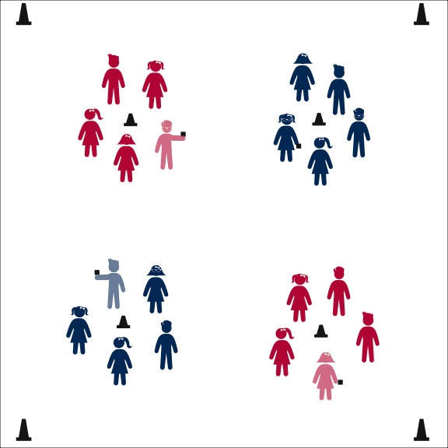

**SET THE TABLE**



* **Skill:** I will go counter-clockwise around the circle when it’s my turn to run.
* **Cognitive:** I will listen for the music to start and stop, and I will respond quickly and appropriately when it does.
* **Fitness:** I will actively participate in physical education in order to increase my heart rate.
* **Personal & Social Responsibility:** I will follow all of the class rules and behave appropriately.



* Pass Clockwise to the Music
* Stop when Music Stops
* Drop the Beanbag and Run Counter-Clockwise



**Equipment:**

* 1 beanbag per group of 5 or 6 students
* 1 cone per group of 5 or 6 students
* Music and music player

**Set-Up:**

1. Send groups of 5 or 6 students to a cone, each group with 1 beanbag.
2. Students stand in a circle around the cone.
3. The beanbag begins with the shortest (tallest, youngest, etc.) student.

**Activity Procedures:**

1. One way that we can all be helpful and responsible at home is to help set the table at meal time. Let’s play a game called Set the Table.
2. When the music starts, begin passing the beanbag clockwise around your circle. When the music stops, it’s time to set the table. To do that, the person who is holding the beanbag will place the beanbag on the floor in front of them and then run around the circle counter-clockwise until they are standing back in their spot.
3. When the music starts again, we’ll play another round.

**Grade Level Progression:**

**K:** When the music stops, teacher will call out the name of the player with the beanbag and say, “Run counter-clockwise!” while pointing in the correct direction.

**1st:** When the music stops, students will call out the name of the player with the beanbag and say, “Run counter-clockwise!”

**2nd:** When the music stops, students will move without an auditory cue. Students still forming the circle will complete an exercise while the runner is traveling (e.g., jumping jacks).

**SET THE TABLE**



Helpful, Responsibility, Clockwise, Counter-Clockwise, Around, Appropriate Behavior



* **Standard 1 [E2.2]** Runs with a mature pattern.
* **Standard 2 [E2.1b]** Travels demonstrating a variety of relationships with objects (e.g., around).
* **Standard 3 [E2.K-2]** Actively participates/engages in physical education class (K-1); …in response to instruction and practice (2).
* **Standard 4 [E5.K-2]** Recognizes the established protocol for class activities (K); Exhibits the established protocol for class activities (1); Recognizes the role of rules and etiquette in teacher-designed physical activities (2).
* **Standard 5 [E3.K]** Identifies physical activities that are enjoyable (Ka); Discusses the enjoyment of playing with friends (Kb).



* **DOK 1:** How can you recognize appropriate behavior?
* **DOK 2:** How does appropriate behavior affect learning in physical education?
* **DOK 3:** How are the rules and protocol in physical education related to appropriate behavior?
* **DOK 1:** What activities would be on your list of fun ways to be physically active?
* **DOK 2:** What do you notice about the activities that you listed? What makes them fun?
* **DOK 3:** What specific examples can you talk about that would help prove to another person that an activity that you like is fun? Why did you choose those examples?

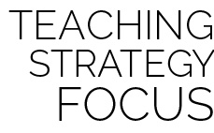

**Help students process content:** This activity provides a fun way to allow young children to practice following rules and protocol in order to provide a safe and effective learning environment. However, the objective of this activity could be easily lost without an attentive and persistent debrief conversation. Ask questions that evoke thoughtful and complete answers while allowing students enough time to struggle with providing detail to support their responses.



When the music stops, player with the beanbag performs a stationary activity or exercise.



* Form larger circles with 2 or more beanbags.
* As runners travel counter-clockwise, players in the circle travel clockwise.