­­­

* Self-Space
* General Space
* Locomotor Skill (Along with cards for individual skills)
* Pathways

­

* **Skill:** I will practice a variety of locomotor skills using the cues my teacher gives me in class.
* **Cognitive:** I will demonstrate at least 3 different pathways while I move throughout the activity area.
* **Fitness:** I will work to stay actively engaged during all of the scarf activities.
* **Personal & Social Responsibility:** I will demonstrate safe behaviors without being reminded by a teacher.
* **Standard 1 [E1.K-2]** Performs locomotor skills (hopping, galloping, running, sliding, skipping) while maintaining balance (K); Hops, gallops, jogs and slides using a mature pattern (1); Skips using a mature pattern (2).
* **Standard 4 [E1.K-2]** Follows directions in group settings (e.g., safe behaviors, following rules, taking turns) (K); Accepts personal responsibility by using equipment and space appropriately (1); Practices skills with minimal teacher prompting (2).
* Student Self Assessment (Locomotor Skills)

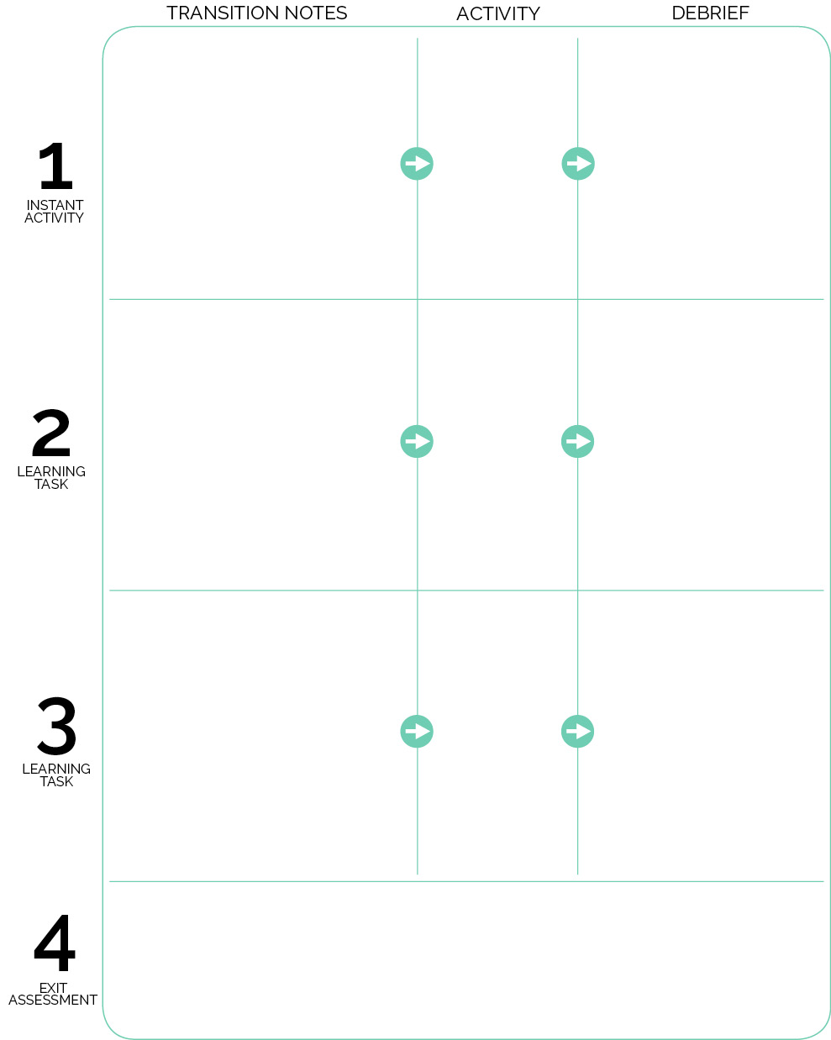

What is a locomotor skill? What are the different locomotor skills that you’ve learned?

How is walking different than galloping? How are they the same?

Locomotor Moves, Levels, Pathways

Complete the Student Self Assessment (Locomotor Skills) as a class. Project the assessment document via the LCD projector.

Point to your right. Point to your left. Use your scarf to draw a circle using a clockwise motion.

Why is it important to know and understand directions like right and left, clockwise and counter clockwise?

What does self-space mean? How is that different from general space?

Shapes and Directions

Juggling Scarf Free Play

Scarves are set out inside 4 large hoops that are scattered around the perimeter. Music is playing as students enter. They collect 1 or 2 scarves and begin to experiment with scarves while scattered self-space.

While in self-space, “Freeze” to stop student movement and focus attention on teacher. Begin activities listed on Activity Card starting with Shapes and Directions. “Freeze” to stop and debrief after Shapes and Directions.

K & 1: Begin by reviewing locomotor skills (see cue posters and teach sheets)

2: Review Scarf Activities, add skipping to the progression, and then progress to Tail Tag.