­­

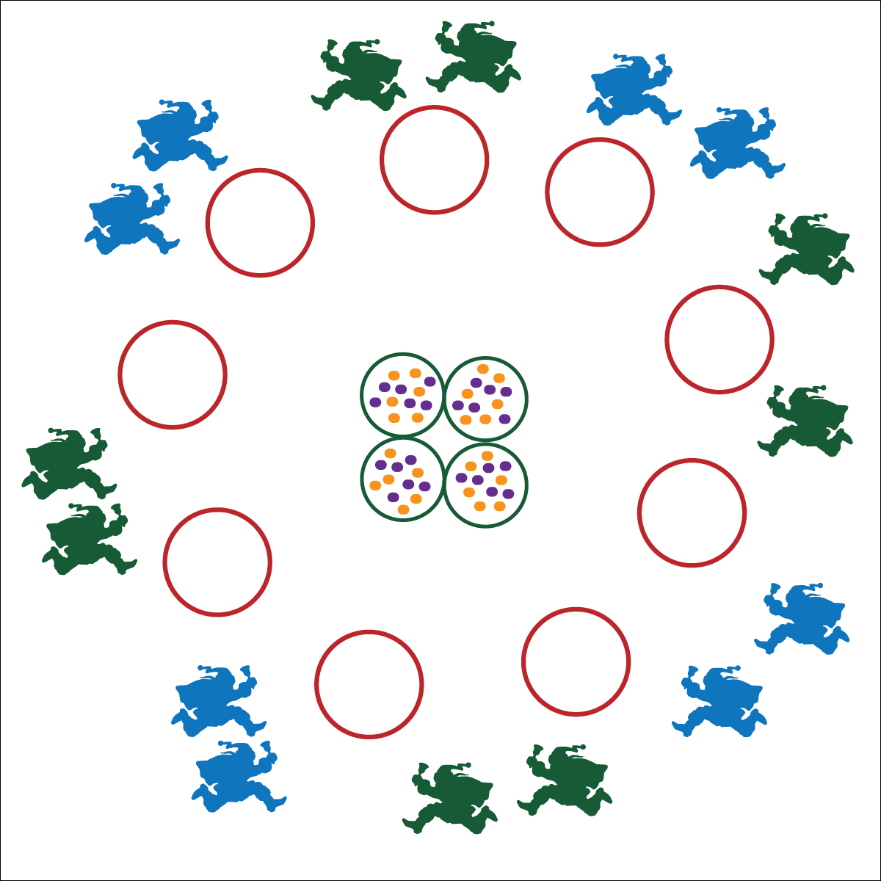



**DOK 1:** How can you praise the performance of your partner?

**DOK 2:** How does it feel when you receive praise from someone that you respect?

**DOK 3:** Why do you believe it’s important to praise others? Can you elaborate on your answer with examples?

**Equipment:**

* 13 hoops
* As many tossables (beanbags or foam balls) as available

**Set-Up:**

1. Use 9 hoops to create a large circle around the perimeter of the activity area.
2. Place 4 at the center of the circle.
3. Scatter tossable objects in the 4 center hoops.
4. Pair students. Scatter pairs around the perimeter.

* Praise Your Partner
* Toss When Your Partner is Ready
* Move Safely
* **Fitness:** I will increase my heart rate to improve my fitness.
* **Social & Emotional Learning:** I will cooperate with partner by using equipment appropriately and effectively.



* **Standard 4 [E4.K-5]** Shares equipment and space with others (K); Works independently with others in a variety of class environments (1); Works independently with others in partner environments (2); Works cooperatively with others (3a); Praises others for their success in movement performance (3b); Praises the movement performance of others both more and less-skilled (4a); Accepts “players” of all skill levels (4b); Accepts, recognizes, and actively involves others with both higher and lower skill abilities into physical activities and group projects (5).

**Activity Procedures:**

1. Before the reindeer can fly to deliver presents, the elves have to feed them a good meal. You and your partner are elves. The object of this game is to take 1 bag of food at a time (tossable objects) and drop them into the reindeer bowls (perimeter hoops).
2. On the start signal, move with your partner to pick up 1 tossable. The partner with the tossable cannot move. Move the food by tossing it to your partner and then moving to toward a bowl to receive another toss.
3. Tosses can only be 5 feet in distance (you can only move 5 feet at a time). If you drop the bag of food, you must return it to the center hoops, collect a new bag and then try again.
4. Continue until all bags of food have been delivered to the reindeer bowls.

**Modifications:**

* Allow younger (or less skilled) students to carry the bags of food cooperatively with no tossing.
* Increase or decrease the distance between hoops to match the ability and fitness of your students.
* Use a variety of tossable objects to either increase or decrease the level of challenge.