­­

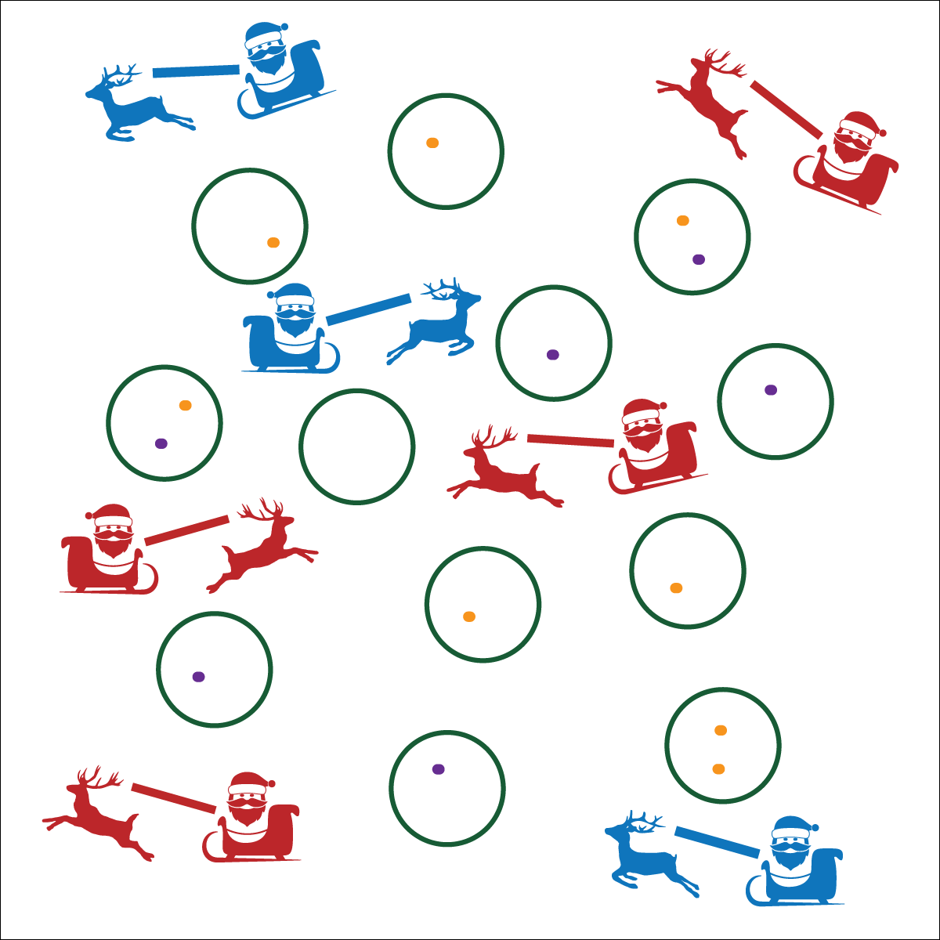



**DOK 1:** How can you recognize responsible decision making in physical education?

**DOK 2:** How does responsible decision-making affect safety?

**DOK 3:** Why do you believe class safety is everyone’s responsibility? Can you elaborate on why you feel this way? Can you elaborate on how you contributed to class safety in today’s activity?

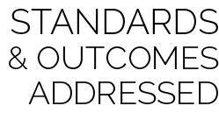

* **Standard 4 [E6.K-5]** Follows teacher directions for safe participation and proper use of equipment with minimal reminders (K); Follows teacher directions for safe participation and proper use of equipment without teacher reminders (1); Works safely with physical education equipment (2b).Works independently and safely in physical activity settings (3); Works safely with peers and equipment in physical activity settings (4); Applies safety principles with age-appropriate physical activities (5).

**Activity Procedures:**

1. It’s time to deliver presents! One student is a reindeer, the other student is Mr. or Mrs. Claus.
2. The object of this activity is to drop your presents, one at a time, into the chimneys (hoops).
3. On the start signal, one partner will sit on the scooter and hold the beanbags. The other partner will use the noodle to pull the her/him at a walking pace. Any scooter moving faster than a walk will receive a speeding ticket. After 2 speeding tickets your sleigh (scooter) will be impounded and you’ll have to walk to deliver the presents.
4. After all presents are delivered, stand next to your partner holding your scooter. When the entire class has delivered their presents, we will switch roles and play again.

**Modifications:**

* This activity can be played without scooters. One student leads the other with the noodle while galloping.
* Use a variety of safe objects as presents.

**Equipment:**

* 12 hoops
* 6 bean bags (or other object) per pair
* 1 scooter per pair
* 1 or 2 noodles per pair

**Set-Up:**

1. Scatter hoops throughout the activity area.
2. Pair students; each pair with a scooter, 6 bean bags, and noodles.

* Stay at a Safe Speed
* Use Equipment Safely
* Be Aware of Space, Objects, and Classmates
* **Fitness:** I will increase my heart rate to improve my fitness.
* **Social & Emotional Learning:** I will cooperate with partner by using equipment appropriately and effectively.