­­

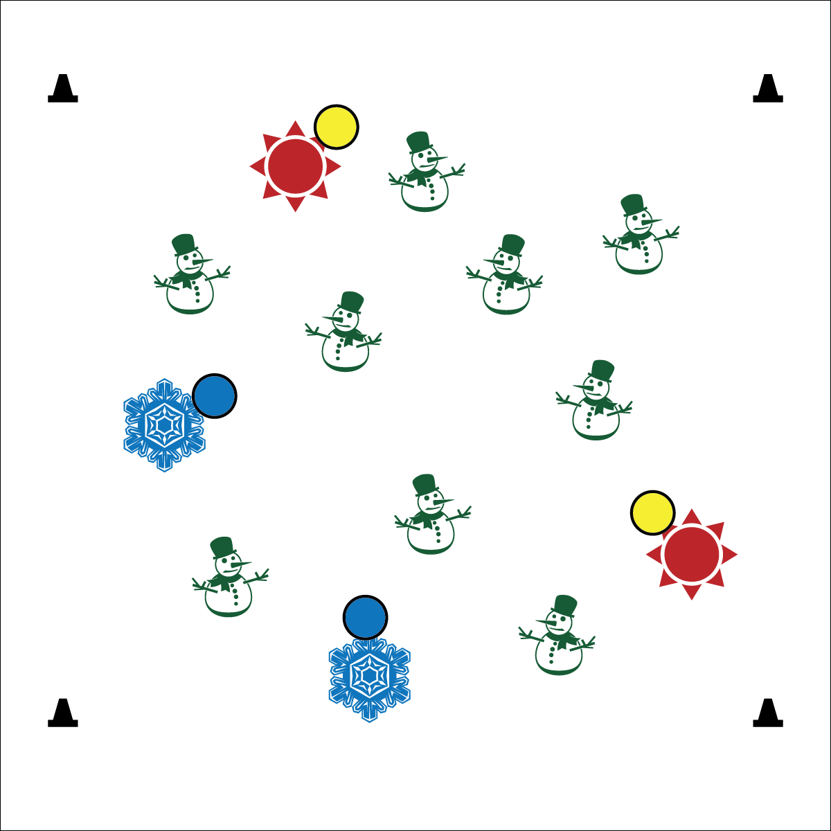



**DOK 1:** What does it look like when a student has good self-control?

**DOK 2:** How do you apply self-control during tag games?

**DOK 3:** How is self-control related to safety? How is it related to personal health and fitness?

**Equipment:**

* 4 cones to create boundaries
* 2 to 3 yellow foam balls to identify the taggers
* 2 to 3 blue foam balls to identify the freezers

**Set-Up:**

1. Create a large playing area using the 4 cones.
2. Scatter students in the activity area.
3. Identify 2-3 taggers by giving them the yellow foam balls.
4. Identify 2-3 freezers by giving them the blue foam balls.

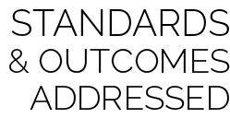

* **Standard 4 [E6.K-5]** Follows teacher directions for safe participation and proper use of equipment with minimal reminders (K); Follows teacher directions for safe participation and proper use of equipment without teacher reminders (1); Works independently and safely in physical education (2a); Works independently and safely in physical activity settings (3); Works safely with peers and equipment in physical activity settings (4); Applies safety principles with age-appropriate physical activities (5).

**Activity Procedures:**

1. Let’s warm up our bodies for physical education class by playing Snowman & Sunshine Tag.
2. When I say “GO!” we’ll begin at a speed-walking pace. Taggers will do 10 jumping jacks to give you time to move away. The taggers are the “suns” looking to melt the snow people of the North Pole (rest of the class).
3. If a snow person is tagged by the sunshine, she/he will stop moving and begin to melt by performing a sun salutation.
4. Continue melting (sun salutation) until a student with a blue ball comes along and refreezes you.
5. Stop and freeze when you hear the stop signal. We will change taggers and freezers and begin again.

**Modifications:**

* Modify sun salutation movements to meet the needs of your students.
* Prompt students to use a variety of locomotor skills.
* Control Your Speed
* Be Aware of Space and Others
* Move and Tag Safely
* **Fitness:** I will increase my heart rate to improve my fitness.
* **Social & Emotional Learning:** I will work safely by controlling my movement and my behavior.