­­

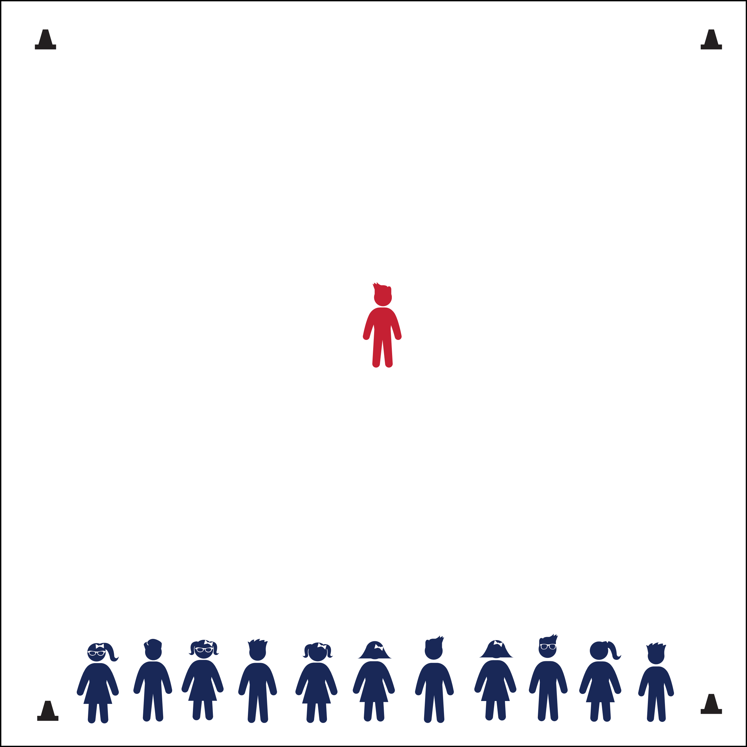

**Activity Procedures:**

1. Today we’re getting ready for the Big Event (a race or sport event), and the Fuel Collector needs to eat foods that are good for her/him *before* the event to fuel her/his body. These foods are fruits and vegetables for energy, as well as water for hydration.
2. (This tag game is similar to *Spiders and Flies*.) When I say “GO!” the Fuel Collector will call out either “fruit,” “vegetable,” or “water.” If the Fuel Collector calls “fruit,” everyone assigned Fruit will run to the other side while the Fuel Collector tries to tag them.
3. If you’re tagged while attempting to get to the other side, join the Fuel Collector in the middle and help tag other students in the next round.

**Grade Level Progression:**

**K:** Play several practice rounds at a speed-walking pace. During practice, have students raise their hands before running across the area. This will help everyone understand who is supposed to run.

**1st - 2nd:** Choose different locomotor movements for students to perform across the activity area.

**3rd – 5th:** Have the Fuel Collector call a specific snack, such as “apple.” The students identify each snack as either a fruit, a vegetable, or water in order to run at the correct time.

* Eyes Up
* Be Aware of Your Surroundings
* Tag Safely
* **Fitness:** I will identify foods that are good to eat before I am active.

**Equipment:**

* 4 cones for boundaries

**Set-Up:**

1. Use 4 cones to create a large playing area.
2. All students on the end line, standing in a straight line.
3. Give each student a title of either “Fruit,” “Vegetable,” or “Water.”
4. Choose one student to begin the game as the “Fuel Collector” and send her/him to the center of the playing area.



* **Standard 3** **[E6.3]** Identifies foods that are beneficial for pre- and post-physical activity.



* **DOK 1:** What type of foods are beneficial for before and after physical activity?
* **DOK 2:** Why is it better to have these foods instead of other foods?