­­

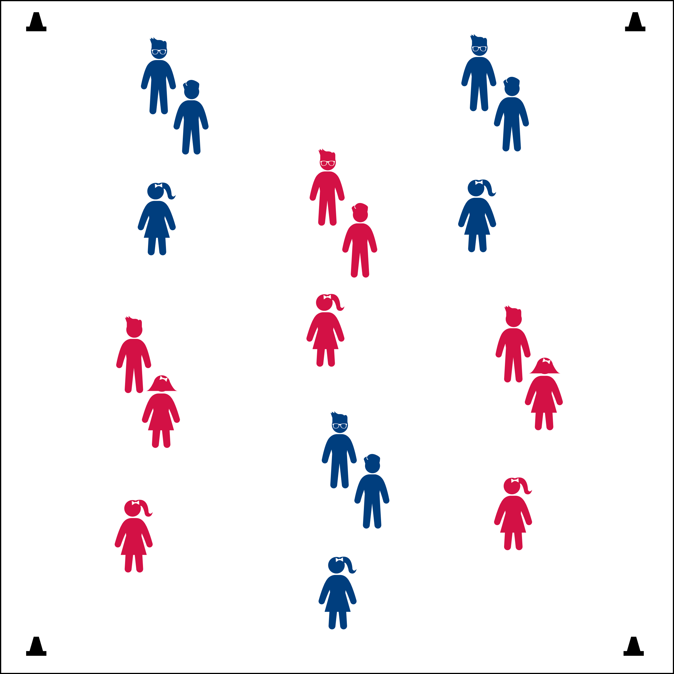



* **DOK 1:** How would you describe Shadow Baseball to a friend or family member?
* **DOK 2:** What did you notice about the other players in your group while you were playing?



* **Standard 5** **[E3.2]** Identifies physical activities that provide self-expression (2); Reflects on the reasons for enjoying selected physical activities (3).

**Activity Procedures:**

1. During the 1920s, 30s, & 40s, black athletes were not permitted to play baseball in the major leagues with white players. As a result, they formed their own league called the Negro Baseball League.
2. The Negro League was a very successful business during the Great Depression era, and the players soon became popular amongst fans of all skin colors.
3. Black players were just as skilled as white players in the major leagues, and their games were exciting to watch. In fact, it was so entertaining that fans would come early just to watch warm-ups.
4. Shadow Ball was a fan favorite. It is a game of imaginary baseball invented by the Indianapolis Clowns. It quickly spread to all the teams. Players pantomime throwing, catching and hitting using an invisible baseball.
5. Your group of 3 will play an imaginary baseball game using invisible equipment. One of you is the pitcher, one of you is the batter, and one of you is the catcher. Every 15-20 seconds, I will signal you to change positions.
6. Remember to stay in your space and be careful of others. Get busy when you hear the music.

**Grade Level Progression:**

**K – 2nd:** Play in groups of 2 with an imaginary game of catch. Add a 3rd player when appropriate.

**3rd – 5th:** Prime Time TV – Use commands such as “pause,” “rewind,” and “slow motion” to add challenge and interest for older students.

* **Fitness:** I will stay actively engaged and keep my body moving.

**Equipment:**

* Music: [*Sweet Georgia Brown* (Brother Bones & His Shadows)](https://itun.es/us/et3Ip)
* Signal (whistle, drum, noise maker, etc.)

**Set-Up:**

1. Students in groups of 3.
2. Scatter groups throughout the activity area.

* Be Aware of Your Surroundings
* Work Together
* Have Fun