­­



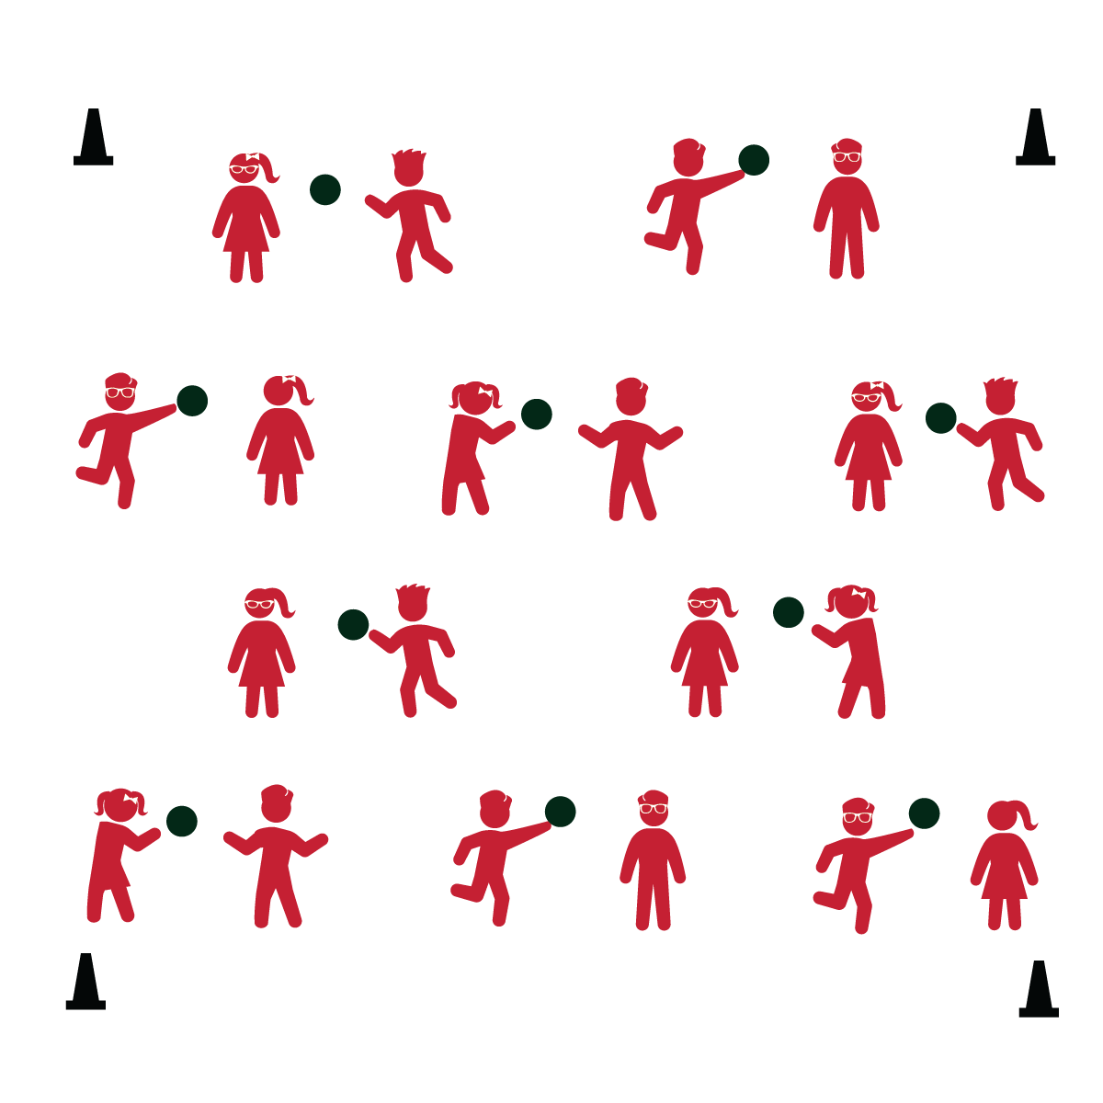

* **Skill:** I will accurately toss and catch with a partner.
* **Fitness:** I will stay actively engaged and warm up my body.



* **DOK 1:** What does “accurate” mean?
* **DOK 2:** How does the accuracy of a toss affect a person making a catch?
* **DOK 3:** What do you think the purpose of this activity is? Can you support your answer with facts and examples?



* **Standard 1 [E16.3-5c]** Catches a gently tossed hand-sized ball from a partner, demonstrating four of the five critical elements of a mature pattern (3); Catches a thrown ball at chest/waist level using a mature pattern in a non-dynamic environment (4); Catches with accuracy, both partners moving (5b); Catches with reasonable accuracy in dynamic, small-sided practice tasks (5c).

**Activity Procedures:**

1. Today we’re going to think about the five food groups while we practice tossing and catching skills.
2. The object of Toss 3 is to work with as many Toss 3 partners as you can while the music is playing.
3. When the music starts, the partner with the ball will begin with a toss. Each pair will make 3 tosses. The partner who now has the ball will travel and find a new partner who does not have a ball.
4. With each toss, name a food from the Grain food group (change food groups each round).
5. Freeze when the music stops.

**Grade Level Progression:**

**K:** Play the game with a balloon or yarn ball. Add the nutrition element only after students have mastered the toss/catch task.

**1st - 2nd:** Play the game as described at a walking pace.

**3rd – 5th:** Add a variety of locomotor skills. Alternate passing tasks (e.g., basketball bounce pass, floor hockey passing, etc.).

**Equipment:**

* 1 ball per 2 students
* 4 cones

**Set-Up:**

1. Create a large activity space using 4 cones to mark boundaries.
2. Scatter pairs of students throughout the activity area. Each pair with a ball.

* Look for Hands Up, Eyes Ready
* Step with Opposition, Tick Tock Toss
* Two Handed Catch with Soft Hands