­­

**INSTANT ACTIVITIES**

**FIRST THINGS FIRST**

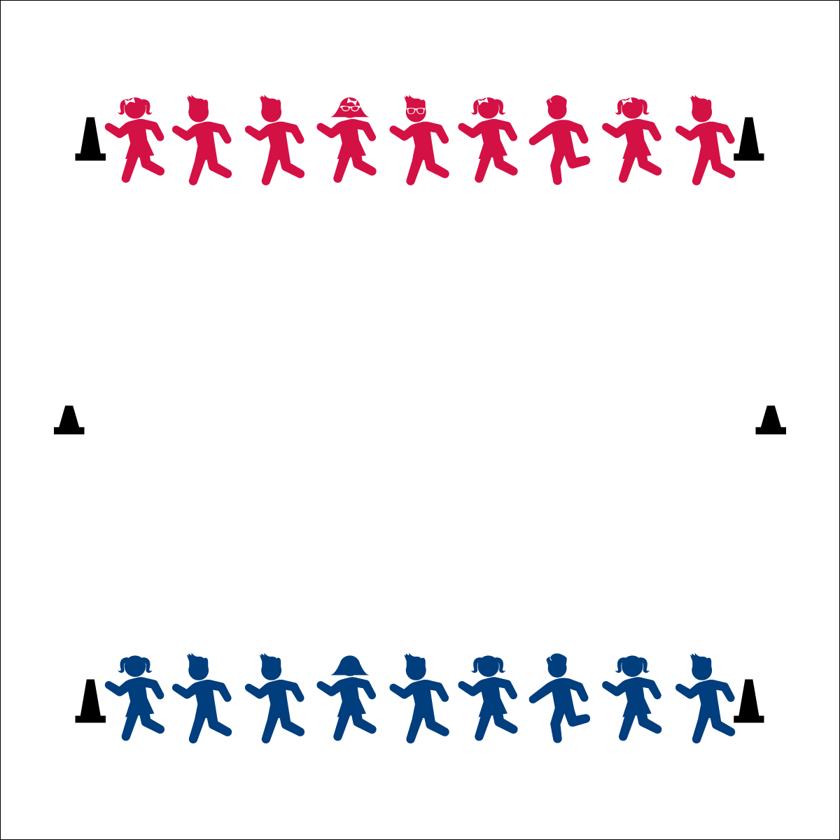

**Activity Procedures:**

1. The objective of the activity is to create a sequence of 4-6 moves.
2. Designate one side of the gym to be the “First-Things-First Partner.” This group will create the first move
3. On “Go!”, partners travel together and stop at the center line. First-Things-First Partner creates a move or exercise that both partners do together. For example, burpee, hip bump, low five, super hero pose, etc. When finished, partners return to their respective lines.
4. Next, the other line becomes Second-Things-Second Partner. On “Go!” partners return to the center line, repeat the first move, and now add a Second-Things-Second Move. When done with both moves, partners return to their respective lines.
5. Repeat with the first group; now the Third-Things-Third Partner. Finish with the second group and call them Last-Things-Last Partners. The result will be a sequence of 4 moves or exercises that pairs complete at the center line. (Feel free to add more moves.)

**Grade Level Progression:**

**K– 2nd:** Teach food groups. Whole Grains – wave hands and arms high above head. Fruit – jump up high and pick fruit from tree branches. Vegetables – push a shovel into the ground and dig up the vegetable. Lean Protein – pose in a double bicep flex position. Dairy – pretend to milk a cow.

**3rd – 5th:** Play the song *Chariots of Fire* and have students complete moves in slow motion.



* **Standard 3** **[S3]** Actively participates in physical education class (K); Actively engages in physical education class (1); Actively engages in physical education class in response to instruction and practice (2); Engages in the activities of physical education class without teacher prompting (3); Actively engages in the activities of physical education class, both teacher-directed and independent (4); Actively engages in all the activities of physical education (5).



* **DOK 1:** What are some things you can do at home to stay active?
* **DOK 2:** What do you know about why it is important to stay healthy and active?

**Equipment:**

* 6 cones or spot marker to mark lines.

**Set-Up:**

1. Create 3 parallel lines 8-10 yards apart. Two home lines on the ends and a center line in the middle.
2. Students are in pairs. Partners facing each other on opposite home lines.

* Move with body control.
* Cooperate and work together.
* Choose to be safe. This is not a race but an assignment.
* **Fitness:** I will safely participate in order to increase my heart rate and warm up my body.
* **Fitness:** I will demonstrate my knowledge of exercises that I can do on my own that will keep my body healthy.