­­

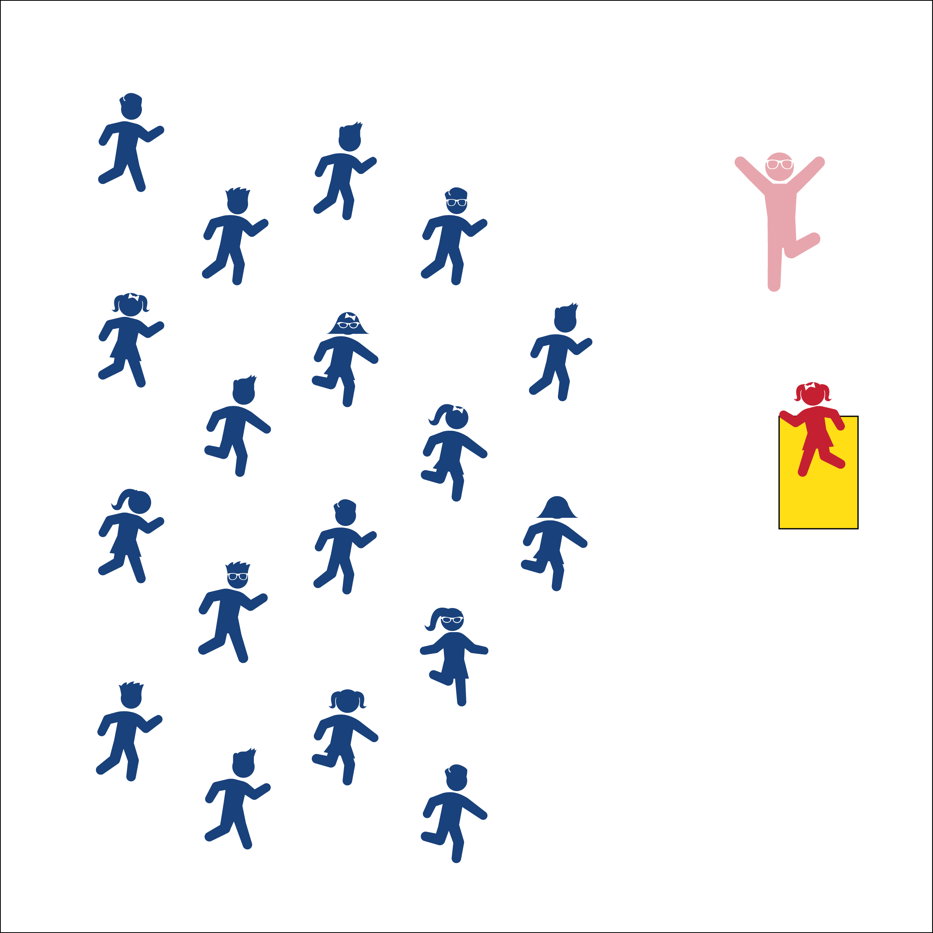

Written by: Jim DeLine



* **Standard 3** **[S3]** Actively participates in physical education class (K); Actively engages in physical education class (1); Actively engages in physical education class in response to instruction and practice (2); Engages in the activities of physical education class without teacher prompting (3); Actively engages in the activities of physical education class, both teacher-directed and independent (4); Actively engages in all the activities of physical education (5).

**Activity Procedures:**

1. Today’s Instant Activity is called Hot, Hot, Hot! If you want to be the Movement Leader raise your hand when I ask, *“Who’s feeling hot hot hot?”*
2. Together we will ask the Movement Leader, *“What you got got got?”*
3. The Movement Leader hustles to the stage, and leads the class in s safe exercise or dance move for 15-20 seconds. The rest of us copy the movement.
4. After 15-20 seconds, I’ll ask everyone to tell our Movement Leader they are, *“Hot Hot Hot!”* For example, *“Tell Kurt he’s Hot Hot Hot!”* Respond back together, *“You’re Hot Hot Hot!”*
5. I’ll ask again, *“Who’s feeling Hot Hot Hot?”* Raise your hand, and the class will ask you to, *“What you got got got?”* It’s okay if you don’t want to be the Movement Leader, but everyone should try the exercise move that the Movement Leader is doing.

**Grade Level Progression:**

* **K – 2nd: Grade:** The Movement Leader actively pantomimes a sports skill or activity and the class has to guess what they are doing (dribbling a ball, jumping rope, etc.).
* **3rd – 5th Grade:** Give students time to create dance moves or exercises in pairs (this is a great station activity). In the next round of Hot Hot Hot, call pairs to be Movement Leaders.



* **DOK 1:** What is a leader?
* **DOK 2:** What did you notice about a particular leader’s movement or dance move?
* **DOK 3:** How could you change their exercise or move and create your own?
* Choose an Exercise or Dance Move that is Safe
* Follow the Movement Leader. Copy Their Movements.

**Equipment:**

* Music: *Hot Hot Hot*, by Buster Poindexter & His Banshees of Blues ([iTunes Link](https://itunes.apple.com/us/album/hot-hot-hot-radio-edit/id304837426?i=304837434))
* Small “stage,” (e.g., 2 folded mats side-by-side)
* 1 poly spot per student

**Set-Up:**

1. Scatter students, each with a poly spot to mark their space. Or, have them stand in file formation on permanent spots already marked.
2. Create a small stage in front of the class (2 folded gymnastic mats side-by-side work well).

* **Fitness:** I will follow along with the Movement Leader, warm-up my muscles, and prepare for PE class.