­­

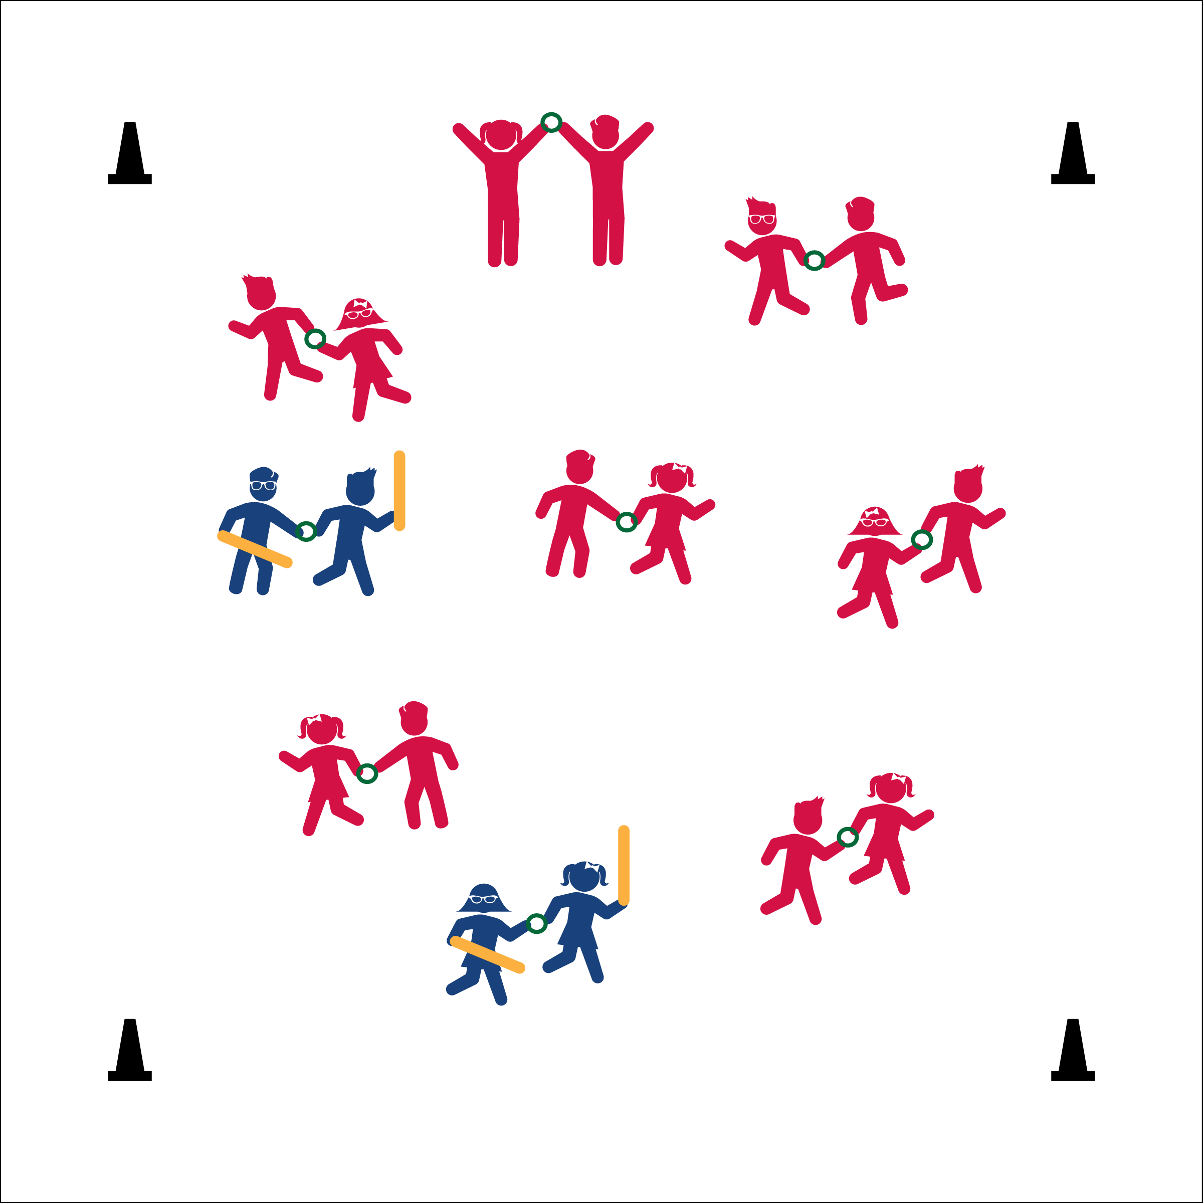



* **DOK 1:** How did you know you and your partner were working well together?
* **DOK 2:** How did working together or not working well together impact your effort?
* **DOK 3:** How could you and your partner develop strategies that would help you work better together, or fix any problems you might have experienced?



* **Standard 4** **[S4.E6]** Works safely with peers and equipment in physical activity settings (4).
* Work Together
* Communicate with your Partner
* Pulling the Ring is NOT Safe
* **Personal & Social Responsibility:** I will demonstrate responsibility and work safely with my partner.

Written by: Jim DeLine

**Activity Procedures:**

1. Pairs are “No-Tug Tug Boats.” They must skip around the space without “tagging themselves.” The following is a list of ways pairs can tag themselves: A) Pulling, tugging, or jerking their partner; B) Bumping into other pairs; C) Falling down; D) Coming apart (not letting go of the deck ring); E) Stepping out of bounds.
2. Pairs that “tag themselves” put the ring on the ground and do 5 high-lows (squat and touch the ground then jump up high) before returning to the game.
3. Taggers attempt to tag Tug Boats with noodles (taggers do 5 high-lows if they let go of the deck ring).
4. When tagged, Tug Boats stop and makes a draw bridge by lifting their ring high in the air.
5. To get unfrozen, another Tug Boat must travel under the draw bridge.
6. Note: Taggers can tag a pair if they are stopped doing hi-lows because they “tagged themselves.” In fact, this is a good strategy for the taggers to use.

**3rd – 5th Grade Progressions:**

1. To get unfrozen another Tug Boat has to go under, then around, and under a second time.
2. The taggers do not have to be connected. They are Patrol Boats and work individually.

**Equipment:**

* Cones to designate activity are suitable for a tag game
* Deck rings (1 per pair)
* 2 foot noodles (2 per every 10 pairs)

**Set-Up:**

1. Using 4 cones, create a large playing area.
2. Pair students. Each pair holds a deck ring.
3. Give 4 noodles to 2 pairs (each partner holds 1 noodle in the outside hand and the deck ring in the inside hand).