­­­­­

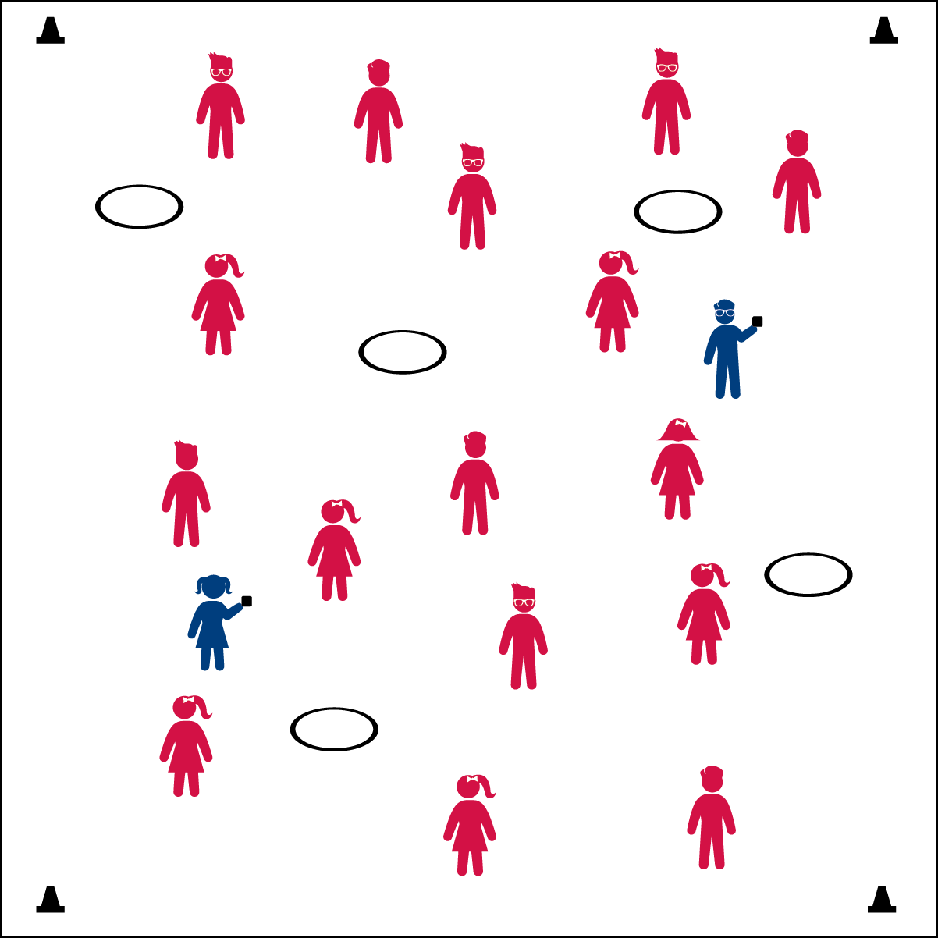



* **DOK 1:** What are the five food groups that make up a healthy meal?
* **DOK 2:** What are some examples of foods from each group?
* **DOK 3:** Why is it important to eat foods from each food group?

**Activity Procedures:**

1. Today we’re going to warm up our bodies for physical education class by playing Harvest Tag.
2. When I say “GO!” begin playing at a speed-walking pace. The taggers will do 5 jumping jacks to give you time to move away from them.
3. If you’re tagged, move inside a hula hoop and wait there for 4 other players to join you, forming a group of 5 people. (If you don’t have hula hoops available, students can link arms to form the group.)
4. The hula hoop represents a plate, and the 5 people in the hoop represent the healthy food groups you should include in every meal (Fruits, Vegetables, Protein, Grains, and Dairy).
5. As soon as you have a group of 5, everyone in that group is free and reenters the game.
6. Freeze when you hear the stop signal and we’ll change taggers.

**Grade Level Progression:**

**K:** Keep the pace at a speed-walk. When the students find a group of five, have them hold up individual numbers (1-5) with their hands to show that there are five people.

**1st – 2nd:** When students demonstrate safe movement, increase the pace to a skip or gallop. Have the students recite the five food groups before they can be unfrozen.

**3rd – 5th:** Have the students name a specific food from each food group before they can be unfrozen.

* Eyes Up
* Be Aware of Your Surroundings
* Tag Safely
* **Fitness:** I will name each of the 5 food groups and discuss why each food group is important.

**Equipment:**

* 4 cones for boundaries
* Bean bags or rubber critters to identify taggers
* 4-5 hula hoops

**Set-Up:**

1. Use the cones to create a large activity area.
2. Scatter students in the activity area.
3. Spread the hula hoops out within the activity area.
4. Give bean bags to 2 or 3 students to identify them as taggers



* **Standard 3** **[E6.2]** Recognizes the “good health balance” of nutrition and physical activity.