­­



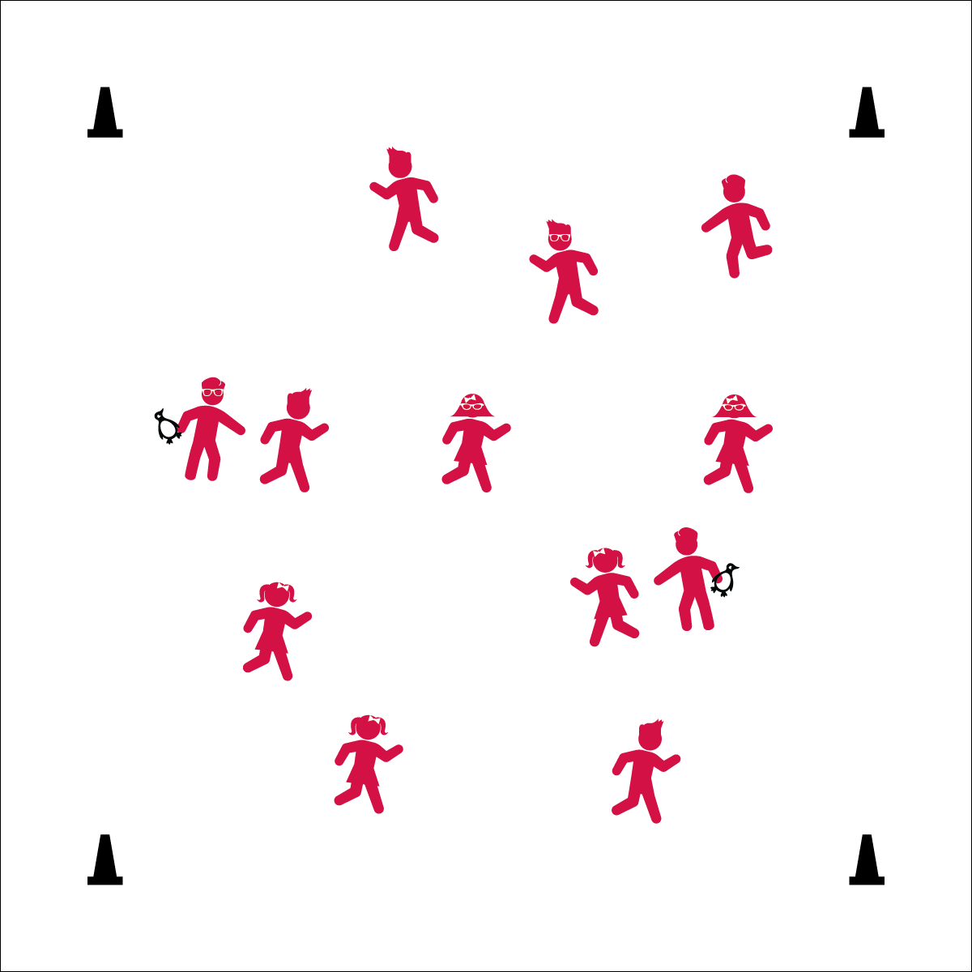

* Eyes Up
* Be Aware of Your Surroundings
* Safe Tagging



* **Standard 3** **[E3.2]** Identifies physical activities that contribute to fitness (2b).
* **Standard 3 [E1.4]** Analyzes opportunities for participating in physical activity outside of physical education class (4).

**Equipment:**

* 4 cones for boundaries
* Bean bags or rubber critters to identify taggers

**Set-Up:**

1. Create a large playing area using the 4 cones.
2. Scatter students in the activity area.
3. Identify 2 or 3 taggers by giving them bean bags or critters.

* **Fitness:** I will identify different activities that contribute to my fitness.

**Activity Procedures:**

1. Today we’re going to warm up our bodies for physical education class by playing Snowman Tag.
2. When I say “GO!” we’ll begin at a speed-walking pace. The taggers will do 5 jumping jacks to give you time to move away from them.
3. If you’re tagged, crouch down and hug your knees so you look like the base of a snowman.
4. To be freed, a classmate will come over and stack their fists, one-by-one, on top of each other to form a snowman with 3 fists. As you stack hands say “1, 2, 3, snowman!” On, “Snowman!” you’re then free and can continue playing.
5. Freeze when you hear the stop signal and we’ll change taggers.

**Grade Level Progression:**

**K:** Use a speed-walking pace.

**1st – 2nd:** When students demonstrate safe movement, increase the pace to a skip or gallop.

**3rd – 5th:** When the students finish creating snowmen with their hands, add a star jump before returning to the game. Add a basketball, soccer, or floor hockey dribble as an extended challenge.



* **DOK 1:** What winter activities can you do outside of physical education class that contribute to your fitness?
* **DOK 2:** How do these activities contribute to your fitness? Provide facts as support.