­­



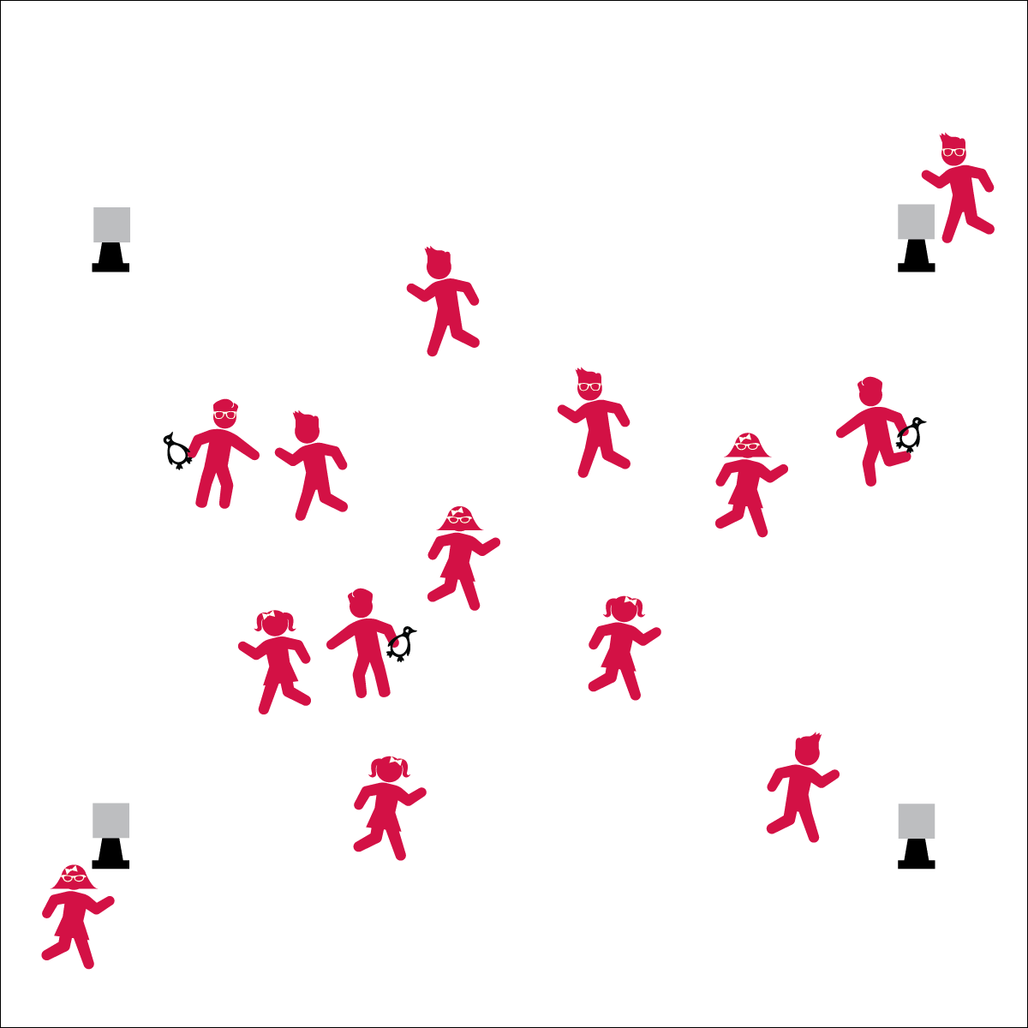



* **Standard 3** **[E6.5]** Analyzes the impact of food choices relative to physical activity, youth sports, & personal health (5).

**Equipment:**

* 4 cones for boundaries
* Bean bags or rubber critters to identify taggers
* Resolution Tag Reentry Cards

**Set-Up:**

1. Create a large playing area using 4 cones.
2. Scatter students in the activity area.
3. Give bean bags to 2 or 3 students to identify them as taggers.
4. Place a Reentry Card on each of the 4 perimeter cones.

* **Fitness:** I will perform all of the reentry tasks while analyzing personal choices that impact my personal health.

**Activity Procedures:**

1. Today we’re going to warm up our bodies for physical education class by playing Resolution Tag.
2. When I say “GO!” begin playing at a speed-walking pace. The taggers will do 5 jumping jacks to give you time to move away from them.
3. If you’re tagged, go to 1 of the 4 corners and read the Reentry Card with a task and resolution category.
4. To be freed, complete the task and shout your resolution.
5. Freeze when you hear the stop signal and we’ll change taggers.

**Grade Level Progression:**

**K:** Create 1 reentry area with the teacher guiding students who come to complete the task.

**1st - 2nd:** Create 4 reentry areas as indicated above. However, provide 1 area with teacher guidance for students who do not read well.

**3rd - 5th:** Play the game as described above.

* Eyes Up
* Be Aware of Your Surroundings
* Safe Tagging



* **DOK 1:** What is a personal choice?
* **DOK 2:** What are some personal choices that can have an impact on your health?