­­

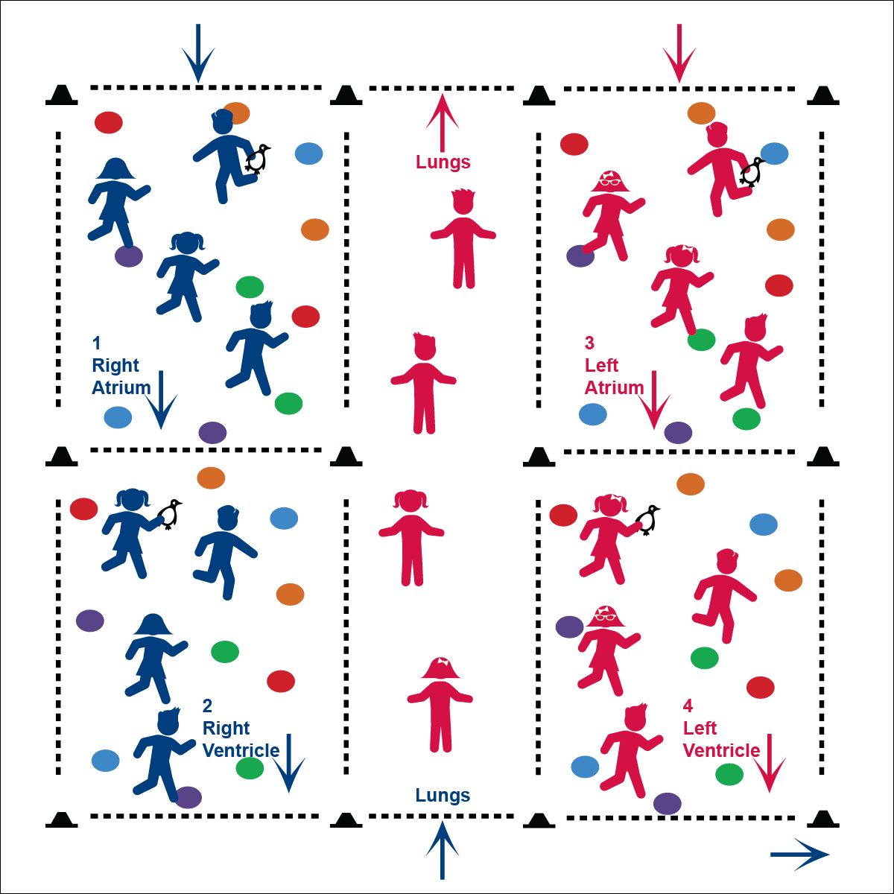

* Eyes Up
* Be Aware of Your Surroundings
* Safe Tagging

**Activity Procedures:**

1. Today we’re going to warm up our bodies for physical education class by playing Heart Tag.
2. There are 4 playing areas. These are the different chambers of the heart. The long middle area represents the lungs. You are the blood flowing through the heart.
3. To get through each heart chamber, you must step on five different poly spots (without getting tagged). Then you can go to the next chamber. Poly spots represent foods that keep your heart healthy from each of the 5 food groups.

***Teaching Tip:*** *Teach the flow of student movement before adding Taggers.*

1. The taggers represent things that can make your heart unhealthy (such as tobacco). If you touch 5 spots and make it through the chamber without being tagged, you can move to the next chamber. If you’re tagged, though, you must step on 5 more spots before you can continue to the next chamber. Taggers may not re-tag a person in that has already been tagged. When a student enters a new chamber, they can be tagged again.
2. Follow the flow, going from chambers 1-2-3-4. In order to travel from chamber 2 to 3, the blood goes through the lungs to become oxygenated. When you enter the lungs, do 10 jumping jacks, and then move to chamber 3. When you make it through all 4 chambers, circulate around the body by jogging back to chamber 1.
3. On “GO!” begin playing at a speed-walking pace. Freeze on the stop signal and we’ll change taggers.

**Grade Level Progression:**

**1st – 2nd:** Have the students play the game as described

**3rd – 5th:** Switch the locomotor movement to skip, jog, gallop, etc.

**6th – 8th:** Students call out the chamber they are entering (R Atrium, R Ventricle, Lung, L Atrium, L Ventricle)

**Equipment:**

* 20 cones for activity areas
* Bean bags or rubber critters to identify taggers
* 40 poly spots

**Set-Up:**

1. Create 4 playing areas (4 chambers of the heart) with 1 long area in the middle (the lungs).
2. Scatter 10 poly spots in each of the 4 areas.
3. Scatter students in the activity areas.
4. Send 1 student to each chamber with a bean bag to identify them as taggers.



* **DOK 1:** What are some things people do that are NOT good for their hearts?
* **DOK 2:** Why are these things bad for our heart?
* **DOK 2:** What are some ways that we can keep our heart healthy and strong?



* **Standard 3** **[E3.1]** Identifies the heart as a muscle that grows stronger with exercise, play, and physical activity (1).
* **Fitness:** I will identify ways that I can make my heart healthy and strong.