­­

**INSTANT ACTIVITIES**



**Say “Cheese” Tag**

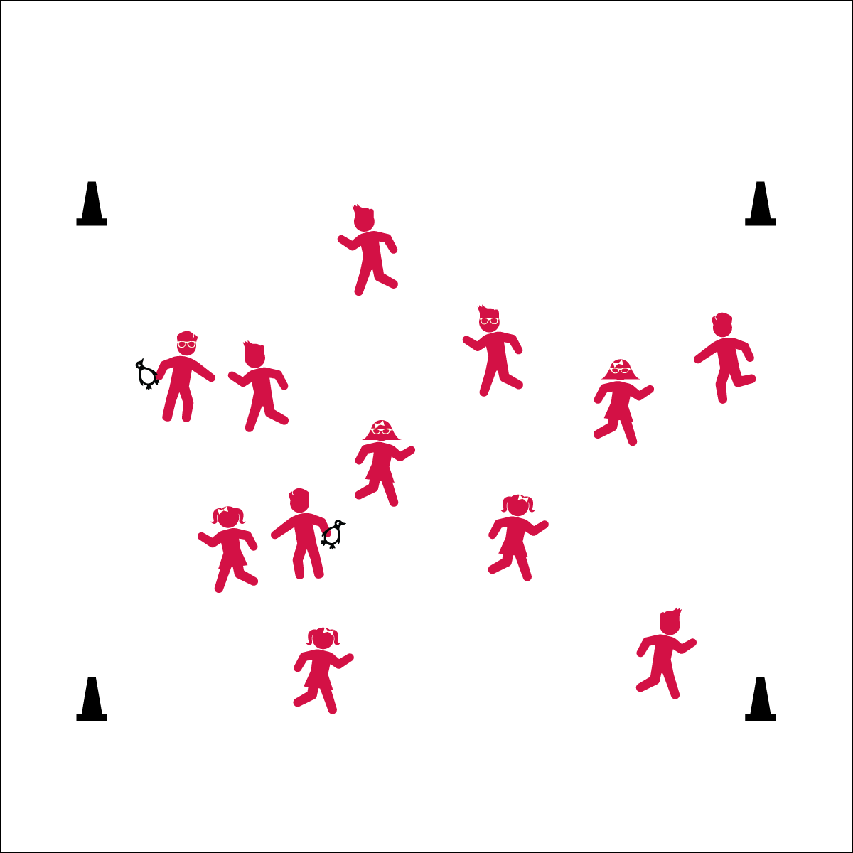

**Equipment:**

* 4 cones for boundaries
* Bean bags or rubber critters to identify taggers

**Set-Up:**

1. Create a large playing area, using four cones.
2. Scatter students in the activity area.
3. Give bean bags to 2 or 3 students to identify them as taggers.

* **Fitness:** I will be able to name healthy foods in order to be freed during our tag game.

**Activity Procedures:**

1. Today we’re going to warm up our bodies for physical education class by playing Say Cheese Tag.
2. When I say “GO!” begin playing at a speed-walking pace. The taggers will do 5 jumping jacks to give you time to move away from them.
3. If you’re tagged, freeze in your favorite selfie pose.
4. To be freed, someone will come over to take a selfie with a person who is frozen. When taking a selfie, say the name of a favorite fruit or veggie instead of saying ‘cheese’. For example, “Say Broccoli!” Then, both students will say “broccoli” while pretending to take a selfie.
5. Freeze when you hear the stop signal and we’ll change taggers.

**Grade Level Progression:**

**K:** Keep the pace at a speed walk.

**1st – 2nd:** When students demonstrate safe movement, increase the pace to a skip or gallop. Change food groups that they have to say throughout the activity.

**3rd – 5th:** Students could do an ‘action shot’ for their picture. They can add their favorite invisible jump rope trick when they say a food and take a picture.



* **Standard 3** **[E6.1]** Differentiates between healthy and unhealthy foods (1).
* Eyes up
* Be aware of your surroundings
* Safe tagging



* **DOK 1:** What type of foods are beneficial for before and after physical activity?
* **DOK 2:** Why is it better to have these foods compared to other foods?