­­



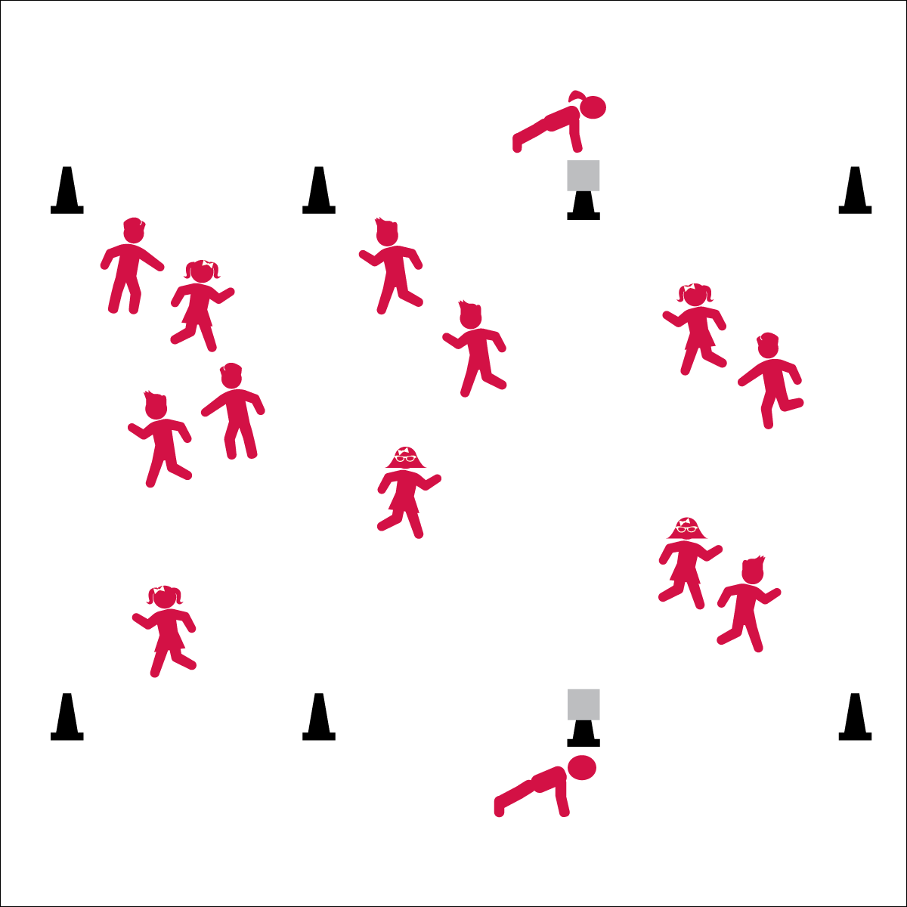

**Equipment:**

* 8 cones for boundaries

**Set-Up:**

1. Create a large playing area, using four cones.
2. Divide the area into three sections.
3. Scatter students in the first section of the playing area.

**Activity Procedures:**

1. Today we’re going to warm up our bodies for physical education class by playing Tax Day Tag. The object of the game is to make as many Tag-Dollars as you can and get to a higher tax bracket.
2. When I say “GO!” begin playing at a speed-walking pace. Everyone is a tagger.
3. Each tag equals five dollars. You are responsible for keeping track of your earnings. Once you get 100 dollars, you will go to the next tax bracket.
4. Before entering the next bracket do 10 jumping jacks, then begin to tag others in the new bracket. There are three tax brackets.
5. Freeze when you hear the stop signal.
6. Teachers: Stop and reset the game when there are only a few students that haven’t made it past the first bracket.

**Grade Level Progression:**

**K:** Students can count by one’s and work up to 10 dollars.

**1st – 2nd:** Change the locomotor movement from a fast walk to a skip.

**3rd – 5th:** Have students do a math problem at the end of zone 3 (Sample question involves a percentage. Modify the problem based on grade/ability level).

* **Fitness:** I will be able to describe what happens to my heart when I exercise.



* **Standard 3 [E2.1]** Actively engages in physical education class (1).
* **Standard 3 [E3.K]** Recognizes that when you move fast, your heart beats faster and you breathe faster (K).
* Eyes up
* Be aware of your surroundings
* Safe tagging



* **DOK 1:** If you were actively engaged in this activity, what should your heart be doing?
* **DOK 2:** Why does your heart beat faster?