­­

**INSTANT ACTIVITIES**



**FLOWER POWER TAG**

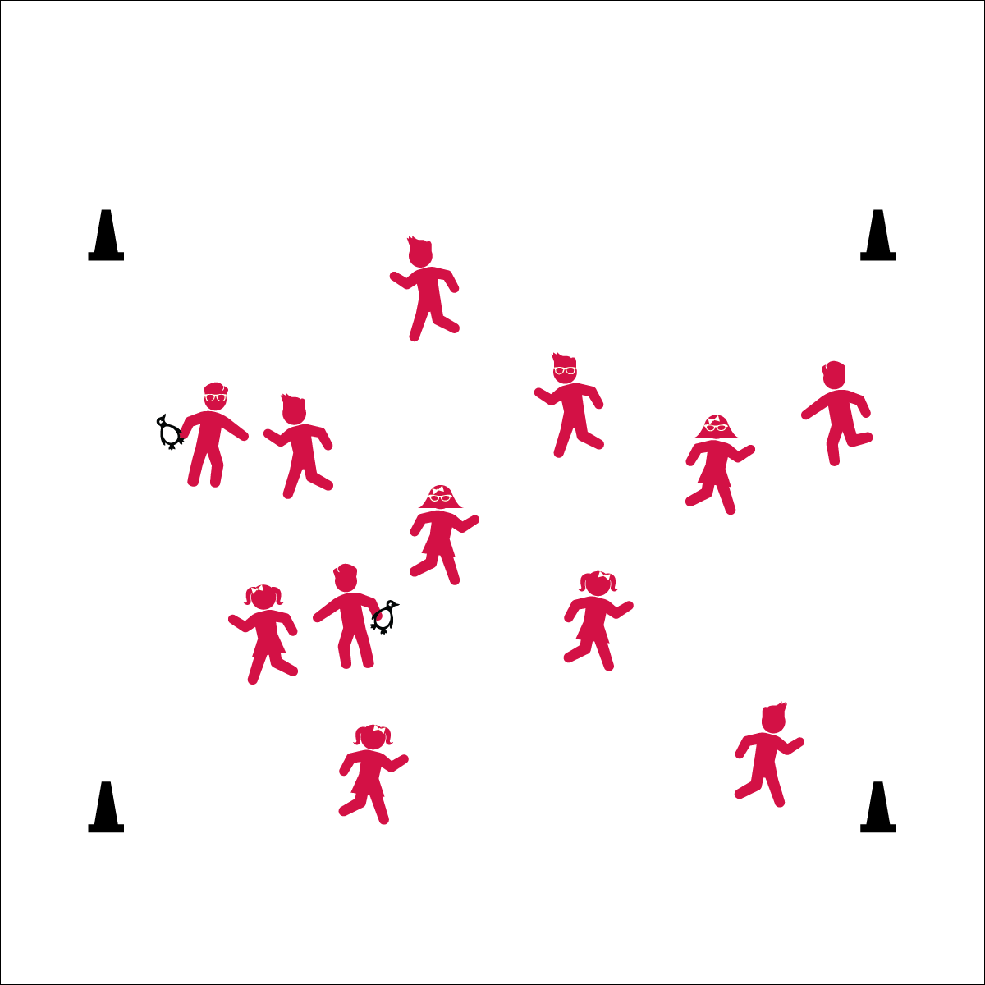

**Activity Procedures:**

1. Today we’re going to warm up our bodies for physical education class by playing Flower Power Tag.
2. When I say “GO!” you will become a seed and begin playing at a speed-walking pace. Taggers will do 5 jumping jacks to give you time to move away from them.
3. If you’re tagged, turn into your favorite flower. Stand tall with your arms connecting over your head to form a circle.
4. To be freed, another student will transform into a bee, fly over, and pollinate your flower by giving it a double high five. This will make the flower turn back into a seed allowing both students to continue playing.
5. Freeze when you hear the stop signal and we’ll change taggers.

**Grade Level Progression:**

**K:** Keep the pace at a speed walk.

**1st – 2nd:** When students demonstrate safe movement, increase the pace to a skip or gallop.

**3rd – 5th:** Along with a few taggers, designate a few students to be permanent bees who will be the only people that are allowed to unfree all of the flowers. When all of the bees become tagged, reset the game.

**Equipment:**

* 4 cones for boundaries
* Bean bags or rubber critters to identify taggers

**Set-Up:**

1. Use 4 cones to create a large playing area.
2. Scatter students in the activity area.
3. Give critters or bean bags to 2 or 3 students to identify them as taggers.

* **Fitness:** I will be able to identify healthy foods from the vegetable and fruit groups.



* **Standard 3** **[E3.1]** Actively engages in physical education class (1).
* **Standard 3 [E3.1]** Differentiates between healthy and unhealthy foods (1).

* Eyes up
* Be aware of your surroundings
* Safe tagging



* **DOK 1:** There are seeds for flowers, are there any foods that have seed in them?
* **DOK 2:** Why is it important to eat a variety of fruits and vegetables.?