­­

**INSTANT ACTIVITIES**



**SUMMER FUN TAG**

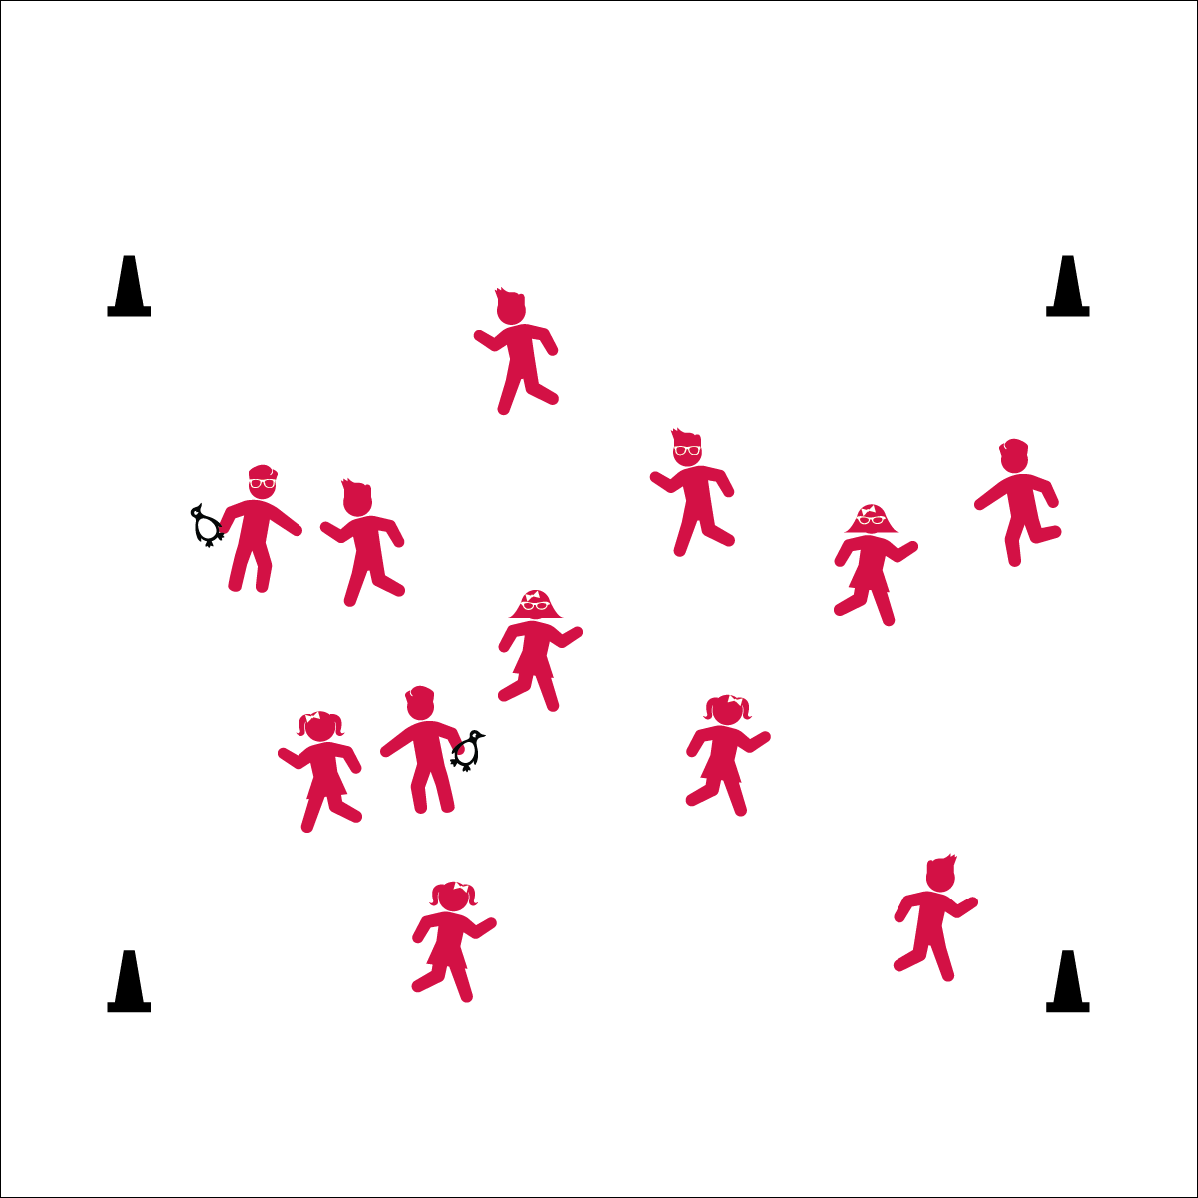

**Activity Procedures:**

1. Today we’re going to warm up our bodies for physical education class by playing Summer Fun Tag.
2. When I say “GO!” begin playing at a speed-walking pace. The taggers will do 5 jumping jacks to give you time to move away from them.
3. If you’re tagged, stop and begin to act out 1 physical activity that you did this summer to keep you healthy and fit.
4. To be freed, someone will come over and try guess what activity you’re doing. They get 2 guesses. As soon as they guess correctly, or after the second guess, you’re free to rejoin the game.
5. Freeze when you hear the stop signal and we’ll change taggers.

**Grade Level Progression:**

**K:** Keep the pace at a speed walk.

**1st – 2nd:** When students demonstrate safe movement, increase the pace to a skip or gallop.

**3rd – 5th:** Students could do an ‘action shot’. To be freed, someone comes and “takes a picture” of their activity.

**Equipment:**

* 4 cones for boundaries
* Bean bags or rubber critters to identify taggers

**Set-Up:**

1. Create a large playing area using four cones.
2. Scatter students in the activity area.
3. Give bean bags (or rubber critters) to 2 or 3 students to identify them as taggers.



* **DOK 1:** What would you include on a list about summer physical activity?
* **DOK 2:** How does staying activity in the summer affect your personal health?
* **DOK 3:** How did (or could) you adapt activities and games played in physical education in order to play them at home (at the park, beach, etc…)?



* **Standard 3** **[E1.Various]** Identifies active play opportunities outside physical education class (K); Discusses the benefits of being active and exercising/playing (1); Describes large-motor and/or manipulative physical activities for participation outside physical education class (2); Analyzes opportunities for participating in physical activity outside physical education class (4).
* **Fitness:** I will be able to name physical activities that I did over summer break to help keep me healthy and fit.
* Eyes up
* Be aware of your surroundings
* Safe tagging