­­

Created by Nick Kline

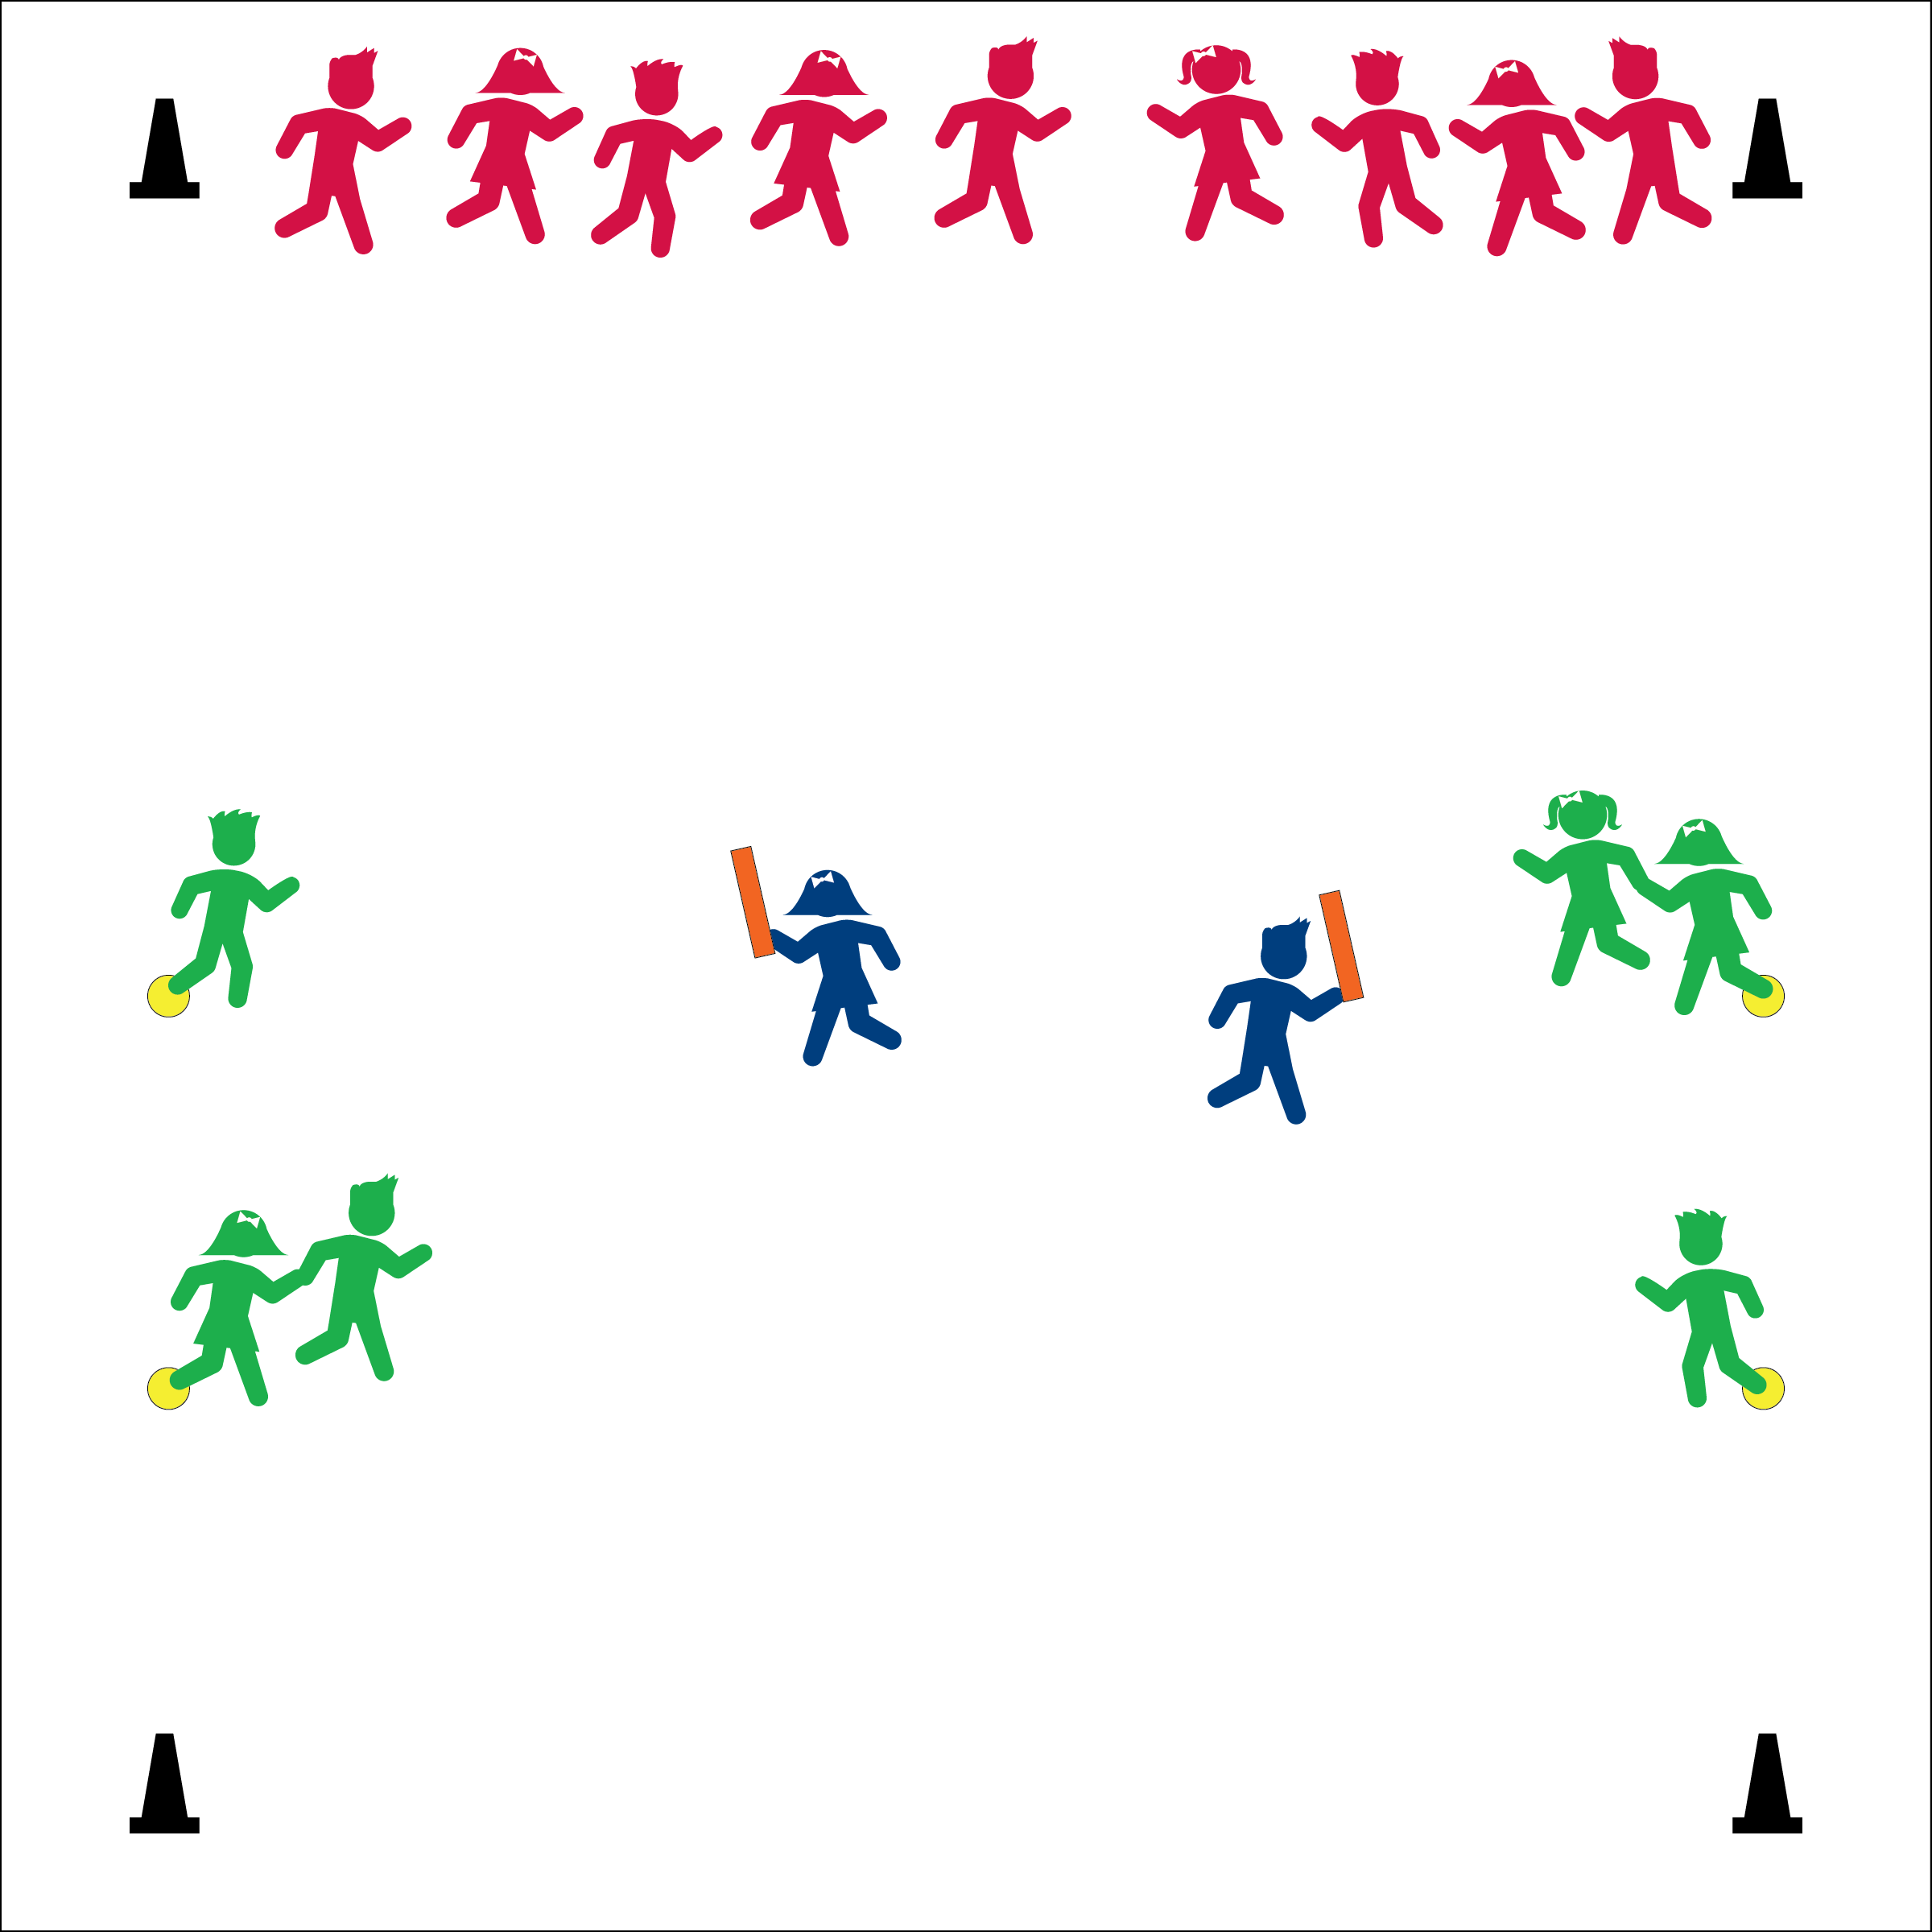

**Activity Procedures:**

1. Today we’re going to play a game called Sea Creature Tag. Sea Creatures begin on the shore and the sea monsters begin in the sea.
2. The tagger calls, “Creatures of the sea; Try to swim past Me!” Students attempt to move from one end line to the opposite end line.
3. Once tagged, students move to the nearest spot on the sideline to become a seaweed monster. The first seaweed monster tagged places a foot on a poly spot and can help tag with his/her outstretched arm. The next student tagged joins hands with the first to make the seaweed longer, and now this student helps tag.
4. Continue until there is one student left. That student can become the new tagger.

**Grade Level Progression:**

**K – 1st:** Start the activity using a walk and then progress to a gallop before allowing students to play using a run.

**2nd – 3rd:** Play the activity as described.

**4th – 5th:** Vary the number of taggers and poly spots.

**Equipment:**

* 4 cones for boundaries
* 2-4 poly spots
* 1-2 small noodle to identify tagger(s)

**Set-Up:**

1. Create a large playing area, using four cones.
2. Place poly spot(s) along the sideline.
3. Student line up across one end line.
4. Identify 1-2 taggers.

* Travel safe with eyes up
* Tag gently
* Work cooperatively when linked
* **Skill:** I will chase, flee, and dodge while keeping my body under control.
* **Fitness:** I will increase my heart rate by remaining physically active during Sea Creature Tag.



* **DOK 1:** What does heart rate mean?
* **DOK 2:** How does physical activity affect your heart rate?
* **DOK 2:** What activities can you do over the summer to increase your heart rate?



* **Standard 3 [E2.1]** Actively engages in physical education class (1).  
  **Standard 3 [E3.K]** Recognizes that when you move fast, your heart beats faster and you breathe faster (K).