­­

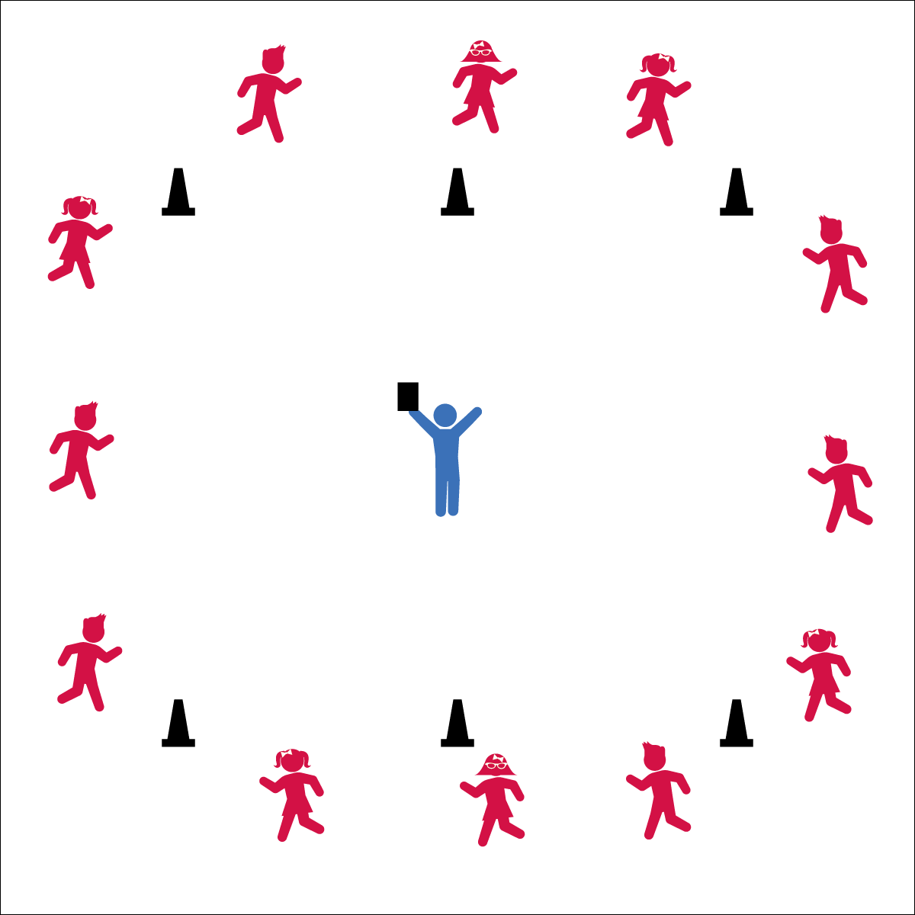

**Activity Procedures:**

1. Today we’re going to practice running around our course at different speeds with a game called Animal Run.
2. Every 10–30 seconds, I’ll callout animal names, and you’ll walk, jog, or run at the same speed as that animal. For example, a turtle walks slowly. A bear can move faster than a turtle, similar to a jog. A horse can run fast, but a cheetah is the fasted, like a sprint.
3. When I say, “GO!” everyone will start by walking around our running course like a turtle. Listen for me to call out different animals.
4. Teachers, limit sprinting to a maximum of 15 seconds. Be sure to allow students to recover from sprints or runs. Mix in plenty of jogs and walks.

**Grade Level Progression:**

**K–2:** Limit the number of animals and speeds to 2 or 3. Focus on the difference between a jog and a sprint.

**3–5:** Use 4 different animals to emphasize a variety of pace options. Or, allow students to choose a pace and discuss the reasons for their selection.



* **Standard 1 [E2.2-5]** Runs with a mature pattern (2a); Travels showing differentiation between jogging and sprinting (2b); Travels showing differentiation between sprinting and running (3); Runs for distance using a mature pattern (4); Uses appropriate pacing for a variety of running distances (5).
* **Standard 2 [E3.K,1a,4a]** Travels in general space with different speeds (K); Differentiates between fast and slow speeds (1a); Applies the movement concepts of speed, endurance, and pacing for running (4a).

* Slow like a Turtle
* Steady like a Bear
* Quick like Horse
* Fast like a Cheetah!
* **Fitness:** I will pace my activity and control my speed in order to build my aerobic capacity.



* **DOK 1:** What does pace mean? How can you recognize a fast pace? A slow pace?
* **DOK 2:** How does your pace affect your ability to run a long distance? How does pace affect your running form?
* **DOK 3:** How is pace related to performance in a race? Consider both short- and long-distance races.

**Equipment:**

* 6 cones to mark running course

**Set-Up:**

1. Create a medium-sized running course that will allow students to run at full speed, but still hear teacher commands.
2. Have students spread out around the running course to begin.
3. View this activity online: <https://youtu.be/GaHoloyn8nM>

Elementary Grades