­­



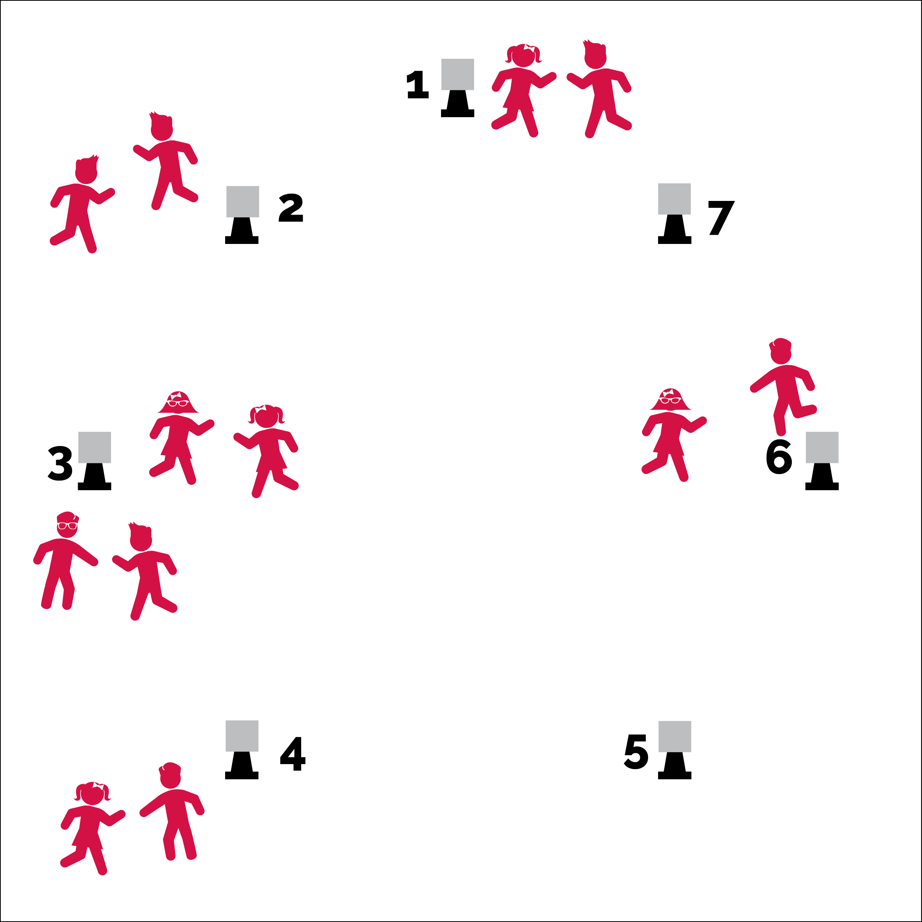



* **DOK 1:** What is an example of a responsible behavior?
* **DOK 2:** How do responsible behaviors affect our learning environment in physical education class?
* **DOK 3:** What facts can you use to encourage others to use responsible behaviors? Why did you choose those facts?



* **Standard 4** **[S4.E1]** Engages in physical activity with responsible interpersonal behavior (e.g., peer to peer, student to teacher, student to referee). (S4.E1.5)

**Activity Procedures:**

1. Today we’re going to warm up our bodies by playing Around the World Rock, Paper, Scissors.
2. When I say “GO!” please walk to Zone 1. At Zone 1, find a partner and play 1 game of Rock, Paper, Scissors.
3. If you win, please move to Zone 2 and play again. If you lost, play again with a new partner.
4. If you lose at Zone 2 or higher is when you have a choice. You can “Wait” or you can choose to “Challenge,” and immediately play again with a new partner at that zone.
5. If you chose to “Wait,” then perform 5 exercises of your choice (push-ups, jumping jacks, etc.). Once finished, find a new partner at that zone to play against.
6. If you chose “Challenge” and win, then you are safe and move up a zone. However, if you “Challenge” and lose, then you must go back to Zone 1!

**Grade Level Progression:**

**K:** Students play at Zone 1 as described. Have all students move to Zone 2 and play with someone new.

**1st – 2nd:** “Full-Body-Style” instead of using hands to play. Rock = Bend knees, arms in; Paper = Legs straddles, Arms out; Scissors = Legs & Arms staggered. Students jump 3 times and then make their symbol!

**3rd – 5th:** Instead of just 5 exercises to “Wait,” use math (i.e. double the zone #... Zone 4 = 8 exercise).

**Equipment:**

* 7 cones for boundaries
* World Zone Card
* 7 Task Tents

**Set-Up:**

1. Print 7 Around the World Zone Cards and use Task Tents to attach each to a cone.
2. Place the 7 cones around the perimeter of the playing area. Spacing can vary based on group size, age/fitness level, and space available.
3. Have all students begin at the Zone 1.

* **Personal & Social Responsibility:** I will work safely and demonstrate responsible behaviors during Around the World R,P,S.
* Be fair
* Be aware
* Be safe