­­



Created by: Jim DeLine  
& Aaron Hart

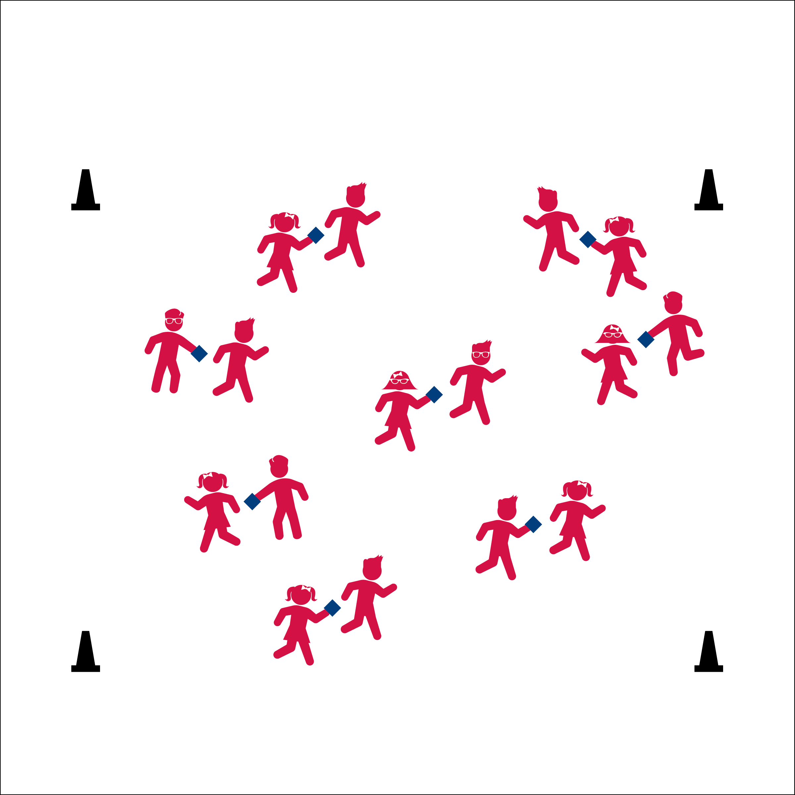

**Activity Procedures:**

1. It’s time for Turkey Tag! The hunter will try to catch the turkey, and the turkey will try to escape the hunter.
2. When the music starts, begin tossing the beanbag back and forth with your partner. When the music stops, the partner with the beanbag is the hunter! Speed walk through open space with the hunter chasing the turkey and they turkey fleeing the hunter. *(If you have vegetarians in the class, they can be Farm Sanctuary Agents working to catch the Turkeys to keep them safe from becoming Thanksgiving dinner.)*
3. When the music starts again, Hunters who tagged their turkey get 1 dessert point. Turkeys who did not get tagged get 1 day-of-freedom point.
4. This activity is an oldie-but-goody. Switch it up to meet the season and theme of your class. Elves vs Gingerbread Men, King Kong vs His Prey, Sharks vs Shark Bait – whoo-ha-ha.

**Grade Level Progression:**

**K-2nd:** Begin with students in two parallel lines. Student can only move straight to and from the end lines.

**3rd – 5th:** Students can move throughout the activity area. Increase from a speed walk to a gallop, from a gallop to a skip, and from a skip to beyond!



* **Standard 3** **[E3.K-1]** Recognizes that when you move fast, your heart beats faster and you breathe faster (K); Identifies the heart as a muscle that grows stronger with exercise/play and physical activity (1).
* **Standard 3 [E6.2]** Recognizes the “good health balance” of good nutrition with physical activity.
* **(S3.E6.2)**



* **DOK 1:** What is a healthy food that you might eat at a holiday meal?
* **DOK 2:** What do you know about balancing holiday meals with physical activity?
* **DOK 3:** What facts would you select to support being physically activity with your family during the holiday season?

**Equipment:**

* 1 beanbag, foam ball, OR critter per pair
* Music and player

**Set-Up:**

1. Pair students.
2. Each pair with a beanbag (or other tossable), safely spaced in the activity area.

* **Fitness:** I will recognize the effect that being physically activity has on my body (e.g., increase HR, sweat, etc.).
* **Fitness:** I will discuss the good health balance of good nutrition and physical activity.
* Eyes Up
* Be Aware of Your Surroundings