­­



Created by Andy Pickett

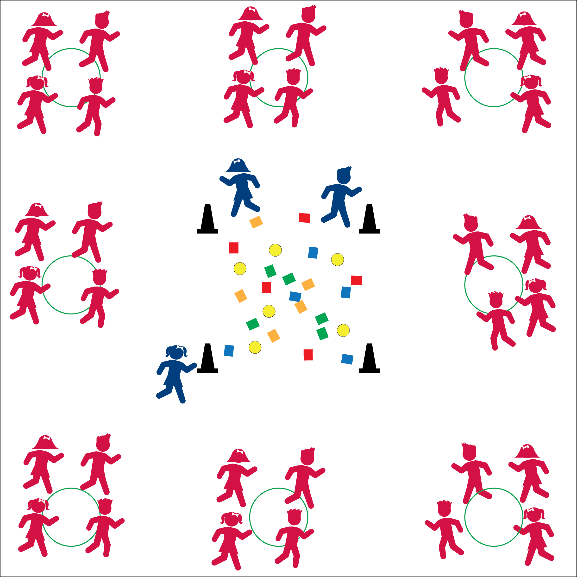



* **DOK 1:** How can you recognize safe behavior in the game Farmville?
* **DOK 2:** What did you notice about our game with respect to safety? Can you give examples of safe behaviors / unsafe behaviors?
* **DOK 3:** How is safety related to learning in physical education class?



* **Standard 3** **[E1.K-5]** Actively participates/engages in physical education class… (K-5).
* **Standard 4 [E6.K-5]** Follows teacher directions for safe participation and proper use of equipment with minimal reminders (K)… Applies safety principles with age-appropriate physical activities (5).

**Activity Procedures:**

1. Let’s get warmed-up with a game of Farmville! The object of the game is for farmers to protect the eggs and super-eggs in the coup from the chickens who are trying to take them back to their nests.
2. Farmers can pull a chicken’s flag feathers to send her/him back to the nest. Once back at the nest chickens put their flag feathers back on and try again.
3. The game continues until all eggs are collected by the chickens. Eggs are worth 1 point, super eggs are worth 5 points (if you want to keep score).

**Grade Level Progression:**

**K – 2nd:** To help chickens, make the coup square a safe, no-tag zone.

**3rd – 5th:** If students prove to be safe and responsible, add a toss and catch back to the nest. With this variation, use a variety of foam balls instead of bean bags.

**Equipment:**

* A lot of Beanbags or fluff balls (2 per student)
* 6 foam balls
* 4 cones
* 8 hoops or jump ropes
* 1 scarf or flag belt per student (optional)

**Set-Up:**

1. Create a “chicken coup” square with the 4 cones in the center of the play area. Scatter bean bags and foam balls in the chicken coup.
2. Space hoops/jump ropes around perimeter as “nests,” with 1 nest per team.
3. Create 8 equal teams, 1 per nest. Designate 2 or 3 students as “farmers.”

* **Fitness:** I will actively participate in Farmville.
* **Personal & Social Responsibility:** I will demonstrate safe behaviors while I participate in Farmville.
* Eyes Up
* Be Aware and Move Safely