­­



Created by Brandon Herwick

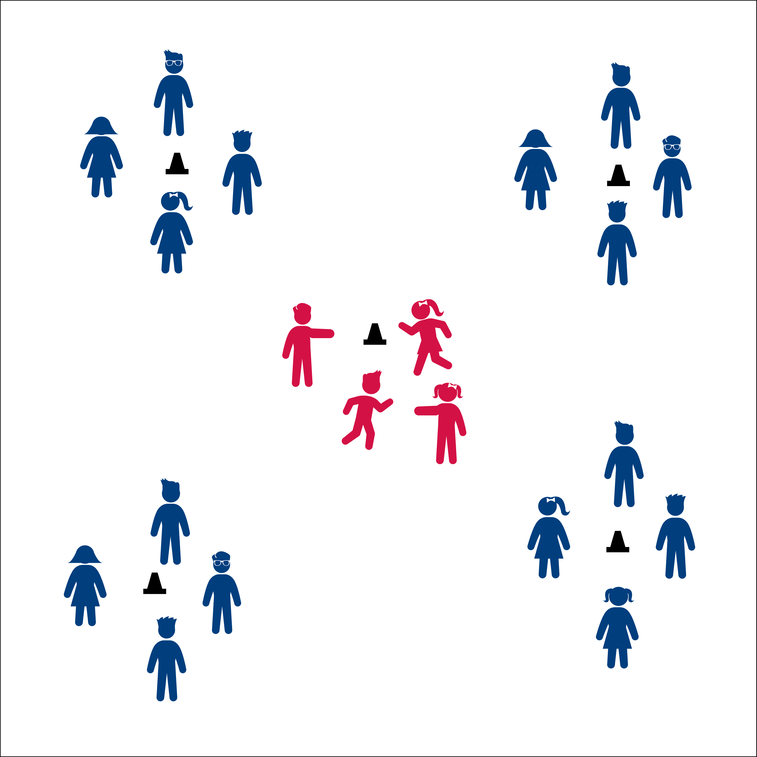



* **Standard 4 [E5.K-5]** Recognizes the established protocol for class activities (K); Exhibits the established protocols for class activities (1); Recognizes the role of rules and etiquette in teacher-designed physical activities (2); Recognizes the role of rules and etiquette in physical activity with peers (3); Exhibits etiquette and adherence to rules in a variety of physical activities (4); Critiques the etiquette involved in rules of various game activities (5).



* **DOK 1:** What does the work etiquette mean?
* **DOK 2:** Why is it important to follow etiquette in physical education class?
* **DOK 3:** How might etiquette be related to a person’s emotions in different social settings? (Provide students with a specific example of a social setting to discuss.)

**Activity Procedures:**

1. Let’s have a little fun with a #PEMannequinChallenge! (Use the #MannequinChallange Info Card to provide students with background and historical information about this challenge.
2. The object of this challenge is for your group to express your given emotion (character trait or scene) as mannequins for the rest of the class to guess.
3. You’ll be given 3 minutes (or set time) to discuss and plan your mannequin poses. When your group gets a “pause button signal,” freeze and strike a mannequin pose for the other groups to observe. After guessing and discussing your group’s scene, we’ll move on to the next group.

**Grade Level Progression:**

**K – 2nd:** Complete this activity as a class. Give all students an emotion or character trait to express and then give the “pause button signal” for all students to follow. Take video or photographs so that students can see their scene

**3rd – 5th:** Complete the activity as described above, with groups working independently.

**Equipment:**

* Teacher’s choice (or none at all)

**Set-Up:**

1. Create groups of 2 to 20.
2. Send groups to different areas of the room, with enough space to quietly discuss their challenge without other groups hearing their discussion.
3. Give each group an emotion, character trait, or scene.

* **Cognitive:** I will define and discuss the importance of etiquette.
* **Personal & Social Responsibility:** I will demonstrate the established protocol for the Mannequin Challenge.
* Strike A Pose
* Be Expressive