­­



Created by Nick Kline  
& Mike Ginicola

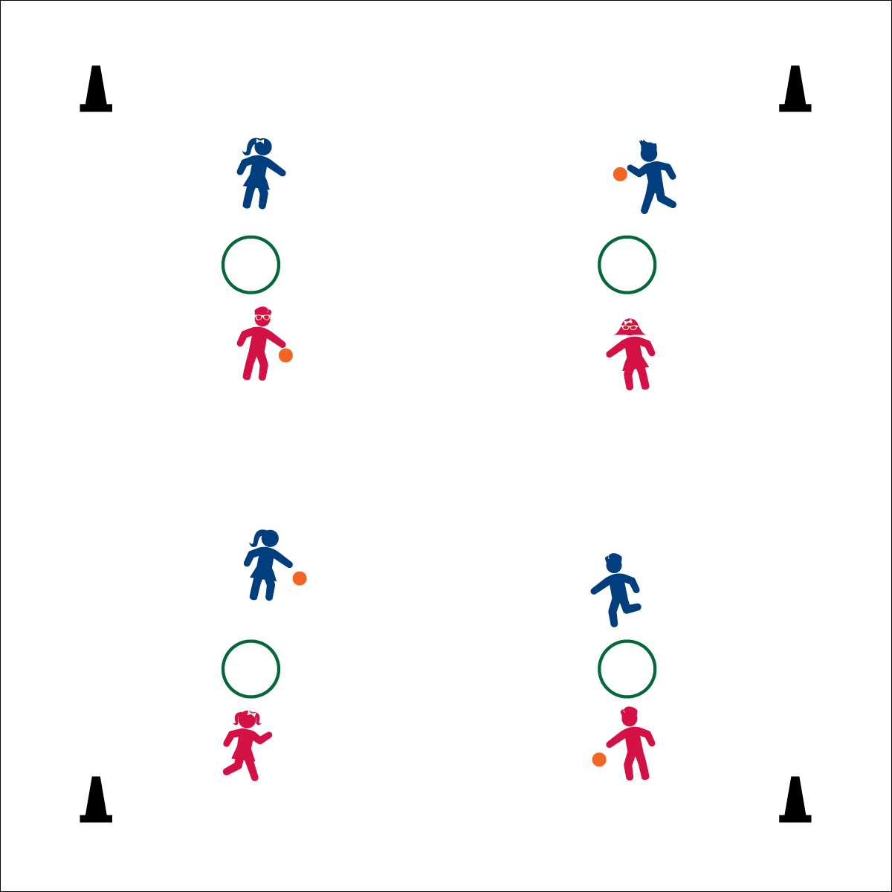

**Activity Procedures:**

1. Today’s activity is called Slam Ball. The object of the game is to successfully throw and catch the ball using a hoop as a target.
2. When I say “GO!” the first player throws the ball into the hoop. The second player attempts to catch it.
3. Scoring:
   1. Ball does not hit inside the hoop (point for receiving player)
   2. Ball hits inside hoop, but does not bounce at least 1 step away from hoop (point for receiving player)
   3. Ball hits inside hoop and bounces over the head of the receiver (point for receiving player)
   4. Ball is not successfully caught by receiving player (point for serving player)
   5. BONUS RULE: If a player wins 3 points in a row, they get to choose a new type of ball.
4. If sharing a hoop with 4 players and the two balls collide, this is a ‘slam’ and the two players that threw the ball switch opponents.

**Grade Level Progression:**

**K:** Allow students to practice bouncing and catching a ball without hoops or opponents.

**1st – 2nd:** Focus on teamwork by counting the number of catches players can make without using scoring.

**3rd – 5th:** Play the game as described.



* **Standard 4 (E14.3):** Throws overhand, demonstrating critical elements of a mature pattern, in non-dynamic environments (closed skills), for distance and/or force (3).



* **DOK 1:** What does reaction time mean?
* **DOK 2:** How did reaction time affect your performance in slam ball?
* **DOK 3:** How would you adapt slam ball to make it easier or more difficult?

**Equipment:**

* 1 hoop per 2 (or 4) players
* 1 ball (e.g. 6” PG Ball) per 2 players

**Set-Up:**

1. Two players stand on opposite sides of a hoop at least one step away.
2. If sharing a hoop, two other players can stand perpendicular at the same hoop.
3. One player starts holding the ball.

* **Fitness:** I will demonstrate quick reaction time when receiving a ball thrown by my opponent.
* **Personal & Social Responsibility:** I will demonstrate fair play.
* Aim for target
* Move to ball
* Soft hands to catch