­­



Created by Joey Feith

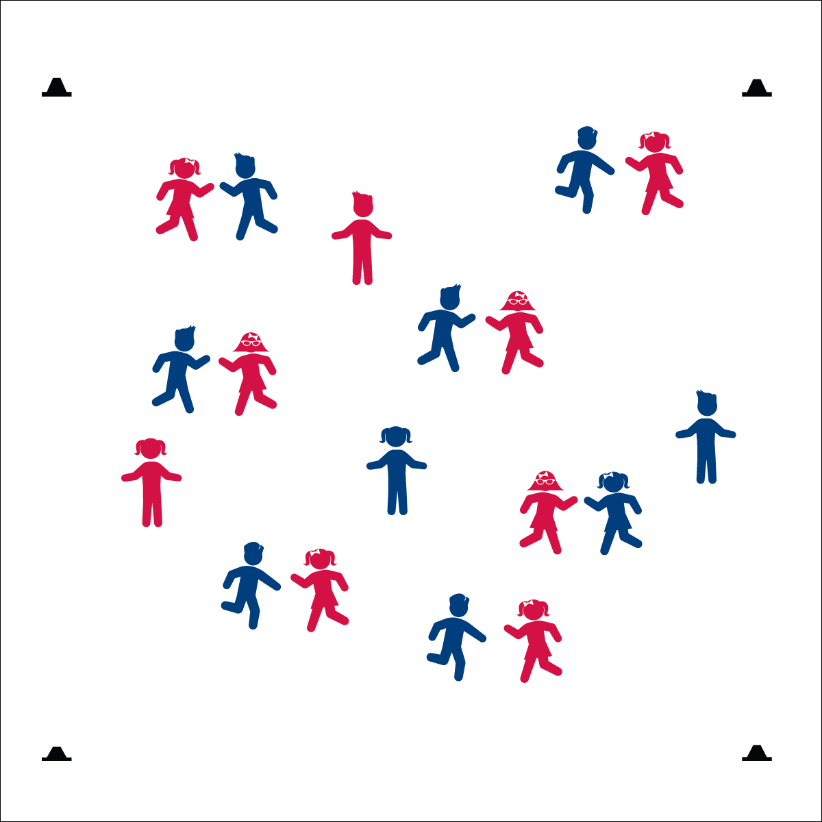

**Equipment:**

* Awesome Rocky music like *Eye of the Tiger* ([iTunes](https://itun.es/us/PTs9p?i=267725692))

**Set-Up:**

1. Students in pairs.
2. Pairs scattered in the activity area.
3. Pump up awesome Rocky music!



* **Standard 4 (E5.K-5):** Recognizes the established protocol for class activities (K); Exhibits the established protocols (1); Recognizes the role of rules and etiquette in teacher-designed physical activities (2); Recognizes the role of rules and etiquette in physical activity with peers (3); Exhibits etiquette and adherence to rules (4); Critiques the etiquette involved in rules of various game activities (5).

**Activity Procedures:**

1. Today’s activity is called Rocky Rock, Paper, Scissor. The object of the game is to win Rocky’s championship belt by beating your opponent in a series of Rock, Paper, Scissor battle rounds.
2. When I say “GO!” begin your RPS battle. The player that loses Round 1 will drop to 1 knee. If that player wins Round 2, she/he can stand back up on two feet and the opposite player will drop to 1 knee.
3. Play continues until a player falls through the following cycle: drops to 1 knee, drops to 2 knees, drops to plank position for 3 seconds (this is a technical knock-out “TKO”). Each time a player wins a round, she/he regains a position (e.g., if on 2 knees and wins, move back up to 1 knee only).
4. When a match is complete each player finds a new challenger to battle.

**Grade Level Progression:**

**K:** Students play 1 round of RPS and then move to a new partner.

**1st – 2nd:** Play activity as described.

**3rd – 5th:** Introduce the championship tournament. When a student is TKO’ed, he/she becomes a trainer for the winner. Each time there is a TKO – all trainers transfer to the winner of the match. Continue play until there are only 2 RPS Boxers left (all others are trainers). Then begin the championship match.

* **Fitness:** I will perform invisible jump rope skills while waiting for a new opponent.
* **Personal & Social Responsibility:** I will demonstrate the Spirit of the Game in my attitude and actions.



* **DOK 1:** What does Spirt of the Game mean?
* **DOK 2:** What do you know about Spirit of the Game?
* **DOK 3:** How is Spirt of the Game related to competitive activities like Rocky RPS?
* Spirit of the Game
* Work Hard
* Have Fun