­­

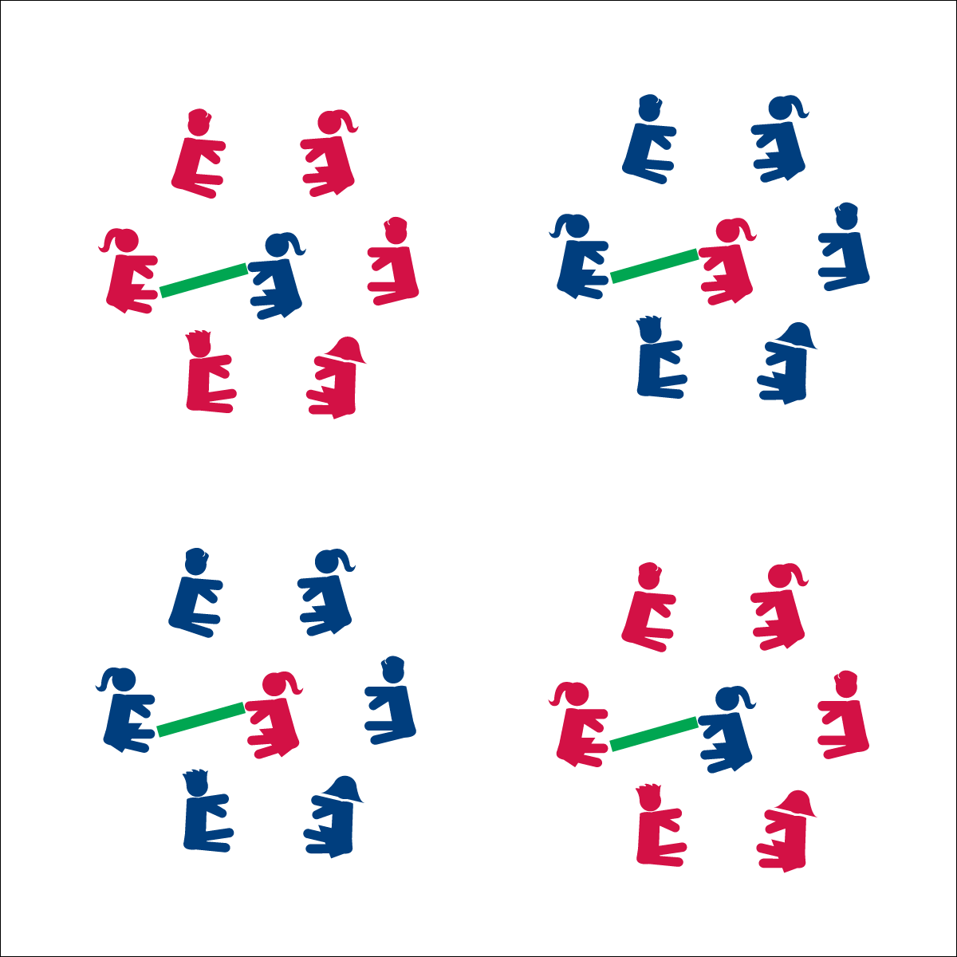

**Equipment:**

* 1 foam noodle per 7 students
* 1 spot marker per 7 students

**Set-Up:**

1. Create groups of 7 students.
2. In each group, 6 students form a circle with 1 student in the center holding the foam noodle and sitting on the spot marker.
3. Students on the outside of each circle sit with their legs extended and feet in the center of the circle.
4. Circles should be just large enough so that the student in the center can reach the outside feet with the noodle.

* Listen
* Respond
* Stay Safe
* **Cognitive:** I will discuss the importance of following class rules and how my behavior relates to learning.

**Activity Procedures:**

1. It’s time to learn names and test our reaction time. This activity is called Name Noodle. The object of the game is for the player in the center to use the noodle to tag the foot of the player whose name is called.
2. If the player whose name is called calls a new name before being tagged, the player in the middle must quickly react and work to tag the new player’s foot. If a player’s foot is tagged before a new name is called, that player moves to the center and becomes the new tagger.
3. If all names in the circle are called without anyone being tagged, the tagger chooses a new person to take her/his place.

**Grade Level Progression:**

**K– 2nd:** The teacher plays as the tagger and remains in the center until students understand and can follow he game’s directions.

**3rd – 5th:** No name can be repeated until all players’ names are called.



* **Standard 4** **[E5.K-5]** Recognizes the established protocol for class activities (K); Exhibits the established protocols for class activities (1); Recognizes the role of rules and etiquette in teacher-designed physical activities (2); Recognizes the role of rules and etiquette in physical activity with peers (3); Exhibits etiquette and adherence to rules in a variety of physical activities (4); Critiques the etiquette involved in rules of various game activities (5).



* **DOK 1:** What is a rule?
* **DOK 2:** How does following class rules affect our games and activities?
* **DOK 3:** How is following rules related to learning in class? How did it relate to your ability to learn and practice your classmates’ names?