­­

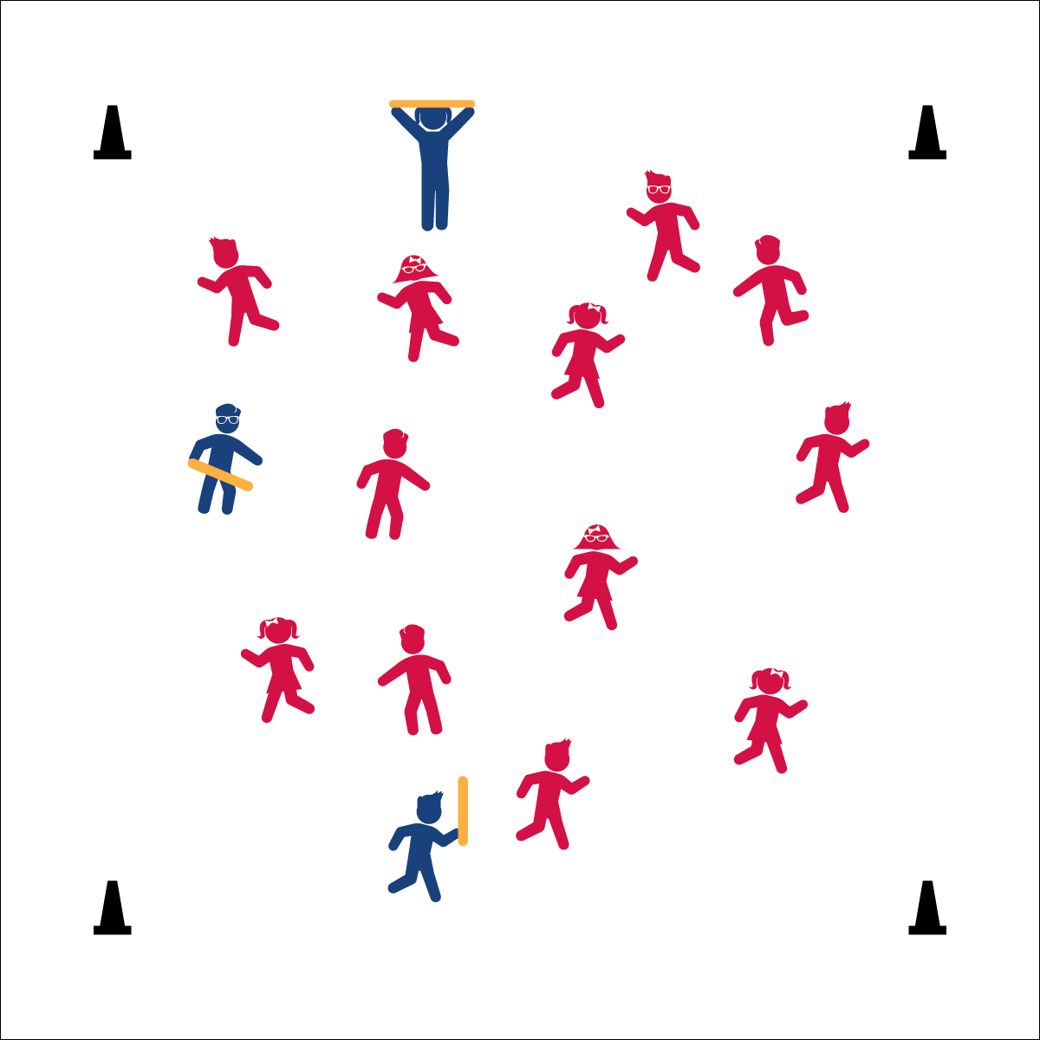



* **DOK 1:** What is self-control?
* **DOK 2:** How do you demonstrate self-control in the game Fiddlesticks?
* **DOK 3:** How is self-control related to learning in class? How is it related to safety?

**Activity Procedures:**

1. It’s time to play a tag game called Fiddlesticks! The object of the game is to flee from taggers so you don’t have a noodle when the music stops. This is a skipping and galloping game – choose one of those locomotor skills.
2. When the music starts, taggers will begin to skip or gallop - working to tag other players with a noodle. When tagged with a noodle, the player tagged takes the noodle, complete 3 high-lows (or other exercise), and then becomes a new tagger. Taggers cannot throw or toss the noodle for any reason.
3. When the music stops, players with a noodle say, “FIDDLESTICKS!” Players without a noodle say, “CHA-CHING!”
4. Replay as many times as you want.

**Grade Level Progression:**

**K– 2nd:** Play the game as written. Change locomotor skills to meet learning objectives.

**3rd – 5th:** Students fleeing are dribbling basketballs. Taggers are “defenders” working to tag the basketball with the noodle. When tagged, players swap the ball for the noodle and change roles.

**Equipment:**

* 3 to 5 foam noodles
* Cones to create boundaries
* Music and music player

**Set-Up:**

1. Using 4 cones, create a large playing area.
2. Scatter students in general space.
3. Give 3 to 5 noodles (depending on size of the group) to students designated as taggers.
4. Use music as a start/stop signal.

Written by: Jim DeLine

* Watch Where You Go
* Control Your Speed
* Tag Safely
* **Personal & Social Responsibility:** I will demonstrate responsibility and demonstrate self-control while chasing and fleeing.



**Standard 4 (E1.K-2)** Follows directions in group settings (e.g., safe behaviors, following rules, taking turns) (K); Accepts personal responsibility by using equipment and space appropriately (1); Practices skills with minimal teacher prompting (2). Exhibits personal responsibility in teacher-directed activities (3); Exhibits responsible behavior in independent group situations (4); Engages in physical activity with responsible interpersonal behavior (e.g., peer to peer, student to teacher) (5).