­­

Written by: Joey Feith

[ThePhysicalEducator.com](https://thephysicaleducator.com/game/star-wars-tag/)

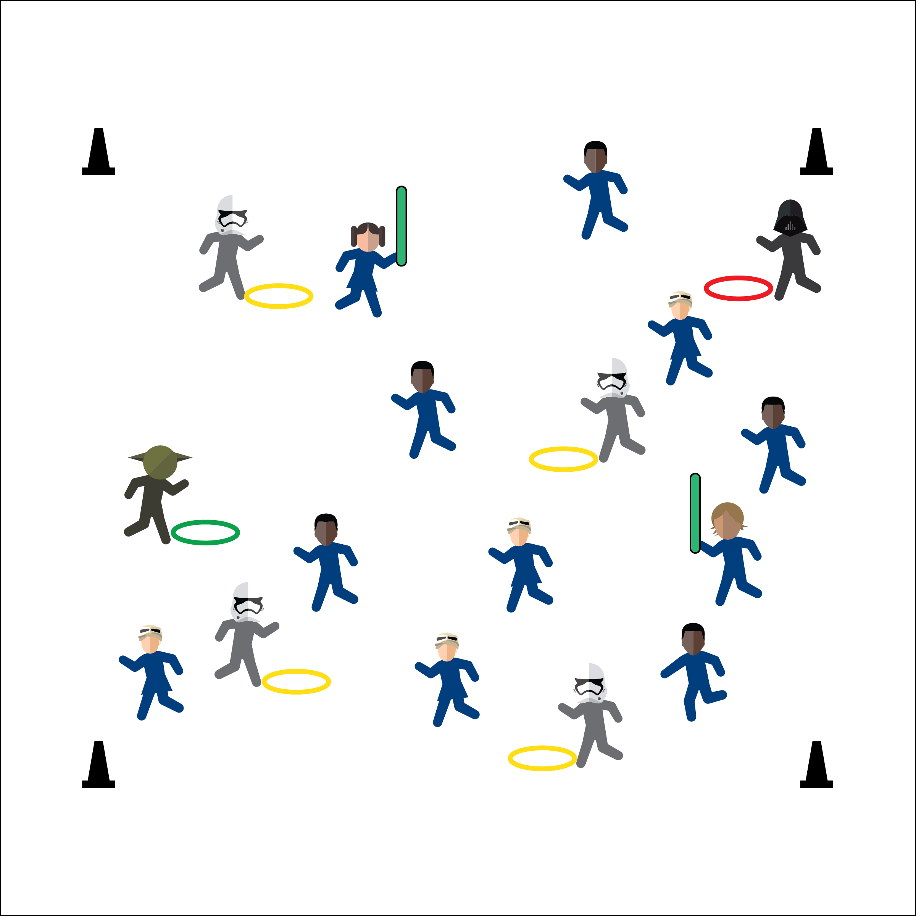



**DOK 1:** What is chasing? What is Fleeing?

**DOK 2:** What do you know about chasing and fleeing in physical education? In sport?

**DOK 3:** How is safety related to chasing and fleeing?



**Standard 2** **[E5.3-4]** Applies simple strategies/tactics in chasing activities (3a); Applies simple strategies in fleeing activities (3b); Applies simple offensive strategies/tactics in chasing and fleeing activities (4a); Applies simple defensive strategies/tactics in chasing and fleeing activities (4b).

**Equipment:**

* Pinnies (3 colors, e.g. white, black, green)
* Hula hoops (3 colors, e.g. yellow, red, green)
* Foam noodles
* 4 cones to create boundaries
* Star Wars Tag Language Cards
* Star Wars Tag Chapter 6 Story Starter

**Set-Up:**

1. Create a large play area using 4 cones.
2. Scatter students throughout the area.
3. Organize equipment safely on the sideline, to be used in progression chapters.

* Hoops Stay Flat on Ground
* Avoid Stepping on Hoops
* Control of Your Movement
* I will safely and actively participate in Star Wars Tag while demonstrating respect for self and others.

**Activity Procedures:**

1. Today’s instant activity is called Star Wars Tag. It’s a story broken up into five chapters.
2. **One:** Rebels. All students are Rebels. The object is to explore the star system while avoiding other rebels. On the start signal, begin skipping (running, etc.) in the boundaries. Freeze on the stop signal.
3. **Two:** Stormtroopers. With new Rebel activity, the Empire is sending in Stormtroopers. Storm troopers wear white pinnies and have yellow blasters (hoops). They tag Rebels by sliding the hoops across the floor using their feet. If a hoop tags a Rebel they Freeze. Continue until all Rebels are frozen.
4. **Three:** Rebel Leaders. The Rebel Alliance is sending Luke Skywalker & General Leia to free frozen Rebels by tapping them with lightsabers (foam noodles). Stormtroopers can freeze Luke and Leia!
5. **Four:** Darth Vader. Darth Vader is joining the battle to deal with Luke and Leia! He has a black pinnie and a red blaster (hoop). If tagged by Vader, rebels put on a white pinnie and become storm troopers. If Luke or Leia get tagged, they drop their lightsaber. Any rebel can pick it up and continue.
6. **Five:** Return of the Jedi. Master Yoda has joined the action. He has a green pinnie & blaster. If a Stormtrooper is tagged by Yoda, return the pinnie and blaster and become a Rebel. As masters of the Force, both Yoda and Vader are immune to all blaster attacks (including each other’s).