ThePhysicalEducator.com

You’ve experience the first 5 chapters of Star Wars Tag. Now it’s time for you to write the next chapter!

First, circle the main character that you will use as the first-person narrator of your new chapter. Next, quickly write 3 notes to help define your story elements (characters, setting, main idea). Finally, use your notes to write the first draft of your Chapter 6 stories.
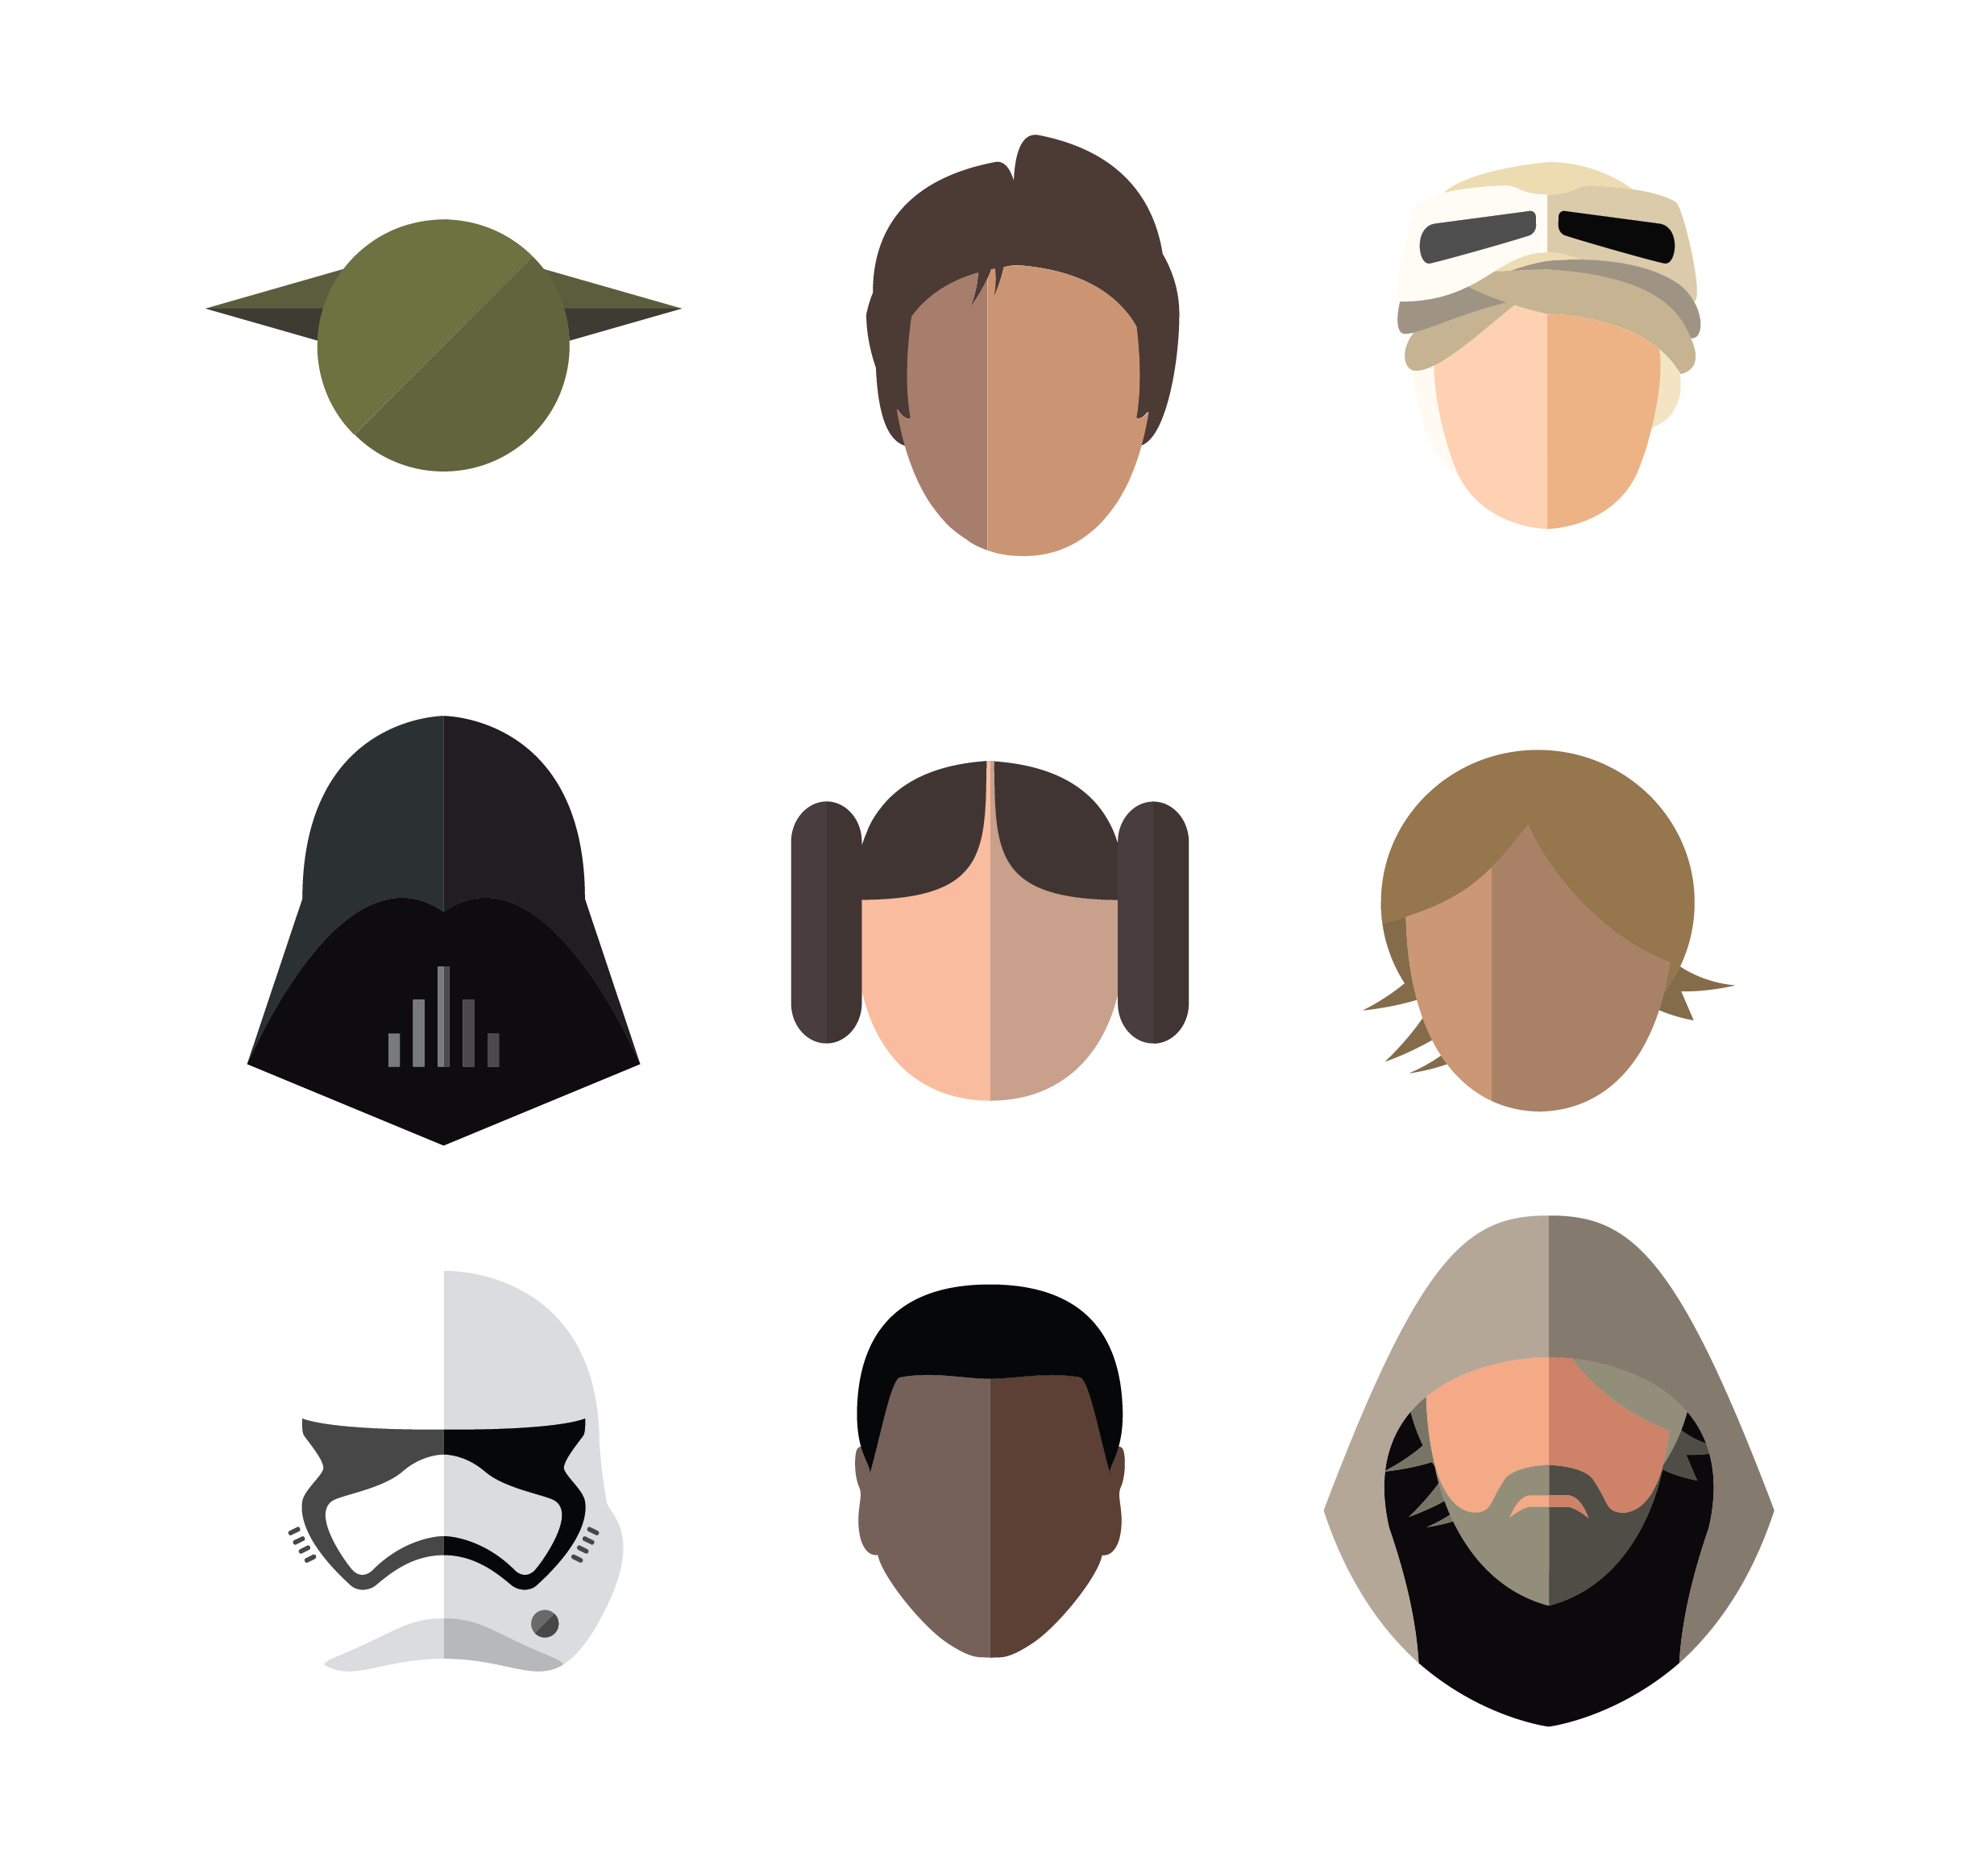

Draft of Chapter 6:
Circle your main character:
Characters
1)
2)
3)
Setting
1)
2)
3)
Main Idea
1)
2)
3)
Write Quick Notes:

