­­



Created by

Dillon Chichester

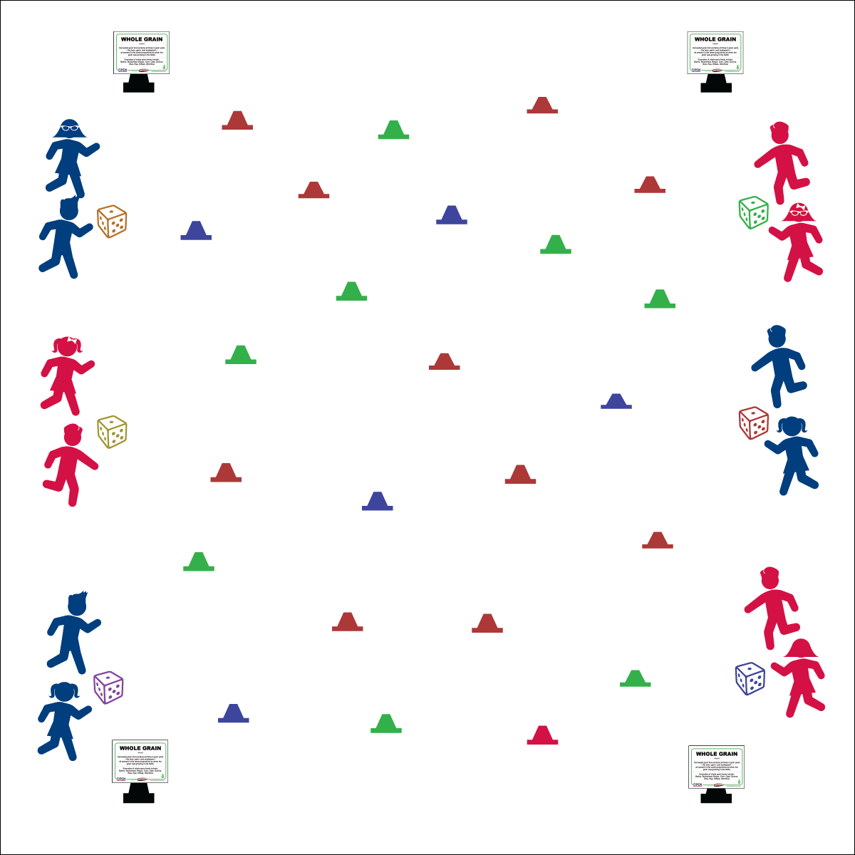

**Activity Procedures:**

1. Today we’re going to play a game called “Whole Grains Scramble.” The object of the game is for each group to name while grains as they move around low profile cones.
2. The game starts with the teacher calling out a locomotor movement. (Call a new movement each minute.)
3. When a movement is called, 1 student in each group rolls a die. The number on the die equals the number of cones that each student must move around, and the number of whole grains to shout out. Example: If a group rolls a “3” each group member must move around 3 different cones and call out 3 different whole grains. After completing all cones, the group returns and rolls again. Continue until the stop signal.
4. Students who can’t remember a variety of whole grains can move to a task tent and reference the academic language card.

**September is “Whole Grains Month.” Use this link for additional resources:**

<https://wholegrainscouncil.org/get-involved/celebrate-whole-grains-month-september>

**Grade Level Progression:**

**K:** Roll one die as a class. Give students the names of whole grains before they move.

**1st – 2nd:** Begin with groups roll a die and move around the cones, without naming whole grains. Then progress to the full game.

**3rd – 5th:** Play the activity as described.

**Equipment:**

* 24 low profile cones
* 6 dice
* 4 large cones to create boundaries
* 4 whole grain academic language card
* 4 task tents

**Set-Up:**

1. Create a large activity area with 4 large cones.
2. Scatter low profile cones throughout the activity area.
3. Use task tents to post the whole grain academic language cards on each large cone.
4. Space 6 dice out along 2 sidelines (3 on each sideline).
5. Create 6 even groups of students; each behind a die.



* **Standard 1 [E1.K]:** Performs locomotor skills (hopping, galloping, running, sliding, skipping) while maintaining balance (K).
* **Standard 3 [E6.1]:** Differentiates between healthy and unhealthy foods (1).



* **DOK 1:** How would you describe a whole grain?
* **DOK 2:** What are all of the things that you know about whole grains?
* Eyes Forward
* Take Turns
* Know Your Grain
* **Skill:** I will use a variety of locomotor movements to safely move through general space.
* **Fitness:** I will name a variety of whole grains.