­­



* **Fitness:** I will be aware of my surroundings when performing various locomotor skills.

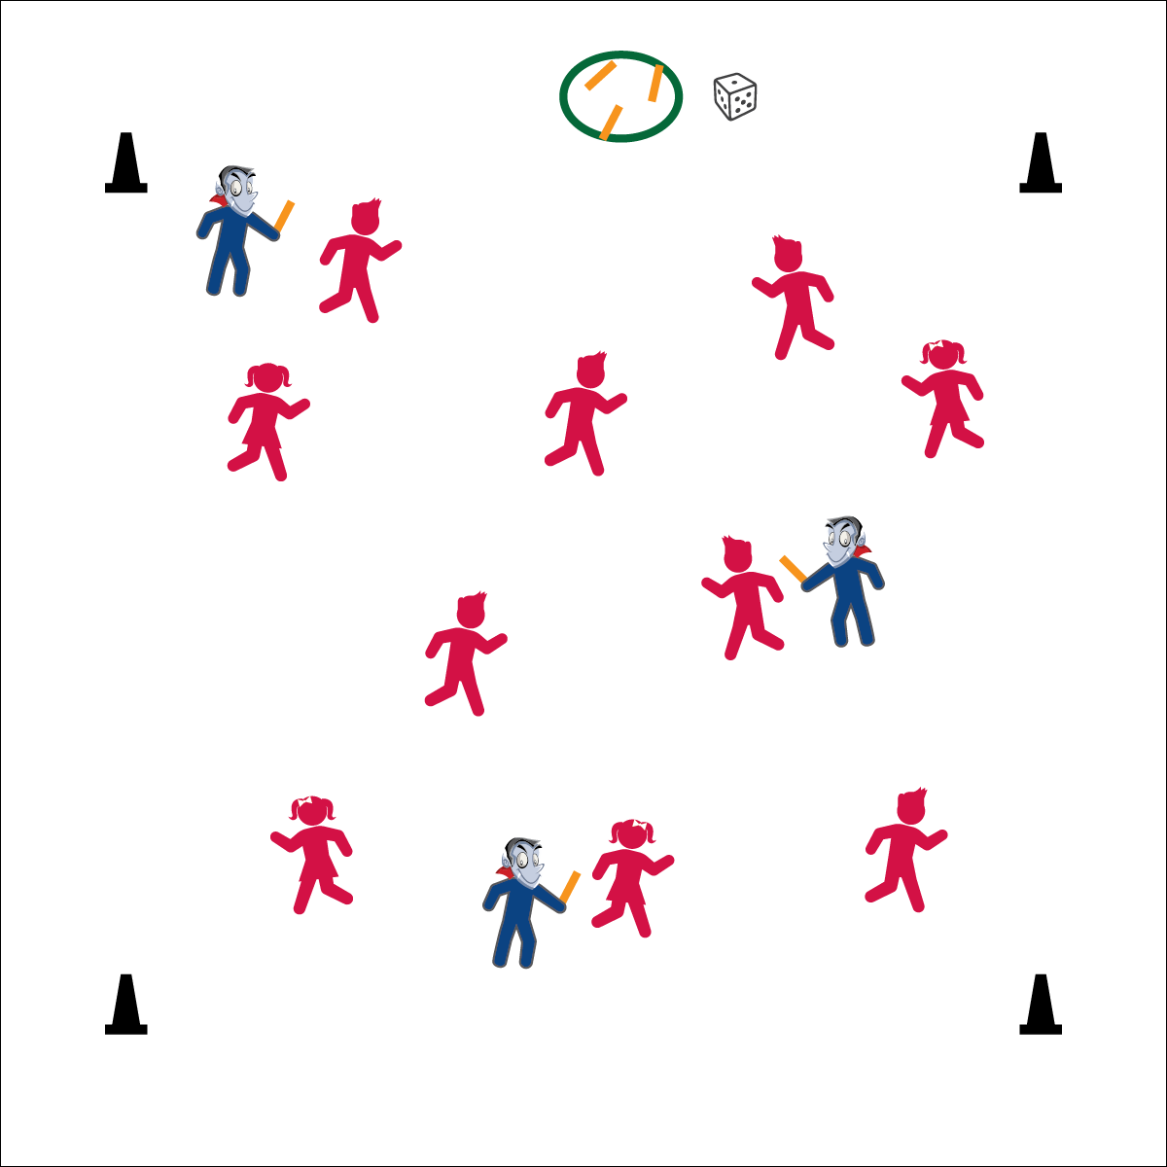



**Standard 1 [E1.4]** Uses various locomotor skills in a variety of small-sided practice tasks, dance and educational gymnastics experiences (4).

**Standard 2 [E1.K]** Differentiates between movement in personal (self-space) and general space [Ka].

**Standard 4 [E6.1]** - Follows teacher directions for safe participation and proper use of equipment without teacher reminders (1).

**Activity Procedures:**

1. It is time for “Calling all the monsters.”
2. Each student must receive a number from 1-6. Each number represents a monster for example, 1= Frankenstein, 2= vampire, 3= ghost, 4= werewolf, 5= mummy, and 6= witch.
3. The teacher will roll the die and the number rolled will designate which monster will be “It.”
4. On, “BOO!” the designated monsters will get a noodle from the “monster pit” (aka a hula hoop), and then begin tagging other students.
5. If tagged, two students must come together to create an arc by joining hands above their heads. Then, a third student who has not been tagged will free the other two by moving underneath the arc.

**Grade Level Progression:**

**K –** Use locomotor skills such as walking and hopping.

**1st – 2nd:** When students demonstrate safe movements, they can increase their speed by changing locomotor skills to a skip or gallop.

**3rd – 5th:** When tagged, students must perform 5 monster maker exercises (i.e., mountain climbers).



* **DOK 1:** What is general space? What is personal space?
* **DOK 2:** How is general space different than personal space?
* **DOK 3:** How is safety related to both general space and personal space?

**Equipment:**

* 4 Cones for the boundary
* 1 Dice
* 3-6 noodles to identify taggers

**Set-Up:**

1. Using the 4 cones, create a large playing area
2. Give each student a number, 1 through 6.
3. Roll the die, the number that the die lands on are the taggers and receive the noodles.

* Follow Instructions
* Safe Tagging
* Eyes Up