­­

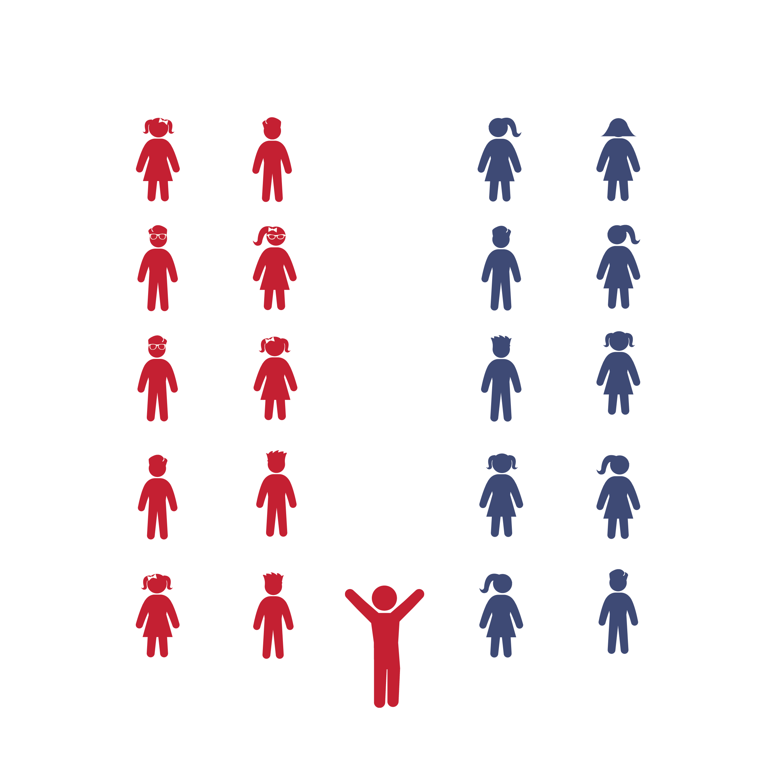

**Created for the song: Crazy Frog Jingle Bells (**[**iTunes**](https://itunes.apple.com/us/album/jingle-bells-single-mix/93350997?i=93351004)**)**

Thank you to: Scott Williams, Brandon Herwick & Deedi Brown

**Activity Procedures:**

1. Today we’re going to participate in a partner dance to Crazy Frog’s Jingle Bells! You and your partner will follow a set of movements during some parts of the song and dance along to movements you create during other parts.
2. The song’s melody repeats, and so does the pattern of our dance movements. Listen to the music and my cues, and have fun with this holiday dance!
3. Teachers: use the Crazy Frog Jingle Bell Activity Card to teach the choreography of this dance.

**Grade Level Progression:**

**K–5th:** Repeat the prescribed choreography for the entire song rather than having students create their own movements. (K–3) Have students create their own choreography in the designated sections of the dance. (4) Place students into larger groups for more collaborative choreography and performance. (5)



* **DOK 1:** What dance movements did we all use to perform this dance?
* **DOK 2:** How did you and your partner work together to create your unique movements?
* **DOK 3:** Discuss with your partner what inspired you to create those movements.



* **Standard 3** **[S3.K-5]** Actively participates in physical education class (K); Actively engages in physical education class (1); Actively engages in physical education class in response to instruction and practice (2); Engages in the activities of physical education class without teacher prompting (3); Actively engages in the activities of physical education class, both teacher-directed and independent (4); Actively engages in all the activities of physical education (5).
* **Fitness:** I will actively engage by following all movement cues for this dance.
* Follow Along with Dancers
* Follow Teacher’s Cues
* Find and Follow the Beat of the Music

**Equipment:**

* Music Player
* *Jingle Bells* by Crazy Frog ([available on iTunes](https://itunes.apple.com/us/album/jingle-bells-single-mix/93350997?i=93351004))
* Jingle Bells Activity Card
* Jingle Bells Dance Video ([on YouTube](https://youtu.be/wIwWcHE6yBc))

**Set-Up:**

1. Pair students. Pairs can be in lines or scattered throughout the activity area.
2. Be sure students have enough space to dance safely.