­­

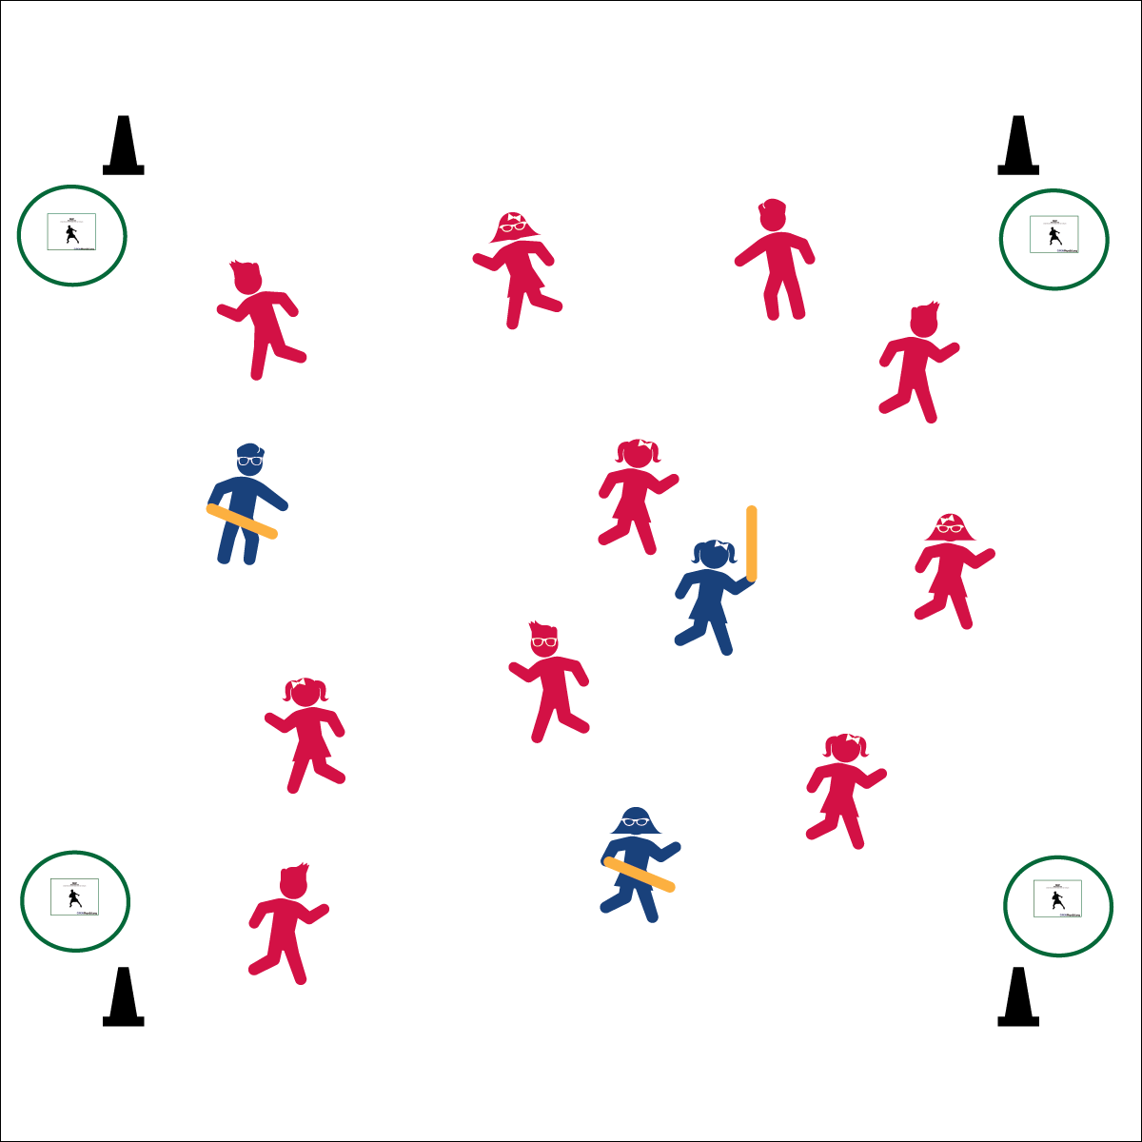

**Equipment:**

* Any song from the [*Trolls*](https://itunes.apple.com/us/album/trolls-original-motion-picture-soundtrack/1154238159) soundtrack
* Cones (optional)
* 4 pinnies - 2 different colors
* 3-6 half noodles (optional) for tagging
* Trolls Tag Dance Cards
* Hula Hoops

**Set-Up:**

1. Use cones to establish a large activity.
2. Place hoops outside boundary lines and place the dance cards at each hoop.
3. Scatter students inside the area. Designate 3-6 students as Bergens (taggers) with noodles.

**Activity Procedures:**

1. Today we’re going to participate in a dancing tag games called Trolls Tag! This game is based on the movie *Trolls*. In the movie there are Trolls and Bergens. The Trolls loved to sing, hug, and dance in order to stay happy, and the Bergens were only happy if they ate the Trolls.
2. The object is for the Trolls to avoid the Bergens, while the Bergens chase and safely tag the Trolls.
3. If a Troll is tagged, they move to a hoop, perform the dance on the card for 8 beats in order to regain their happiness, and then rejoin the game.

**Progression:**

Use pinnies to designate 2 Trolls to be Poppy and Branch. They are Trolls who rescue captured friends. Poppy and Branch can’t get tagged. Use a different colored pinnie to designate the Chef and give her/him a pool noodle. The Chef is the main Bergen. Trolls freeze if the chef came near. In this game, if the Chef tags a Troll, then the student freezes with a hand in the air. Poppy or Branch must go to that student and do a partner dance (do-si-do, polka, pop and lock wave, etc.) in order to unfreeze her/him.



* **Standard 3** **[S3.K-5]** Actively participates in physical education class (K); Actively engages in physical education class (1); Actively engages in physical education class in response to instruction and practice (2); Engages in the activities of physical education class without teacher prompting (3); Actively engages in the activities of physical education class, both teacher-directed and independent (4); Actively engages in all the activities of physical education (5).

Created by: Dan Tennessen

**Use any song from the *Trolls* movie soundtrack: (**[**iTunes**](https://itunes.apple.com/us/album/trolls-original-motion-picture-soundtrack/1154238159)**)**



* **DOK 1:** How can you recognize a dance that will elevate your heart rate?
* **DOK 2:** How can the tempo of the music affect your heart rate?
* **DOK 3:** How could you change this game to make it more or less vigorous?
* **Fitness:** I will dance and play vigorously in order to elevate my heart rate and improve my cardiorespiratory endurance.
* Keep a Steady Beat
* 8 Counts of Movement
* Match the Tempo of the Music