WHIP
Dance Move Card
Complete this dance move for 8 beats, and then return to the game.

NAE NAE
Dance Move Card
Complete this dance move for 8 beats, and then return to the game.

DAB
Dance Move Card
Complete this dance move for 8 beats, and then return to the game.
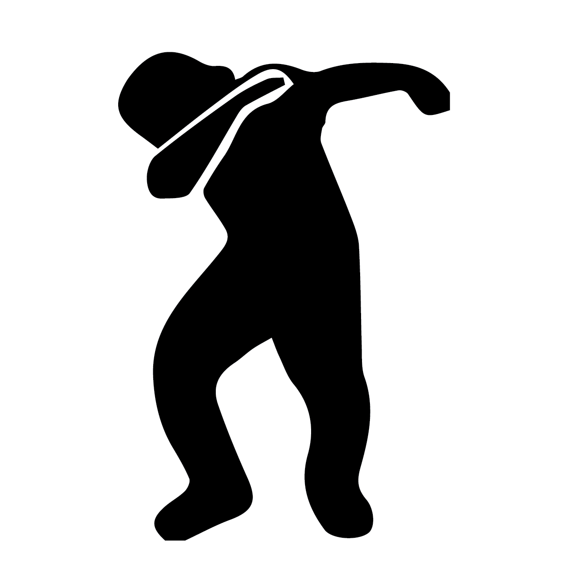

FREESTYLE
Dance Move Card
Complete this dance move for 8 beats, and then return to the game.

