­­

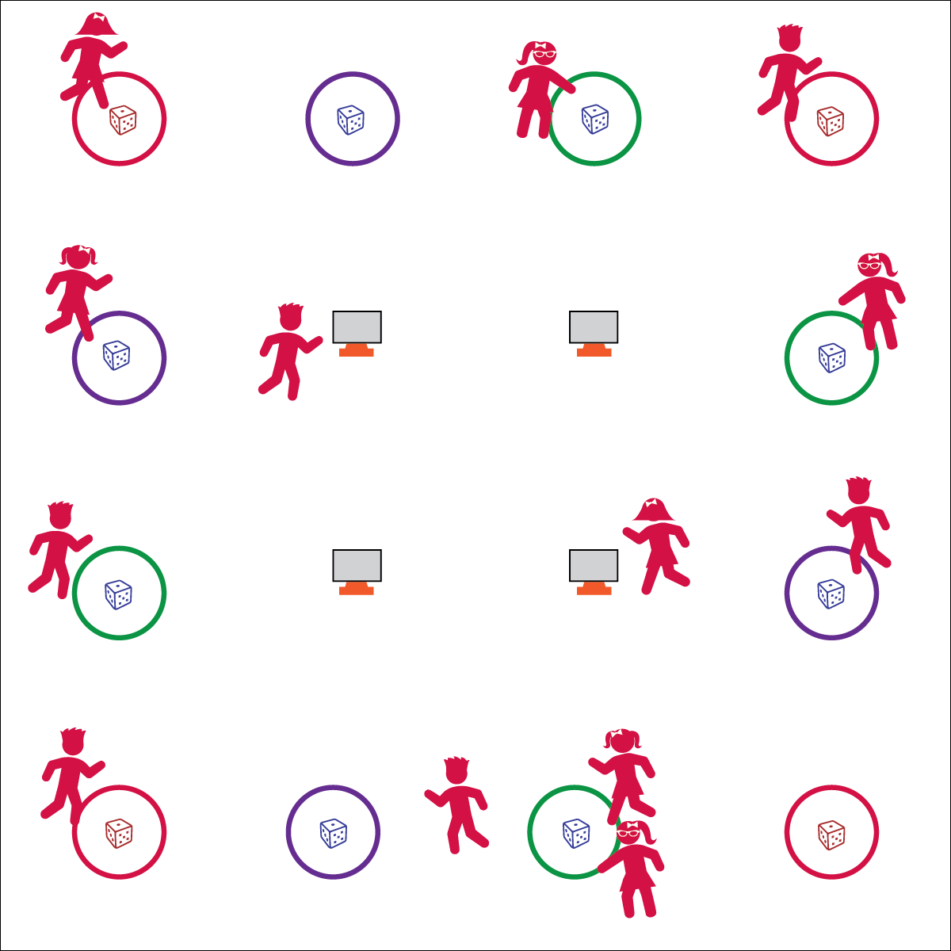

By Brian Devore



* **Standard 3** **[E2.K-2]** Actively participates in physical education class (K); Actively engages in physical education class (1); Actively engages in physical education class in response to instruction and practice (2).
* **Standard 3 [E3.3-5]:** Describes the concept of fitness and provides examples of physical activity to enhance fitness (3); Identifies the components of health-related fitness (4); Differentiates between skill-related and health-related fitness (5).
* **Fitness:** I will provide examples of activities and exercises that enhance fitness.

**Activity Procedures:**

1. It’s time to start our class with Roll & Go! The object of the activity is to move to as many corner hoops as you can during our warm-up.
2. As soon as you enter the activity area go to any hoop and roll the die. Jog clockwise that many hoops. If you land on a corner hoop move to the center of the activity area and choose an exercise off the Roll & Go Exercise Chart.
3. This activity can be done individually, in pairs, or in small groups.

**Grade Level Progression:**

**K– 2nd:** Prompt students to use a variety of locomotor skills to move from hoop-to-hoop.

**3rd – 5th:** Use the blank Roll & Go Exercise Charts to allow students to create their own Roll & Go Corner Tasks.

**Equipment:**

* 6 to 12 hoops
* 6 to 12 foam dice
* 4 Roll & Go Exercise Charts
* 4 cones and task tents (optional)

**Set-Up:**

1. Create a large rectangle using hoops. Use 4 red hoops, 1 in each corner.
2. Place 1 foam die in each hoop.
3. Place 1 Roll & Go Exercise Chart in each corner. Display with cones and task tent if available.

* Roll & Go with a Jog
* Stay Alert & Move Safely
* Focus on Exercise Form



* **DOK 1:** What is fitness?
* **DOK 2:** What do you know about health-related fitness?
* **DOK 3:** What activities can you do to enhance your health-related fitness?
* **DOK 4:** Develop a Roll & Go Exercise Chart designed to enhance your fitness.