Biceps Curl
Muscle Focus: Biceps
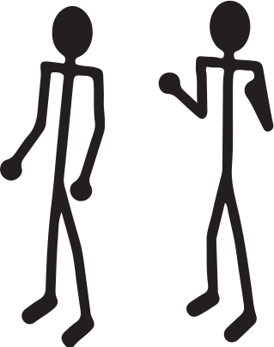 | - Stand tall with feet shoulder-width apart, invisible dumbbells at hips  - Curl both invisible dumbbells up toward shoulders  - Lower arms and repeat  - You do < 12 Reps = 500 Body Building Points  - You do > 12 Reps = 1000 Body Building Points

Dumbbell Crunch
Muscle Focus: Rectus Abdominis
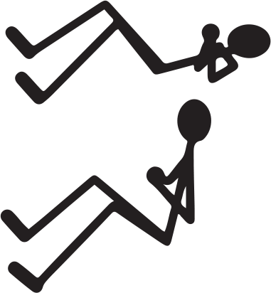 | - Lay on your back with your knees bent, holding the invisible dumbbell on your chest  - Slowly curl your head and shoulders up, and then back down to starting position  - You do < 6 Reps = 500 Body Building Points  - You do > 6 Reps = 1000 Body Building Points

Dumbbell Twisters
Muscle Focus: Internal Oblique, External Oblique
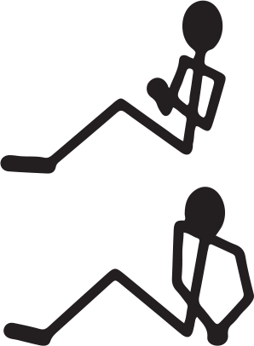 | - Sit on the floor with your knees bent, holding the invisible dumbbell on your chest  - Rotate upper body all the way to the right and tap the invisible dumbbell on the floor  - Rotate upper body all the way to the left and tap the invisible dumbbell on the floor  - Count 1 rep every time you tap to the left  - You do < 6 Reps = 500 Body Building Points  - You do > 6 Reps = 1000 Body Building Points

Dumbbell Lunges
Muscle Focus: Biceps Femoris (Hamstrings), Quadriceps
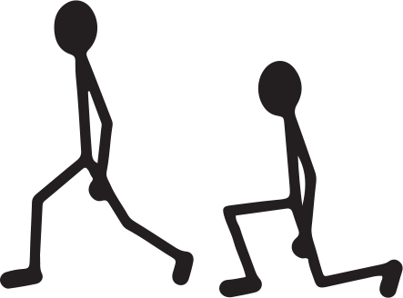 | - Stand tall, invisible dumbbells straight down at your sides  - Step with your right foot until your right thigh is parallel with the floor (left leg stays in place)  - Push back up into starting position  - Repeat with the left leg  - Count 1 rep every time you complete a lunge left leg  - You do < 4 Reps = 500 Body Building Points  - You do > 4 Reps = 1000 Body Building Points

Dumbbell Heel Lifts
Muscle Focus: Gastrocnemius
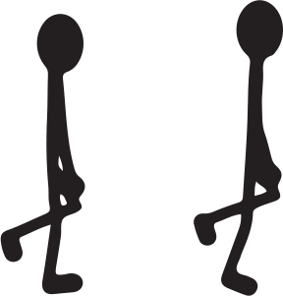 | - Stand on your right foot with your left foot raised behind you 6 inches off the ground  - Push up onto your right toe and hold for 2 seconds at the top  - Lower your heel back to starting position and repeat on the same side  - Complete reps on the right side and then repeat on the left  - You do < 6 Reps = 500 Body Building Points  - You do > 6 Reps = 1000 Body Building Points

Bend Ups
Muscle Focus: Lower Trapezius, Erector Spinae
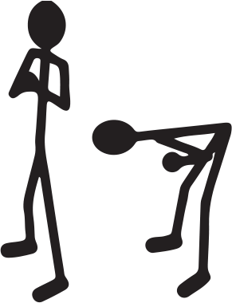 | - Stand tall, feet shoulder-width apart and the invisible dumbbell against the middle of your chest  - Slowly bend over, moving your chest toward the floor until your back is parallel to the floor  - Slowly bend back up to starting position, keeping your back straight and long  - You do < 4 Reps = 500 Body Building Points  - You do > 4 Reps = 1000 Body Building Points

Dumbbell Plank Rows
Muscle Focus: Pectoralis, Biceps, Deltoids
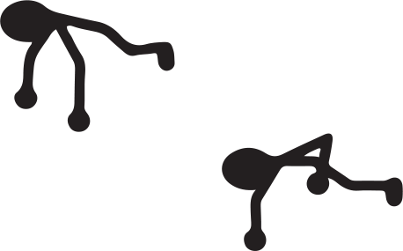 | - Start in plank position  - Shift weight to one your left arm and then pull a invisible dumbbell up to your shoulder with your right arm  - Return to plank position and repeat on the left side  - Count 1 rep every time you complete a row with your left arm  - You do < 6 Reps = 500 Body Building Points  - You do > 6 Reps = 1000 Body Building Points

Shoulder Raises
Muscle Focus: Deltoid
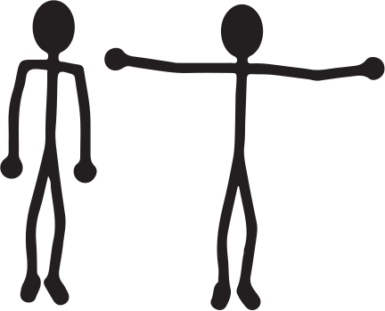 | - Stand tall with feet shoulder-width apart, invisible dumbbells at your sides  - With arms straight, raise the invisible dumbbells up and out to the sides until they reach shoulder height  - Slowly return to starting position  - You do < 6 Reps = 500 Body Building Points  - You do > 6 Reps = 1000 Body Building Points

Dumbbell Row
Muscle Focus: Latissimus Dorsi, Trapezius, Rhomboids
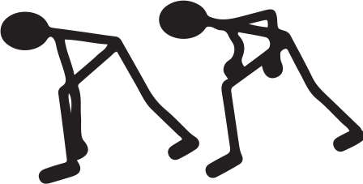 | - Start in lunge position with the left foot forward and your back long and straight  - Invisible dumbbell in your right hand, arm extended down toward the floor  - Pull, bending your arm to bring the invisible dumbbell up to your shoulder  - Slowly lower it to starting position, repeat with right arm  - Complete reps on the right side and then repeat on the left side  - You do < 10 Reps = 500 Body Building Points  - You do > 10 Reps = 1000 Body Building Points

Dumbbell Squats
Muscle Focus: Quadriceps, Gluteus Maximus
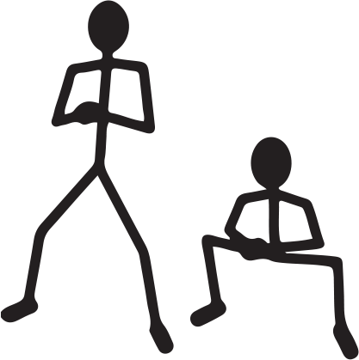 | - Stand tall with feet wider than shoulder-width, holding invisible dumbbell with 2 hands at the center of your chest  - Squat down, keeping your knees above your toes, and then stand back to starting position  - You do < 6 Reps = 500 Body Building Points  - You do > 6 Reps = 1000 Body Building Points

Dumbbell Triceps Push
Muscle Focus: Triceps
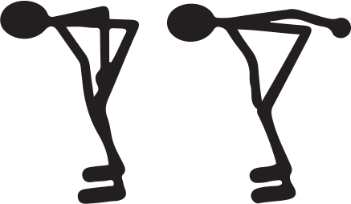 | - Feet shoulder-width apart, bend forward with back straight, parallel to the floor  - Hold invisible dumbbell in your right hand with your elbow close to your body and arm bent at a right angle  - Push back and extend your arm, lifting the invisible dumbbell until your arm is straight  - Slowly return back to starting position  - You do < 6 Reps = 500 Body Building Points  - You do > 6 Reps = 1000 Body Building Points

Standing Dumbbell Twisters
Muscle Focus: Internal Oblique, External Oblique
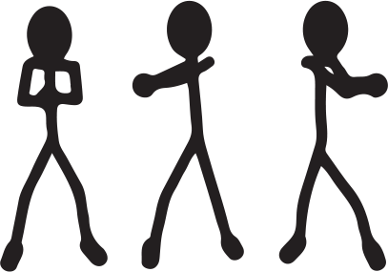 | - Stand tall with feet shoulder-width apart, invisible dumbbell out in front of you in 2 hands  - Slowly twist your upper body and the invisible dumbbell all the way to the right, keeping your arms straight  - Slowly twist your upper body and the invisible dumbbell all the way to the left, keeping your arms straight  - Count reps every time you twist to the left  - You do < 6 Reps = 500 Body Building Points  - You do > 6 Reps = 1000 Body Building Points

