­­­

**Insert Module Name & Lesson # Here**

* Academic language
* Academic language

­

* **Skill:** Skill focus
* **Cognitive:** Cognitive focus
* **Fitness:** Fitness focus
* **Personal & Social Responsibility:** PSR focus
* **Standard** [Outcome.Code] Outcome description
* **Standard** [Outcome.Code] Outcome description
* Selected Assignment

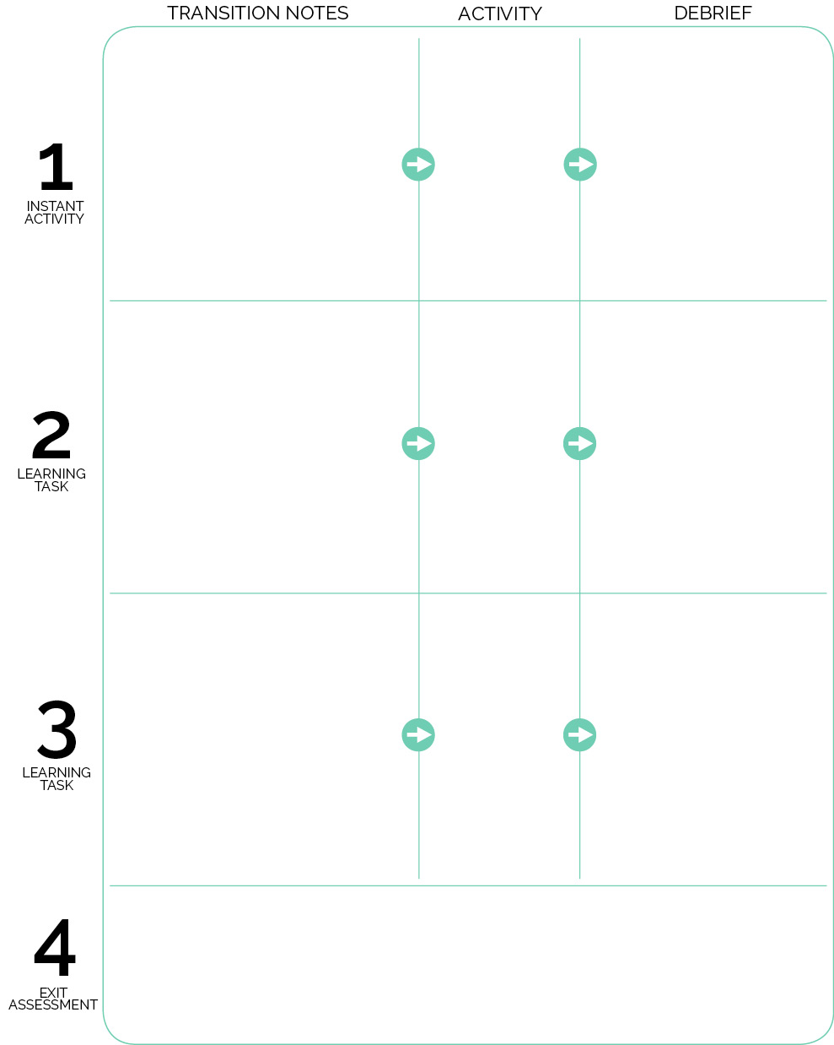

Debrief questions

Activity name

Exit assessment

Debrief questions

Debrief questions

Activity name

First activity

Transition Notes for first activity

Transition notes for next activity

Transition notes for next activity