­­

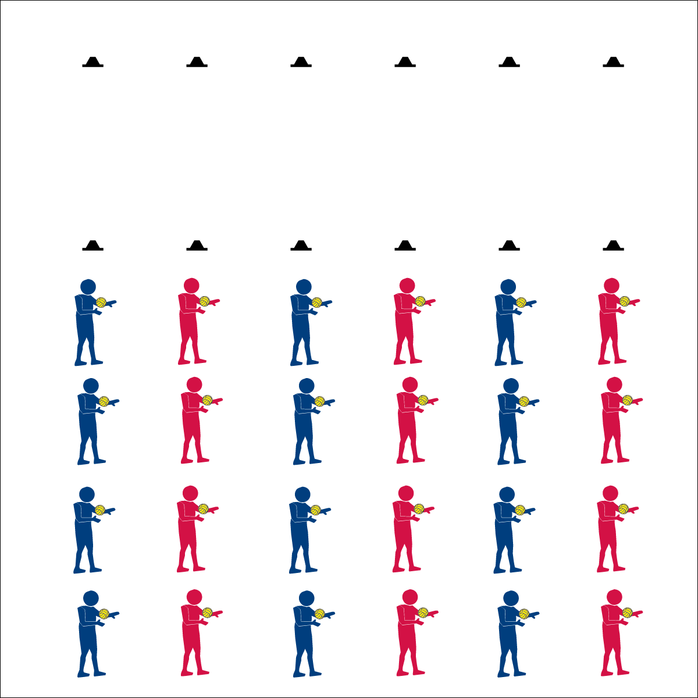

**Activity Procedures:**

1. Today we’re going to start our Roundnet training by completing a series of self-passing challenges. There are two types of passes used in Roundnet: 1) Below-Chest; 2) Above-Chest.
2. Both passes require you to be ready in an athletic stance, use proper hand placement, and use a Palm Strike to hit the ball (demonstrate and practice critical elements).
3. Below-Chest passing requires hand placement at waist level, palms out, and fingers away from the body.
4. Above-Chest passing requires hand placement at shoulder level, palms out, and fingers pointing up toward the head.
5. On the start signal, work to complete the self-passing challenges found on the Challenge Card. Reach JV level with 10 successful self-passes. Reach Varsity level with 20 successful self-passes.
6. Freeze and be ready to listen when you hear the stop signal.

**Grade Level Progression:**

**6th:** Completes challenges demonstrating cooperative behaviors and appropriate behavior.

**7th:** Appropriately communicates suggestions for improvement and assistance to partners.

**8th:** Works with partner to develop a play of action for improving challenge performance.

**Equipment:**

* 2 low profile cones per group of 4 students
* 1 Spikeball® (or foam ball) per student
* 1 Task Tent per group of 4 students
* 1 large cone
* 1 Self-Passing Challenge Card per group of 4 students
* 1 Passing Cue Chart per group of 4 students

**Set-Up:**

1. Create 6 or more lines using 2 low profile cones set 10 paces apart.
2. Divide students into groups of 4, each student with a ball.
3. Line each group of 4 students up behind 1 cone. Provide students with enough personal space for moderate activity.

* **Skill:** I will demonstrate below-chest & above-chest passes.
* **Cognitive:** I will identify the components of skill-related fitness required for successful participation in Roundnet.
* **Fitness:** I will work consistently to improve my skill-related fitness during all self-passing challenges.
* **Personal & Social Responsibility:** I will listen to feedback and use suggestions to improve my Roundnet skills.
* Athletic Stance (Feet, Knees, Hands, Eyes Ready)
* Hand Placement (Below-Chest: Palms Up, Fingers Away; Above-Chest: Palms Out, Fingers Toward Head)
* Palm Strike (Palm Flat, Strike Between Heel & Fingers)

**Self-Passing Challenges**

**Self-Passing Challenges**





Above-Chest Pass, Below-Chest Pass, Athletic Stance, Consistently, Control, Demonstrate, Skill-Related Fitness, Feedback

* **Adaptation:** Use a balloon or lightweight ball.
* **Extension:** Prompt students to create their own challenges.



* **DOK 1:** What are the components of skill-related fitness?
* **DOK 2:** Which components affect Roundnet performance? Why? (provide evidence)
* **DOK 3:** How would you adapt one (or several) of the self-passing challenges to work on specific components of skill-related fitness (e.g., coordination)?
* **DOK 4:** Develop a self-passing practice plan that you can do outside of class in order to improve one or more component of skill-related fitness.



* **Standard 3 [M7.6-8]:** Identifies the components of skill-related fitness (6); Distinguishes between health-related and skill-related fitness (7); Compares and contrasts health-related fitness components (8).
* **Standard 4 (M3.6-8]:** Demonstrates self-responsibility by implementing specific corrective feedback to improve performance (6); Provides corrective feedback to a peer, using teacher-generated guidelines, and incorporating appropriate tone and other communication skills (7); Provides encouragement and feedback to peers without prompting from the teacher (8).
* **Standard 5 [M3.6-8]:** Recognizes individual challenges and copes in a positive way, such as extending effort, asking for help/feedback, and/or modifying the tasks (6); Generates positive strategies such as offering suggestions/assistance, leading/following others, and/or providing possible solutions when faced with a group challenge (7); Develops a plan of action and makes appropriate decisions based on that plan when faced with an individual challenge (8).



**Identify critical content:** Below-chest and above-chest passing (along with spiking) are among the most essential fundamental skills needed for successful Roundnet play. Use a video of competitive Roundnet to provide students with evidence that passing elements and cues are critical to their skill development. Then, provide students with ample time for purposeful practice.

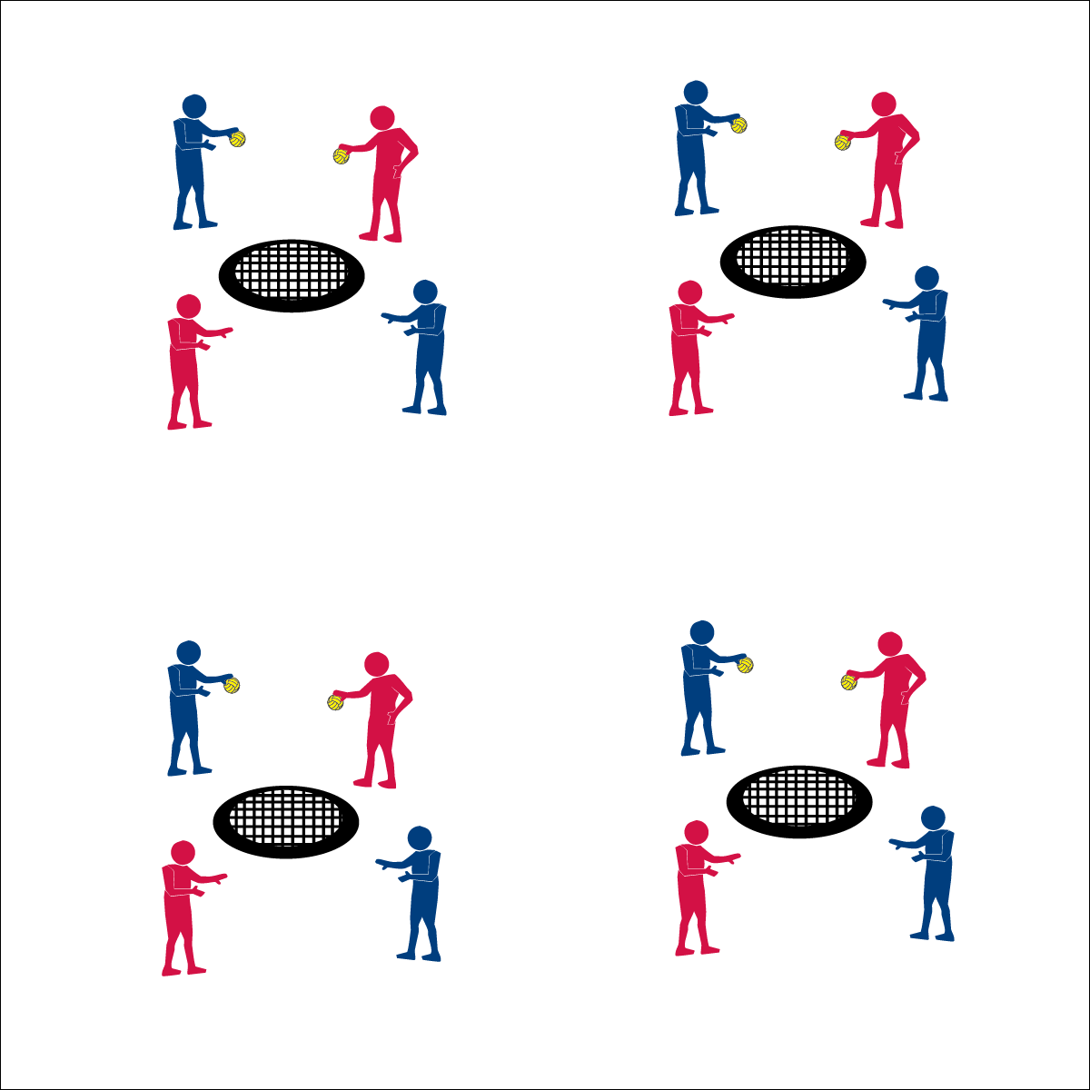

**Spikeball® Bounce & Catch**

**Equipment:**

* 1 Spikeball® net and 2 balls per group of 4 students
* 1 large cone
* 1 Task Tent per group of 4 students
* 1 Bounce & Catch Challenge Card per group of 4 students

**Set-Up:**

1. Set Spikeball® nets up in a large activity area with plenty of room for vigorous activity.
2. Place 2 Spikeballs® at each net.
3. Display 1 Bounce & Catch Challenge Card at each net using a Task Tent and a cone.
4. Pair students and then send 2 pairs to each Spikeball net.

**Activity Procedures:**

1. It’s time to get introduced to the Spikeball® Net that we’ll use to play Roundnet. This is a game of bounce and catch with 4 levels of play.
2. The object is to make different types of bounces for your partner to catch. Each level of play introduces a different type of bounce. This will teach us how the ball will react to and rebound off of the net.
3. There will be 2 sets of partners per net. Alternate bounces with the other pair at your net.
4. Complete 10 successful bounces at each level. Begin at level 1 when you hear the start signal.
5. Level 1: Basic Bounces – bounce the ball back and forth directly to your partner.
6. Level 2: High Bounce – use enough force and the correct trajectory to bounce the ball high off of the net.
7. Level 3: Low Bounce – change the trajectory so that the bounce comes low off of the net.
8. Level 4: Drop Bounce – limit the force and modify the trajectory so that the ball bounces low and drops to the floor close to the net.

**Grade Level Progression:**

**6th:** Participates with peers and demonstrates appropriate responses to self and group challenges.

**7th:** Demonstrates the ability to follow and/or lead appropriately.

**8th:** Works with partner to develop a plan of action for improving challenge performance.

* **Skill:** I will use accurate tosses with appropriate force.
* **Cognitive:** I will describe the similarities and differences between the different types of bounces used in Roundnet.
* **Fitness:** I will actively engage in all practice tasks in order to improve my skill-related fitness.
* **Personal & Social Responsibility:** I will make positive suggestions to my partner and group in order to help improve our performance.
* Accurate Bounce
* Appropriate Force
* Ready to Catch

**Spikeball® Bounce & Catch**





Accuracy, Appropriate, Control, Force, Practice, Improve, Safety

* **Adaptation:** Remove the Spikeball® Net from this task. Students bounce a ball back and forth. Allow students to choose a ball that they are comfortable catching.
* **Extension:** Use this same activity format to practice spike serves.



* **Standard 4 [M7.6-8]:** Uses physical activity and fitness equipment appropriately and safely, with the teacher’s guidance (6); Independently uses physical activity and exercise equipment appropriately and safely (7); Independently uses physical activity and fitness equipment appropriately, and identifies specific safety concerns associated with the activity (8).
* **Standard 5: [M3.6-8]:** Recognizes individual challenges and copes in a positive way, such as extending effort, asking for help/feedback, and/or modifying the tasks (6); Generates positive strategies such as offering suggestions/assistance, leading/following others, and/or providing possible solutions when faced with a group challenge (7); Develops a plan of action and makes appropriate decisions based on that plan when faced with an individual challenge (8).



* **DOK 1:** Can you name and describe each of the bounces used in this activity?
* **DOK 2:** How does the angle at which the ball is thrown affect the way it bounces off off he net?
* **DOK 3:** How is a person’s knowledge of each of these bounces related to their Roundnet performance?
* **DOK 4:** Design a practice task that will help you improve your ability to spike the ball using different bounces.



**Organize students to interact with content:** Learning the ball’s reaction to the net will provide students with a fundamental understanding of how and why different spikes will offer different results. Students are generally excited to begin using the Spikeball® net in game play. The Bounce & Catch organization offers the opportunity to learn fundamental concepts using the net in a cooperative and collaborative manner.

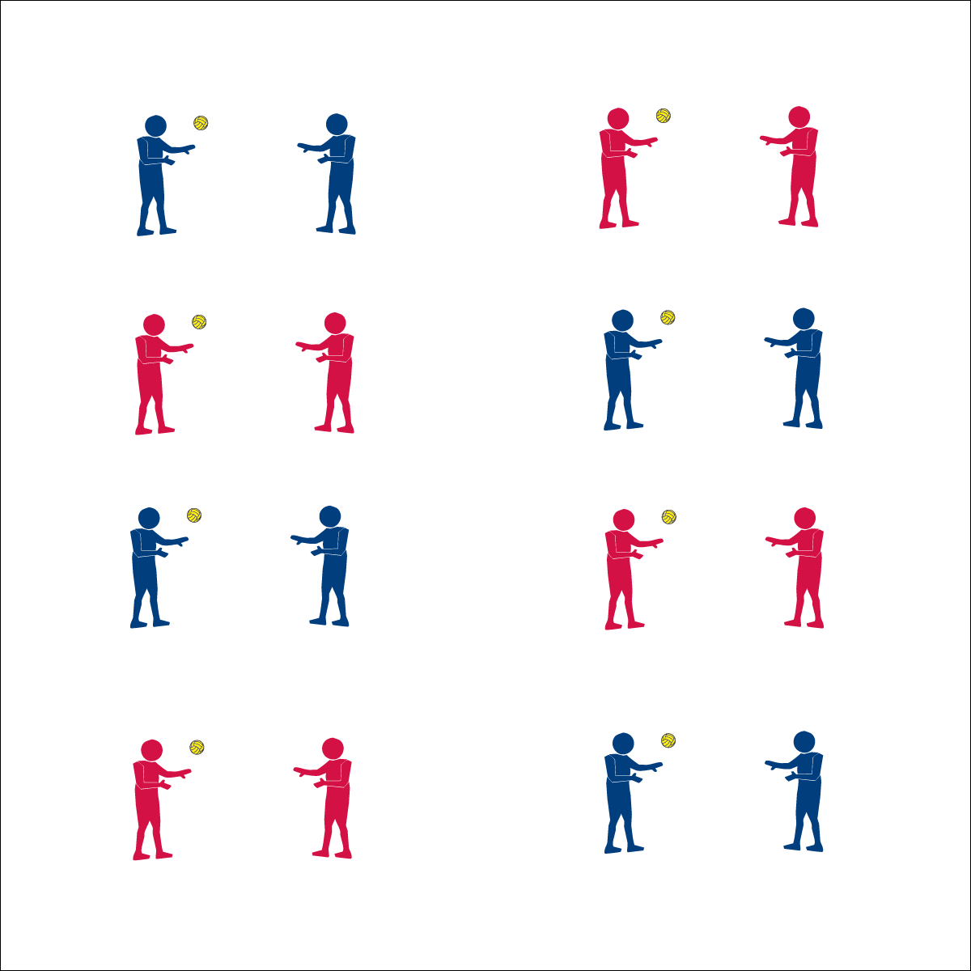

**Partner Passing Plays**

* **Skill:** I will maintain my balance while focusing on accuracy while passing.
* **Cognitive:** I will compare and contrast health-related and skill-related fitness as each relates to Roundnet.
* **Fitness:** I will identify the skill-related fitness component(s) most important for passing.
* **Personal & Social Responsibility:** I will encourage my classmates by offering positive feedback on their performance.
* Accurate Passes
* Maintain Balance
* Offer Encouragement

**Equipment:**

* 1 Spikeball® per pair
* 4-8 Partner Passing Challenge Cards

**Set-Up:**

1. Pair students, each pair with a ball.
2. Post several Partner Passing Challenges Cards throughout the activity area for students to see and reference.

**Activity Procedures:**

1. We’re going to continue our Roundnet passing drills by completing a series of partner passing challenges. This will give us more advanced practice with the below- and above-chest passes.
2. Remember, both passes require you to be ready in an athletic stance, use proper hand placement, and use a Palm Strike to hit the ball.
3. On the start signal, begin working to complete the partner passing challenges found on the Challenge Card. Reach JV level with 10 successful partner passes. Reach Varsity level with 20 successful partner passes.
4. Freeze and be ready to listen when you hear the stop signal.

**Grade Level Progression:**

**6th:** Students define and discuss the components of skill-related fitness.

**7th:** Students discuss how Roundnet can effect health- and skill-related fitness.

**8th:** Students discuss how health- and skill-related fitness components relate to Roundnet. More specifically, they discuss how each component can impact an individual’s performance.

**Partner Passing Plays**





Accuracy, Balance, Encouragement, Feedback, Transfer Weight

* **Adaptation:** Use a balloon or lightweight ball.
* **Extension:** Prompt students to create their own challenges.



* **Standard 1 [M15.6]:** Transfers weight with correct timing for the striking pattern (6).
* **Standard 3 [M7.6-8]:** Identifies the components of skill-related fitness (6); Distinguishes between health-related and skill-related fitness (7); Compares and contrasts health-related fitness components (8).
* **Standard 4 [M4.6-8]:** Accepts differences among classmates in physical development, maturation, and varying skill levels by providing encouragement and positive feedback (6); Demonstrates cooperation skills by establishing rules and guidelines for resolving conflicts (7); Responds appropriately to participants’ ethical and unethical behavior during physical activity by using rules and guidelines for resolving conflicts (8).



* **DOK 1:** What is health-related fitness?
* **DOK 2:** How would you compare and contrast health-related fitness with skill-related fitness?
* **DOK 3:** How do you think skill-related fitness relates to health-related fitness? How do each of these relate to Roundnet?
* **DOK 4:** As as class, let’s develop a comprehensive training plan that could improve a person’s health- and skill-related fitness in order to optimize Roundnet performances.



**Help students process content:** Students may not associate fitness components with Roundnet participation. It’s important to introduce and infuse fitness concepts whenever appropriate using student-centered dialog and not strictly lecture. Allow students to build off the ideas of their peers to summarize and elaborate on cognitive content. Use the Depth of Knowledge (DOK) questions above to start this type of content-rich discussion.

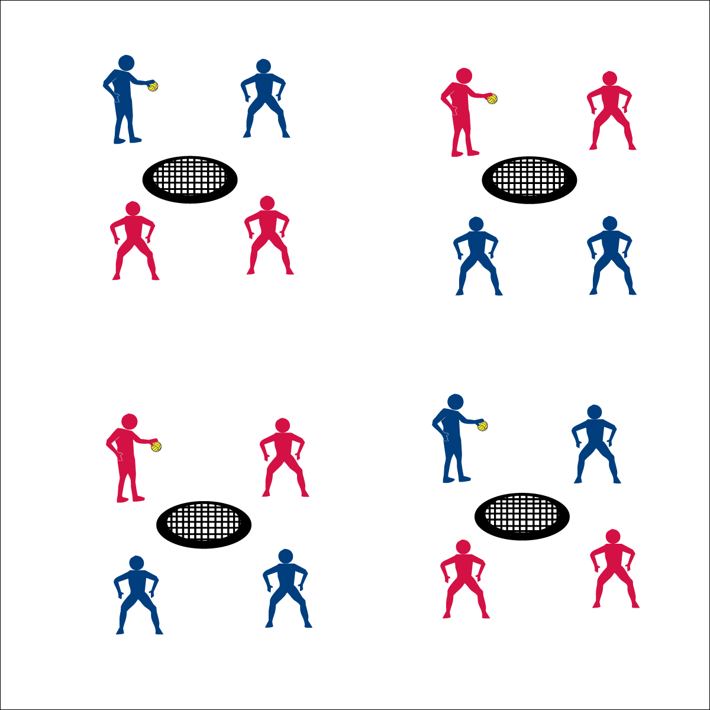

* **Skill:** I will pass and spike using all skill cues.
* **Cognitive:** I will list the fitness benefits of playing Roundnet.
* **Fitness:** I will distinguish between skill-related and health-related fitness benefits.
* **Personal & Social Responsibility:** I will respond appropriately to all challenges in order to promote a positive activity environment for all.

**Rally Time**

* Pass, Pass, Spike
* Spike: Palm Flat, Contact Between Heel & Fingers, Follow Through Down
* Cooperate & Encourage

**Equipment:**

* 1 Spikeball® net and 1 ball per group of 4 students

**Set-Up:**

1. Set Spikeball® nets up in the activity area, allowing space for vigorous activity.
2. Place 1 Spikeball® at each net.
3. Pair students and send 2 pairs (4 players) to each net.

**Activity Procedures:**

1. Today’s activity is a cooperative game called Rally Time.
2. The object of the activity is to to build a rally with consecutive Roundnet passes and spikes.
3. Begin each rally with a tossed serve to a member of the opposite team. Teams have a maximum of 3 hits (2 passes and 1 spike) to send the ball down to the net for a change of possession.
4. Each change of possession scores a rally point. Score 10 consecutive possession changes to achieve JV status. Score 20 to achieve Varsity status.
5. Hold the ball and be ready to listen when you hear the stop signal.

**Grade Level Progression:**

**6th:** Create a non-dynamic environment with the serving team catching the spike, then changing roles with the spiker now becoming the server. Each spike on net scores a rally point.

**7th:** Play the game as described above.

**8th:** After students achieve Varsity status, allow them to play a game of Roundnet for Rookies.

**Rally Time**





Spike, Strike, Health-Related Fitness, Skill-Related Fitness, Positive Environment, Rally

* **Adaptation:** Increase the size of the net/target or remove the net altogether.
* **Extension:** Limit teams to 2 hits (i.e., 1 pass and 1 spike).



* **DOK 1:** What are all of the fitness benefits of playing Roundnet?
* **DOK 2:** Which of these benefits are skill-related and which are health-related?
* **DOK 3:** How would you describe your overall reaction to your participation in Rally Time? Provide details with respect to your physical, cognitive, and emotional response? Why did you respond in these ways?
* **DOK 4:** What information can you gather from your peers to support your ideas about how and why you reacted in the ways that you did.



* **Standard 1: [M13.6-8]:** Strikes with a mature overarm pattern in a non-dynamic environment for net/wall games such as volleyball, handball, badminton, or tennis (6); Strikes with a mature overarm pattern in a dynamic environment for net/wall games such as volleyball, handball, badminton, or tennis (7); Strikes with a mature overarm pattern in a modified game for net/wall games such as volleyball, handball, badminton, or tennis (8).
* **Standard 3 [M7.6-8]:** Identifies the components of skill-related fitness (6); Distinguishes between health-related and skill-related fitness (7); Compares and contrasts health-related fitness components (8).
* **Standard 4 [M4.6-8]:** Accepts differences among classmates in physical development, maturation, and varying skill levels by providing encouragement and positive feedback (6); Demonstrates cooperation skills by establishing rules and guidelines for resolving conflicts (7); Responds appropriately to participants’ ethical and unethical behavior during physical activity by using rules and guidelines for resolving conflicts (8).



**Help students elaborate on content:** The Rally Time activity format provides students with a controlled and cooperative Roundnet lead-up, allowing them to experience important elements of game play. Prompting students to describe and discuss their experience is an important part of building an appreciation for physical activity and movement. However, many students will offer only short descriptions of their feelings and reactions. Prompt students to elaborate using guiding follow-up questions that ask for specific examples and evidence.

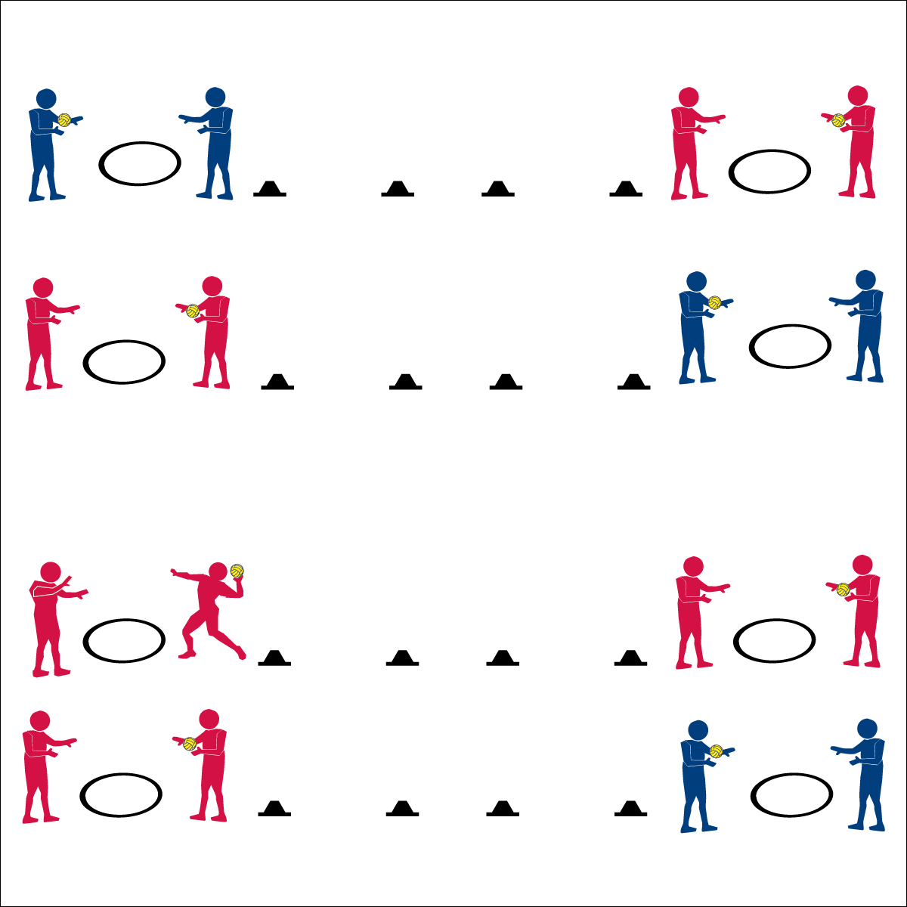

* **Skill:** I will complete all passing pentathlon tasks.
* **Cognitive:** I will accurately record performance data on the Passing Pentathlon Skill Card.
* **Fitness:** I will accurately rate my overall effort on the Skill Card.
* **Personal & Social Responsibility:** I will extend my effort in order to help my partner and myself improve our passing skills.

**Partner Passing Pentathlon**

* Attempt an Event
* Record Your Data
* Repeat for All 5 Events
* Rate Your Effort

**Equipment:**

* 1 ball per pair
* 1 hoop per pair
* 2 low profile cones per pair
* 1 Passing Pentathlon Skill Card and 1 pencil per pair

**Set-Up:**

1. For each pair, place a hoop and a ball 5 paces from one cone, and place another cone 10 paces from the first cone.
2. Duplicate this set-up on the opposite side of the activity area, with hoops on the outside and cones placed toward the middle of the area.
3. Pair students, sending each pair to a hoop.

**Activity Procedures:**

1. It’s time to assess your Netball passing skills with a Passing Pentathlon activity.
2. Your goal is to complete and record your score for the 5 passing challenges found on the Skill Card.
3. You’ll also rate your effort at the bottom of the Pentathlon Skill Card.
4. If you finish the pentathlon challenges early, create your own challenges to be shared with your classmates.

**Grade Level Progression:**

**6th:** Participates with peers and demonstrates appropriate responses to self and group challenges.

**7th:** Demonstrates the ability to follow and/or lead appropriately.

**8th:** Works with partner to develop a plan of action for improving challenge performance.

**Partner Passing Pentathlon**





Accuracy, Pentathlon, Data, Effort, Improve

* **Adaptation:** Use a balloon or lightweight ball. Complete one challenge at a time rather than giving all pentathlon challenges at the start of the activity. Some challenges can be easily modified to match students’ ability and comfort.
* **Extension:** Prompt students to create their own pentathlon challenges.



* **DOK 1:** Based on your performance data, which event was the easiest? Which was the most challenging?
* **DOK 2:** Why do you think one event was easier than the other?
* **DOK 3:** How could you adapt these activities to make them more or less challenging?
* **DOK 4:** Using the data on your sheet, develop a practice plan for improving your performance for your next Passing Pentathlon attempt.



* **Standard 3 [M7.6-8]:** Identifies the components of skill-related fitness (6); Distinguishes between health-related and skill-related fitness (7); Compares and contrasts health-related fitness components (8).
* **Standard 5 [M3.6-8]:** Recognizes individual challenges and copes in a positive way, such as extending effort, asking for help/feedback, and/or modifying the tasks (6); Generates positive strategies such as offering suggestions/assistance, leading/following others, and/or providing possible solutions when faced with a group challenge (7); Develops a plan of action and makes appropriate decisions based on that plan when faced with an individual challenge (8).



**Help students record and represent knowledge:** Utilizing the Pentathlon Skill Card provides students with a visual representation of the skill acquisition process. Day 1 data provides a baseline performance. Following-up this initial performance with purposeful practice gives students an opportunity to improve in areas they now can see need improvement. Day 2 data represents the fruits of student effort and, if the process is done correctly, will visually demonstrate the relationship between practice and improvement.

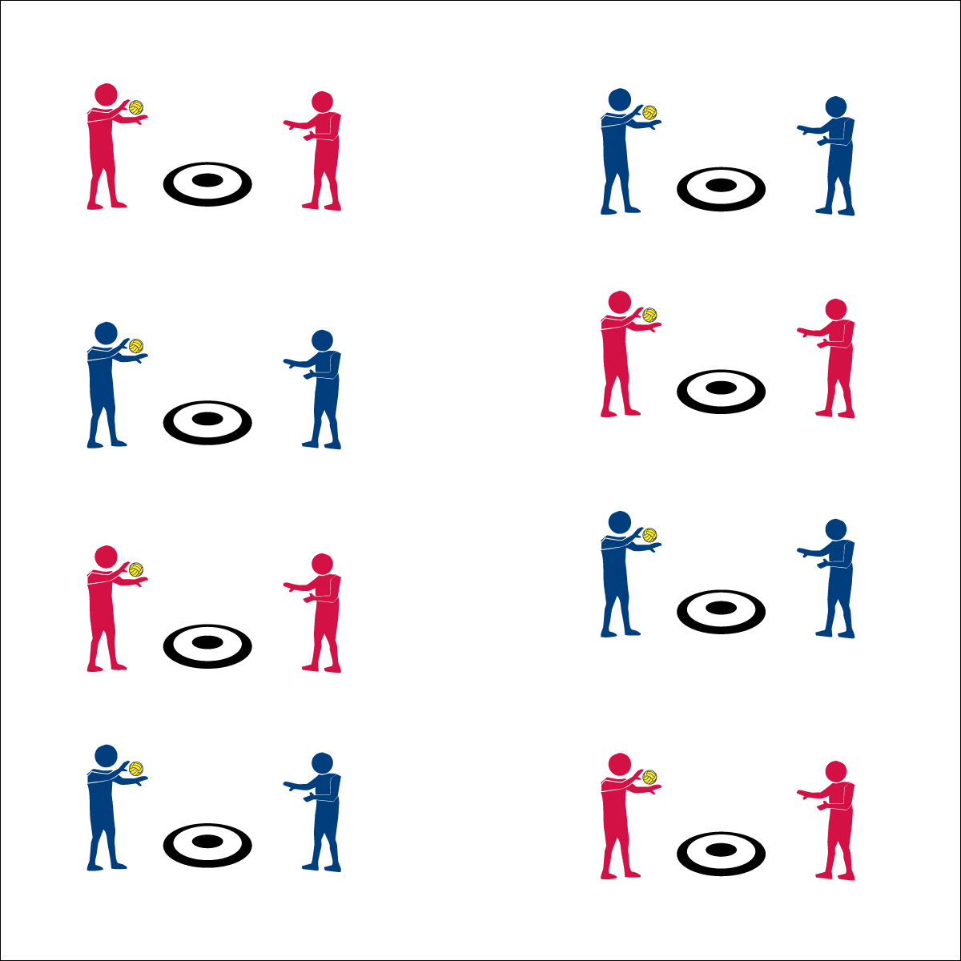

* **Skill:** I will spike the ball with a mature striking pattern, focusing on all cues.
* **Cognitive:** I will develop a plan of action in order to help my partner and myself improve our spiking skills.
* **Fitness:** I will define coordination and explain how it relates to Roundnet.
* **Personal & Social Responsibility:** I will respond appropriately to all challenges in order to promote  
  a positive activity environment for all.

**Selfie Spikes**

* Partner Toss
* Self Pass
* Accurate Spike

**Equipment:**

* 1 hoop per pair
* 1 spot marker per pair
* 1 ball per pair

**Set-Up:**

1. In a large activity area, place 1 spot marker and 1 ball in the center of a hoop for each pair of students.
2. Pair students and send each pair to a hoop.

**Activity Procedures:**

1. This activity is called Selfie Spikes. The object is to land your spikes inside of the hoop.
2. On the start signal, your partner will toss you the ball just above waist level. Self-pass the ball and then spike it into the hoop.
3. Complete 5 attempted spikes and then change roles.
4. When you believe that you’ve mastered the hoop at level 1, move to level 2 and attempt to hit the spot marker with each spike.
5. When you hear the stop signal, hold the ball and be ready to listen.

**Grade Level Progression:**

**6th:** Participates with peers and demonstrates appropriate responses to self and group challenges.

**7th:** Demonstrates the ability to follow and/or lead appropriately.

**8th:** Works with partner to develop a plan of action for improving personal performance.

**Selfie Spikes**



* **Adaptation:** Remove or increase the size of the target. Use a balloon or lightweight ball.
* **Extension:** Decrease the size of the target (e.g., place a sticker or mark on each spot).



Coordination, Mature, Spike, Strike, Plan of Action, Positive Environment



* **DOK 1:** What are the cues for a mature spike?
* **DOK 2:** How did you apply these cues in the Selfie Spike activity?
* **DOK 3:** How are the cues related to successful spiking?
* **DOK 4:** Develop a plan of action that you and your partner can follow to help improve your spiking skills.



* **Standard 1 [M13.6-8]:** Strikes with a mature overarm pattern in a non-dynamic environment for net/wall games such as volleyball, handball, badminton, or tennis (6); Strikes with a mature overarm pattern in a dynamic environment for net/wall games such as volleyball, handball, badminton, or tennis (7); Strikes with a mature overarm pattern in a modified game for net/wall games such as volleyball, handball, badminton, or tennis (8).
* **Standard 3 [M7.6-8]:** Identifies the components of skill-related fitness (6); Distinguishes between health-related and skill-related fitness (7); Compares and contrasts health-related fitness components (8).
* **Standard 5: [M3.6-8]:** Recognizes individual challenges and copes in a positive way, such as extending effort, asking for help/feedback, and/or modifying the tasks (6); Generates positive strategies such as offering suggestions/assistance, leading/following others, and/or providing possible solutions when faced with a group challenge (7); Develops a plan of action and makes appropriate decisions based on that plan when faced with an individual challenge (8).



**Help students practice skills strategies, and processes:** This activity provides a fundamental practice task for developing spiking skills. Using this activity before and after the Spiking Pentathlon Challenge demonstrates a skill development process that students can utilize throughout a lifetime of activity and learning.

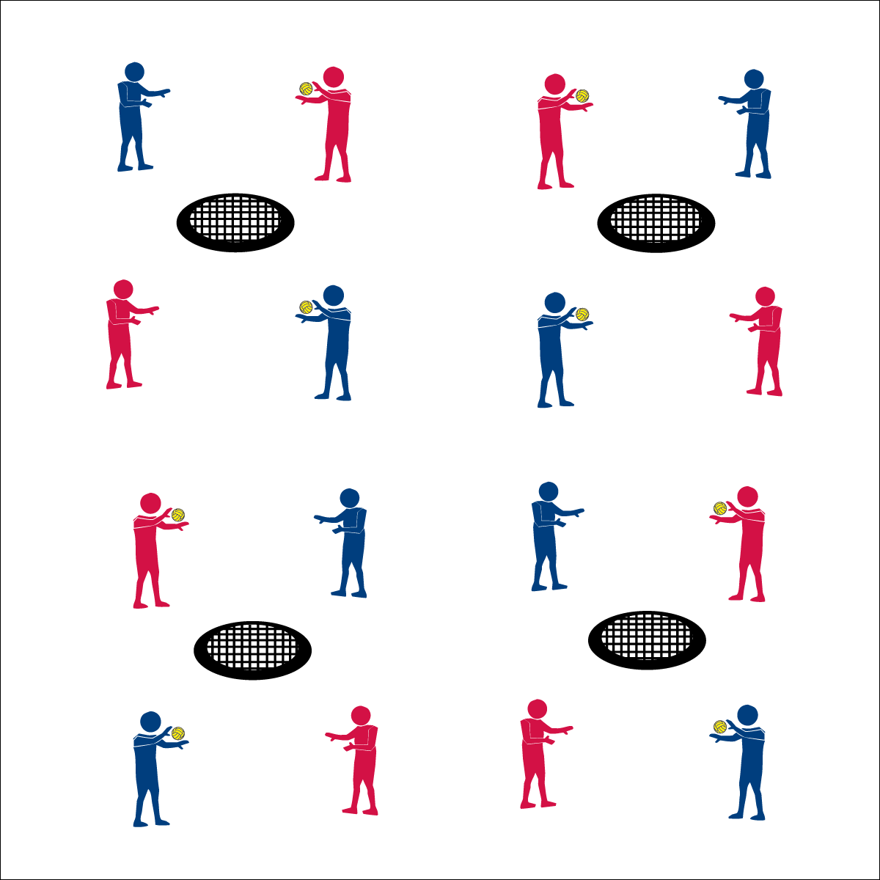

**Equipment:**

* 1 Spikeball® net & 1 ball per group of 4 students
* 1 large cone
* 1 Spiking Pentathlon Skill Card & pencil per pair
* 1 Task Tent per group of 4 students
* 1 Spiking Cue Chart per group of 4 students

**Set-Up:**

1. Set Spikeball® nets up in a large activity area with plenty of room for vigorous activity.
2. Place 1 Spikeball® at each net.
3. Place Spiking Cue Chart in Task Tent and on large cone at each Spikeball® net.
4. Pair students and then send 2 pairs to each Spikeball® net.

* Power Stance (Sideways, Shoulder-Width, Eyes on Ball)
* Core Rotation (Rotate Hips, Hand Up/Open, Swing Down)
* Palm Strike/Follow Through (Palm Flat, Contact Between Heel & Fingers, Follow Through Down)
* **Skill:** I will spike the ball with a mature striking pattern, focusing on all cues.
* **Cognitive:** I will accurately record performance data.
* **Fitness:** I will accurately rate my overall effort.
* **Personal & Social Responsibility:** I will accept the differences between my partner and myself and use encouragement and positive feedback in our communications.

**Spiking Pentathlon**

**Activity Procedures:**

1. It’s time to assess your Netball spiking skills with a Spiking Pentathlon activity.
2. Your goal is to complete and record your score for the 5 spiking challenges found on the Skill Card.
3. You’ll also rate your effort at the bottom of the card.
4. If you finish the pentathlon challenges early, create your own challenges to be shared with your classmates.

**Grade Level Progression:**

**6th:** Works to make accurate tosses to partner and also offers encouragement and positive feedback.

**7th:** Uses class strategies and communication skills to appropriately resolve any conflicts or disruptions.

**8th:** Independently manages behavior and engagement with no teacher reminders or influence.

**Spiking Pentathlon**





Spike, Mature, Data, Effort, Feedback, Communication Skills

* **Adaptation:** Remove or increase the size of the target. Use a balloon or lightweight ball. Complete one challenge at a time rather than giving all pentathlon challenges at the start of the activity. Some challenges can be easily modified to match students’ ability and comfort.
* **Extension:** Prompt students to create their own pentathlon challenges.



* **Standard 1 [M13.6-8]:** Strikes with a mature overarm pattern in a non-dynamic environment for net/wall games such as volleyball, handball, badminton, or tennis (6); Strikes with a mature overarm pattern in a dynamic environment for net/wall games such as volleyball, handball, badminton, or tennis (7); Strikes with a mature overarm pattern in a modified game for net/wall games such as volleyball, handball, badminton, or tennis (8).
* **Standard 3 [M7.6-8]:** Identifies the components of skill-related fitness (6); Distinguishes between health-related and skill-related fitness (7); Compares and contrasts health-related fitness components (8).
* **Standard 4 [M4.6-8]:** Accepts differences among classmates in physical development, maturation, and varying skill levels by providing encouragement and positive feedback (6); Demonstrates cooperation skills by establishing rules and guidelines for resolving conflicts (7); Responds appropriately to participants’ ethical and unethical behavior during physical activity by using rules and guidelines for resolving conflicts (8).



* **DOK 1:** What is accurate data?
* **DOK 2:** What do you know about how data can be used?
* **DOK 3:** Using the performance data that you and your partner collected, what’s your interpretation of your overall performance? Provide details and evidence.
* **DOK 4:** Develop a performance plan that you and your partner can use to improve your next Spiking Pentathlon.



**Manage response rates with tiered questioning techniques:** Utilize the DOK Debrief Questions for a purposeful discussion with ascending cognitive complexity. This helps students deepen their understanding of critical concepts while contextualizing the information in a meaningful and relevant way.

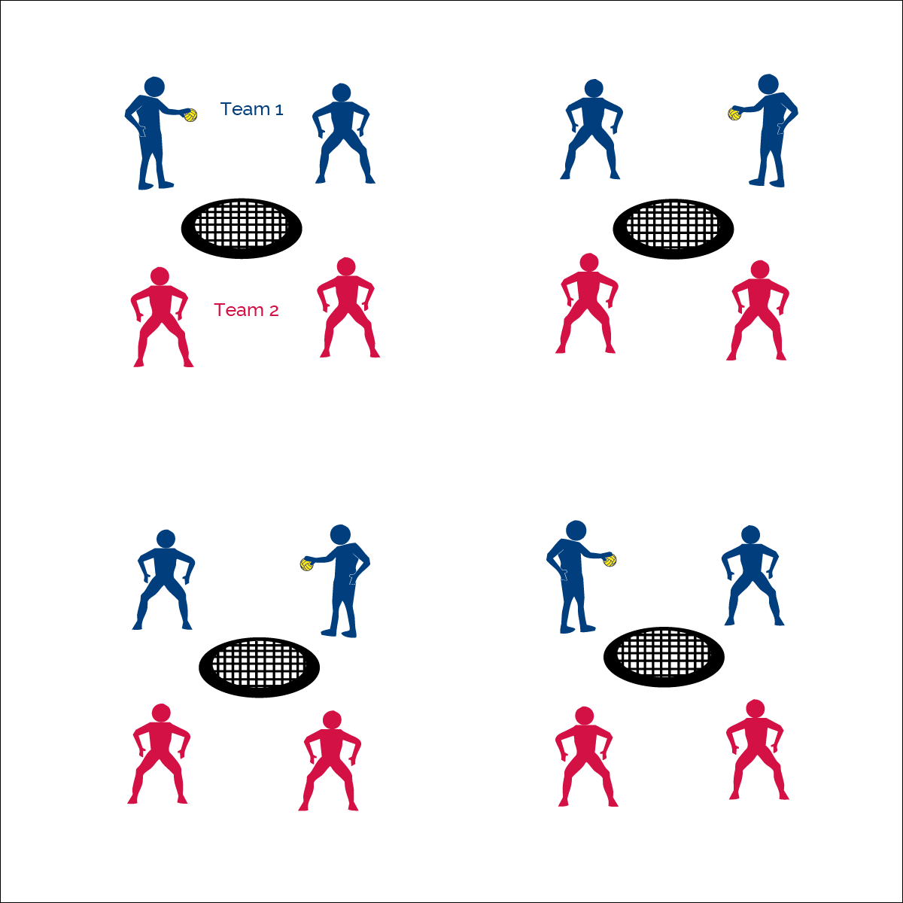

* **Skill:** I will select spike placement in order to make the defender move to make a catch.
* **Cognitive:** I will be able to discuss how force and timing impact spike placement.
* **Fitness:** I will remain actively engaged throughout all activities.
* **Personal & Social Responsibility:** I will act appropriately and with proper Roundnet etiquette.

**Make ‘em Move**

* Toss Serve, 1 Pass, Spike
* Hit to Space (Not to Defense)

**Equipment:**

* 1 Spikeball® net & 1 ball per group of 4 students

**Set-Up:**

1. Set Spikeball® nets up in the activity area, allowing space for vigorous activity.
2. Place 1 Spikeball® at each net.
3. Pair students and send 2 pairs (4 players) to each net.

**Activity Procedures:**

1. Today’s activity is a 2v2 game called Make ‘em Move. The object of the game is to spike the ball into open space and make the defenders move to catch it.
2. Play starts off a tossed served from the defense. The offense gets 1 pass and then must spike the ball to the defenders.
3. If the defense has to move their feet in order to make a catch, the offense scores a point. If the defense catches the ball without moving their feet, the defense scores a point.
4. Offensive players change roles each serve (i.e., passer to spiker). Change offense and defense after every 5 serves.

**Grade Level Progression:**

**6th:** Spikes are made to right or left of defender.

**7th:** Spikes are made to open space, which could include the area closest to the net, right, or left of defender.

**8th:** Spikes are made to open space with varying degrees of force.

**Make ‘em Move**





Placement, Offense, Defense, Force, Timing, Etiquette, Opponent

* **Adaptation:** Use a balloon or lightweight ball. Remove the net from the activity.
* **Extension:** Add a second defender to the activity.



* **Standard 1 [M13.6-8]:** Strikes with a mature overarm pattern in a non-dynamic environment for net/wall games such as volleyball, handball, badminton, or tennis (6); Strikes with a mature overarm pattern in a dynamic environment for net/wall games such as volleyball, handball, badminton, or tennis (7); Strikes with a mature overarm pattern in a modified game for net/wall games such as volleyball, handball, badminton, or tennis (8).
* **Standard 2 [M8.7-8]:** Selects offensive shot based on opponent’s location (hit where opponent is not) (7); Varies placement, force and timing of return to prevent anticipation by opponent (8).
* **Standard 4 [M6.6-8]:** Identifies the rules and etiquette for physical activities/games and dance activities (6); Demonstrates knowledge of rules and etiquette by self-officiating modified physical activities/games or following parameters to create or modify a dance (7); Applies rules and etiquette by acting as an official for modified physical activities/games and creating dance routines within a given set of parameters (8).



* **DOK 1:** What is the definition of force? What is the definition of timing?
* **DOK 2:** How do force and timing affect spiking accuracy? Placement?
* **DOK 3:** How is accuracy related to placement?
* **DOK 4:** Let’s design and conduct an experiment that can be used to help explain the relationship between force, timing, and accuracy.



**Review content:** As fundamental skill practice evolves into small-sided tactical practice, it’s important to introduce strategic concepts while also taking time to review and reinforce the critical skill elements covered in previous lessons. This highlights the cumulative nature of the module content, the relationship between skill development and tactical gameplay, as well as the need for ongoing skill practice.

## 

**Anticipate & Position**

**Equipment:**

* 1 Spikeball® net per group of 4 students
* 2 balls per group of 4 students
* 1 Task Tent per group of 4 students
* 1 large cone
* 1 Defensive Challenge Card per group of 4 students
* 1 Defensive Cue Chart per group of 4 students

**Set-Up:**

1. Set Spikeball® nets up in the activity area, allowing space for vigorous activity.
2. Place 2 Spikeball® at each net.
3. Display 1 Defensive Cue Chart at each net using a large cone and Task Tent.
4. Pair students and send 2 pairs (4 players) to each net.

* **Skill:** I will position myself to reduce offensive options during defensive challenges.
* **Cognitive:** I will define the terms anticipation and positioning as they relate to Roundnet.
* **Fitness:** I will remain actively engaged in all challenges.
* **Personal & Social Responsibility:** I will contribute to a positive activity environment.
* Anticipate (Analyze, Predict)
* Position (Stay Alert, Move to Position, Athletic Stance)

**Activity Procedures:**

1. Today we’re going complete a series of defensive challenges to help us learn how to anticipate a spike and position ourselves to best defend against that spike.
2. Anticipating a spike means that you’re reading and predicting where a spike will go before it’s made by your opponent. Positioning is your response to that anticipation. You move to the spot where the spike can go and you’re ready in athletic stance (demonstrate and practice critical elements).
3. On the start signal, you and your partner are going to work to complete the first set challenges on the Challenge Card. On the stop signal, you’ll reset and work with the other team at your net to complete the second set of challenges on the Challenge Card.
4. Focus your effort on anticipation and positioning.

**Grade Level Progression:**

**6th:** Complete partner challenges.

**7th:** Complete partner and team challenges.

**8th:** Complete all challenges and then play Roundnet for Rookies.



* **Standard 1 [M13.6-8]:** Strikes with a mature overarm pattern in a non-dynamic environment for net/wall games such as volleyball, handball, badminton, or tennis (6); Strikes with a mature overarm pattern in a dynamic environment for net/wall games such as volleyball, handball, badminton, or tennis (7); Strikes with a mature overarm pattern in a modified game for net/wall games such as volleyball, handball, badminton, or tennis (8).
* **Standard 2 [M8.6]:** Reduces offensive options for opponents by returning to mid-court position (6).
* **Standard 5 [M3.6-8]:** Recognizes individual challenges and copes in a positive way, such as extending effort, asking for help/feedback, and/or modifying the tasks (6); Generates positive strategies such as offering suggestions/assistance, leading/following others, and/or providing possible solutions when faced with a group challenge (7); Develops a plan of action and makes appropriate decisions based on that plan when faced with an individual challenge (8).



* **DOK 1:** What is the definition of anticipation? What is the definition of positioning?
* **DOK 2:** How does anticipation affect positioning?
* **DOK 3:** How are anticipation and positioning related to Roundnet defense?
* **DOK 4:** Work with your partner to identify areas of defensive weakness, then design a plan to improve those areas.

**Anticipate & Position**



**Help students examine their reasoning:** Middle school students often find it difficult to self-identify areas of weakness. They associate weakness with failure rather than opportunities for growth. Asking students to examine their weaknesses and provide logical explanations for those deficiencies can help them develop a growth mindset focused on improvement rather than self-doubt/blame. This dialog must be done with patience and care, guiding students to critique the logic surrounding an outcome or challenge rather then focusing on an emotional response to a personal weakness.





Analyze, Anticipation, Athletic Stance, Positioning, Predict, Offense, Defense, Return

* **Adaptation:** Use a balloon and provide a raised surface. Students focus on positioning their hands based on the trajectory of the spiked balloon.
* **Extension:** Add a “Professional” level requiring 30 successes for each challenge.



**ROUNDNET 4 ROOKIES**

* **Skill:** I will combine Roundnet striking and positioning skills with offensive and defensive tactics.
* **Cognitive:** I will discuss the importance of social interaction.
* **Fitness:** I will remain actively engaged in Roundnet games.
* **Personal & Social Responsibility:** I will demonstrate the importance of social interaction as it applies to Spirit of the Game.
* Spirit of the Game: Responsibility, Fair Play, Respect, and Joy of Play

**Equipment:**

* 1 Spikeball® net & 1 ball per group of 4 students

**Set-Up:**

1. Set Spikeball® nets up in the activity area, allowing space for vigorous activity.
2. Place 1 Spikeball® at each net.
3. Pair students and send 2 pairs (4 players) to each net.

**Activity Procedures:**

1. It’s time to play Roundnet for Rookies.
2. This is a full game of Roundnet, using a toss serve to begin the game.
3. Let’s take a look at this quick video from Spikeball® to review how to play: <https://youtu.be/J8T5TIrHtzs>
4. Each game today will be timed for 5 minutes, and then we’ll find new teams to play against.
5. Use rally scoring (points can be won by the serving or receiving team).
6. To serve, begin with a simple toss serve.
7. Each team has up to 3 hits to send the ball to the net for a change of possession. If the ball can’t be returned with a clean bounce on the net, then a point is awarded to the opposing team. The team that wins the point gets the next serve. Alternate servers each time your team becomes the serving team.
8. If there are any questions about infractions or faults, it’s an automatic redo.

**Grade Level Progression:**

**6th:** Play 5 minute games, matching teams with similar abilities.

**7th:** Play 3 minute games in King of the Court tournament format.

**8th:** Allow students to choose opponents. Play games to 21, win by 2. Switch sides when a team scores 11.



**ROUNDNET 4 ROOKIES**



* **Standard 1 [M15.6]:** Transfers weight with correct timing for the striking pattern (6).
* **Standard 2 [M8.6-8]:** Reduces offensive options for opponents by returning to mid-court position (6); Selects offensive shot based on opponent’s location (hit where opponent is not) (7); Varies placement, force, and timing of return to prevent anticipation by opponent (8).
* **Standard 5 [M6.6-8]:** Demonstrates respect for self and others in activities and games by following the rules, encouraging others, and playing within the spirit of the game or activity (6); Demonstrates the importance of social interaction by helping and encouraging others, avoiding trash talk, and providing support to classmates (7); Demonstrates respect for self by asking for help and helping others in various physical activities. (8).



* **DOK 1:** How can you recognize a positive social interaction?
* **DOK 2:** How can different social interactions affect a game of Roundnet?
* **DOK 3:** Can you predict your emotional reaction to a game of Roundnet that involves a positive social interaction? A negative social interaction?
* **DOK 4:** Let’s develop a plan for keeping class social interactions positive.



**Help students engage in cognitively complex tasks:** Roundnet 4 Rookies maybe students’ first experience playing a game of Roundnet. It’s a dynamic but slightly modified activity using the combined skill and tactical elements introduced throughout all previous activities. It’s important to supervise and assess short bursts of student gameplay, looking for areas needing improvement while avoiding excessive frustration. Then allow students to revisit practice tasks and continue building capacity for extended and more competitive game play.





Combine, Positioning, Tactic, Self-Officiating, Serve, Social Interaction, Spirit of the Game, Strategy

* **Adaptation:** Play the game using a balloon and small desk as the spiking surface. Spiker must hit the ball in the direction of 1 of the 2 opponents.
* **Extension:** Progress to Roundnet 4 Pros.



**TEAM TACTICS**

* **Skill:** I will select spike type and placement based on the location of the defense.
* **Cognitive:** I will discuss how placement, force, and timing impact the effectiveness of spikes.
* **Fitness:** I will review the components of fitness impacted by participation in Roundnet.
* **Personal & Social Responsibility:** I will respond appropriately to various social situations that arise  
  in cooperative activity settings.
* Stay Alert
* Cooperate with Clear Communication
* Finish the Play

**Equipment:**

* 1 Spikeball® net & 1 ball per group of 4 students
* 1 large cone
* 1 Task Tent per group of 4 students
* 1 Tactical Team Challenge Card per group of 4 students

**Set-Up:**

1. Set Spikeball® nets up in a large activity area with plenty of room for vigorous activity.
2. Place 1 Spikeball® at each net.
3. Display the Tactical Team Challenge Cards with a Task Tent and a large cone.
4. Pair students and send 2 pairs (4 players) to each net.

**Activity Procedures:**

1. Today is a Team Tactics practice day. You and your partner will work with another team to master a series of tactical team challenges.
2. The focus of the practice will be passing accuracy, spiking accuracy, and shot selection.
3. On the start signal, your group will work to complete the tasks on the Challenge Card.
4. On the stop signal, switch partners to mix up your group and work to complete the challenges again.

**Grade Level Progression:**

**6th:** Focus on refining skills at challenge levels 1-3.

**7th:** Extend the activity with levels 4-6.

**8th:** Allow students to create their own Team Challenge Cards.

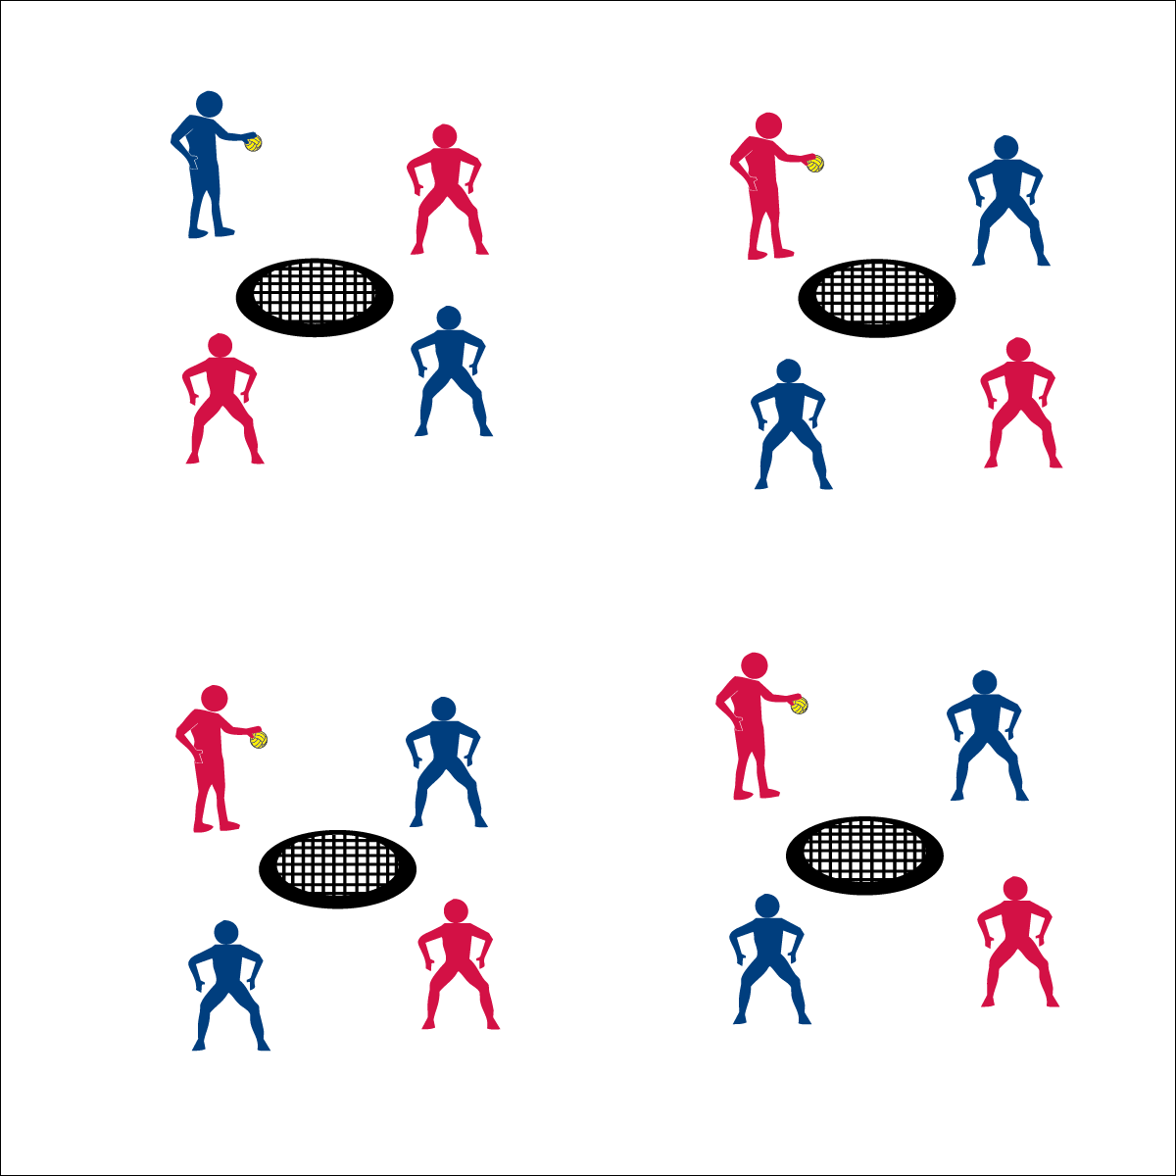



**Help students revise knowledge:** Students revise knowledge and refine skills by correcting performance errors and cognitive misconceptions. Team Tactics performance challenges are designed provide purposeful practice opportunities in between authentic game play experiences. This helps students to see themselves as active learners who can improve though practice.



* **DOK 1:** What would you include on a list that would describe an accurate spike?
* **DOK 2:** How does placement, force, and timing impact the effectiveness of a spike?
* **DOK 3:** How would you describe the sequence of performing a perfect spike?
* **DOK 4:** Create a spiking performance that demonstrates the successful use of placement, force, and timing. Be prepared to replicate that performance.



* **Standard 2 [M8.7-8]:** Selects offensive shot based on opponent’s location (hit where opponent is not) (7); Varies placement, force, and timing of return to prevent anticipation by opponent (8).
* **Standard 4 [M4.6-8]:** Accepts differences among classmates in physical development, maturation, and varying skill levels by providing encouragement and positive feedback (6); Demonstrates cooperation skills by establishing rules and guidelines for resolving conflicts (7); Responds appropriately to participants’ ethical and unethical behavior during physical activity by using rules and guidelines for resolving conflicts (8).

**TEAM TACTICS**





Tactic, Positioning, Placement, Force, Timing, Effective, Cooperation

* **Adaptation:** Focus this activity on challenge level 1 using a balloon or lightweight ball.
* **Extension:** Add a “Professional” level requiring 30 successes for each challenge.



**ROUNDNET 4 PROS**

* **Skill:** I will perform a strike serve to begin each rally.
* **Cognitive:** I will discuss the importance of applying the rules and etiquette of game play.
* **Fitness:** I will remain actively engaged in Roundnet games.
* **Personal & Social Responsibility:** I will demonstrate the importance of applying rules and etiquette of game play.
* Spirit of the Game: Responsibility, Fair Play, Respect, and Joy of Play

**Equipment:**

* 1 Spikeball® net & 1 ball per group of 4 students

**Set-Up:**

1. Set Spikeball® nets up in the activity area, allowing space for vigorous activity.
2. Place 1 Spikeball® at each net.
3. Pair students and send 2 pairs (4 players) to each net.

**Activity Procedures:**

1. It’s time to play Roundnet for Pros. We’ll play Roundnet with a full spike serve to begin the game.
2. Each game today will be timed for 5 minutes, then we’ll find new teams to play against. Use rally scoring (points can be won by the serving or receiving team). To serve, begin with full spike serve.
3. Each team has up to 3 hits to send the ball to the net for a change of possession. If the ball can’t be returned with a clean bounce on net, then a point is awarded to the opposing team. The team that wins the point, gets the next serve. Alternate servers each time your team becomes the new serving team.
4. If there are any questions about infractions or faults, it’s an automatic redo.
5. Work during the game to focus on teamwork and communication.
   1. Call “mine” when moving to play a spiked ball.
   2. Use verbal cues to help your teammate know where you are on the court.
   3. Congratulate ALL players after a good play or rally.

**Grade Level Progression:**

**6th:** Play 5 minute games, matching teams with similar abilities.

**7th:** Play 3 minute games in King of the Court tournament format.

**8th:** Allow students to choose opponent. Play games to 21, win by 2. Switch sides when a team scores 11.

**ROUNDNET 4 PROS**



* **Adaptation:** Play the game using a balloon and small desk as the spiking surface. Spiker must hit the ball in the direction of 1 of the 2 opponents.
* **Extension:** Students must make at least 1 pass per rally using a body part other than the hand



Rally, Serve, Etiquette, Spirit of the Game



* **Standard 1 [M13.6-8]:** Strikes, with a mature overarm pattern, in a non-dynamic environment for net/wall games such as volleyball, handball, badminton or tennis (6); Strikes, with a mature overarm pattern, in a dynamic environment for net/wall games such as volleyball, handball, badminton or tennis (7); Strikes, with a mature overarm pattern, in a modified game for net/wall games such as volleyball, handball, badminton or tennis (8).
* **Standard 2 [M8.6-8]:** Reduces offensive options for opponents by returning to mid-court position (6); Selects offensive shot based on opponent’s location (hit where opponent is not) (7); Varies placement, force and timing of return to prevent anticipation by opponent (8).
* **Standard 4 [M6.6-8]:** Identifies the rules and etiquette for physical activities/games and dance activities (6); Demonstrates knowledge of rules and etiquette by self-officiating modified physical activities/games or following parameters to create or modify a dance (7); Applies rules and etiquette by acting as an official for modified physical activities/games and creating dance routines within a given set of parameters (8).



* **DOK 1:** What does etiquette mean?
* **DOK 2:** What do you know about the etiquette of Roundnet?
* **DOK 3:** Why are rules and etiquette important for successful Roundnet game play?
* **DOK 4:** Develop a class plan for upholding both rules and etiquette.
* **DOK 1:** What is the Spirit of the Game?
* **DOK 2:** How is the Spirit of the Game applied in Roundnet?



**Help students process content:** Roundnet 4 Pros provides an authentic game experience with an emphasis on competent skill application. This format also allows students an opportunity to see why, when, and how the skills and concepts they’ve learned apply to and impact a performance. This step in the progression requires teachers to be fully engaged in observing performances for teachable moments in which meaningful dialog can enhance and experience and therefore promote learning.



**Activity Procedures:**

1. Now that we have Roundnet skills and strategy, it’s time to play in our Annual Roundnet Tournament!
2. Teachers, we recommend 3 different approaches to setting up a Roundnet tournament in your class. *(Download our Tournament Tool Kit for more information and helpful resources.)*
   1. **All-In Round Robin Format:** This format gives all students a chance to play an equal number of games with final rankings based on overall records. It’s okay to have a tie for first place.
   2. **A Varsity & JV Round Robin Format:** Teams are set and ranked based on skill level. The class is then divided in half with the highest skilled playing in the Varsity Tournament and the lowest skilled playing in the JV Tournament. Again, all students play an equal number of games and each tournament is given its own final ranking.
   3. **King of the Court Format:** This format can be used for 1-day tournaments as well as for ranking teams for a more formal Round Robin Tournament. Set up a King of the Court Tournament by numbering off all Spikeball® nets—1, 2, 3, 4…. Games are played for a set amount of time. Winners move one court closer to the #1 court, while non-winners move one court closer to the last # court. All teams should move, except the winners of the #1 court and the non-winners of last court.
      1. To use this format for ranking teams, record where teams finished at the end of class. This will be used to divide the class into two groups for the tournament. The top half of class will be in the Varsity Tournament, and the bottom half of class will be in the JV Tournament.

**Equipment:**

* 1 Spikeball® net and ball per group of 4

**Set-Up:**

1. Set Spikeball® nets up in the activity area, allowing space for vigorous activity.
2. Place 1 Spikeball® at each net.
3. Pair students and 2 pairs (4 players) to each net.
4. Create a tournament format and schedule for teams to follow for a set number of lessons.

* Self-Officiating (Play by the Rules, Score Honestly, Respect All Players)
* Redo ALL Questionable Calls
* **Skill:** I will combine Roundnet striking and athletic positioning skills with offensive and defensive tactics.
* **Cognitive:** I will demonstrate the importance of applying rules and etiquette of game play.
* **Fitness:** I will remain actively engaged in Roundnet games.
* **Personal & Social Responsibility:** I will accept and respect differences among my classmates of varying skill levels.

**TOURNAMENT OPTIONS**



* **Adaptation:** Provide an experienced player or adult at each game to assist with rules, etiquette, skills, and strategy. Modify the game as needed based on successful modifications used in previous activities.
* **Extension:** Explore additional tournament formats such as elimination style formats for advanced players with mature sportsmanship.

**TOURNAMENT OPTIONS**



Combine, Tactics, Etiquette, Spirit of the Game, Tournament



* **Standard** **Standard 1 [M13.6-8]:** Strikes with a mature overarm pattern in a non-dynamic environment for net/wall games such as volleyball, handball, badminton, or tennis (6); Strikes with a mature overarm pattern in a dynamic environment for net/wall games such as volleyball, handball, badminton, or tennis (7); Strikes with a mature overarm pattern in a modified game for net/wall games such as volleyball, handball, badminton, or tennis (8).
* **Standard 2 [M8.6-8]:** Reduces offensive options for opponents by returning to mid-court position (6); Selects offensive shot based on opponent’s location (hit where opponent is not) (7); Varies placement, force, and timing of return to prevent anticipation by opponent (8).
* **Standard 4 [M6.6-8]:** Identifies the rules and etiquette for physical activities/games and dance activities (6); Demonstrates knowledge of rules and etiquette by self-officiating modified physical activities/games or following parameters to create or modify a dance (7); Applies rules and etiquette by acting as an official for modified physical activities/games and creating dance routines within a given set of parameters (8).
* **Standard 4 [M4.6-8]:** Accepts differences among classmates in physical development, maturation, and varying skill levels by providing encouragement and positive feedback (6); Demonstrates cooperation skills by establishing rules and guidelines for resolving conflicts (7); Responds appropriately to participants’ ethical and unethical behavior during physical activity by using rules and guidelines for resolving conflicts (8).



* **DOK 1:** How can you recognize proper etiquette?
* **DOK 2:** With respect to etiquette, what have you noticed about the Roundnet games that we’ve played in class?
* **DOK 3:** What is your interpretation of Spirt of the Game? Can you support your interpretation with specific examples from previous game play?



**Organize students to interact with content:** The nature of physical education requires kinesthetic experiences for skill building and conceptual understanding. Balancing the competitive nature of authentic gameplay with the need for positive and successful experience can be difficult for teachers. It’s important to organize students within tournament formats that match their skill levels and personal preferences. Allowing students to select from competitive and non-competitive formats can help provide the positive movement experience students need in order to develop an appreciation for and a desire to seek out physical activity for a lifetime.