­­

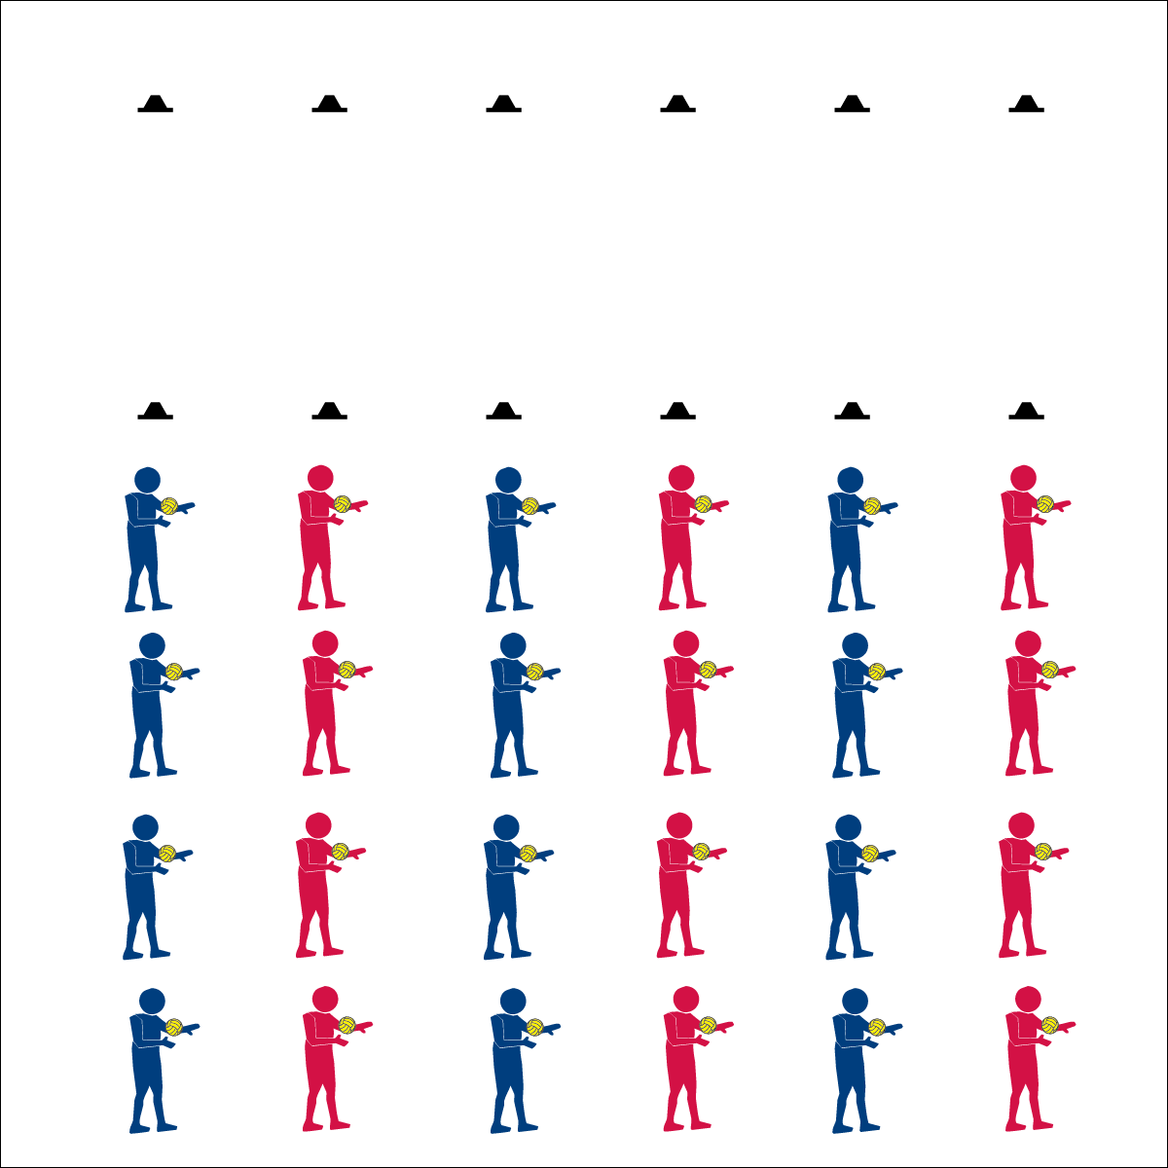

**Self-Passing Challenges**

**Activity Procedures:**

1. Today we’re going to start our Roundnet training by completing a series of self-passing challenges. There are two types of passes used in Roundnet: 1) Below-Chest; 2) Above-Chest.
2. Both passes require you to be ready in an athletic stance, use proper hand placement, and use a Palm Strike to hit the ball (demonstrate and practice critical elements).
3. Below-Chest passing requires hand placement at waist level, palms out, and fingers away from the body.
4. Above-Chest passing requires hand placement at shoulder level, palms out, and fingers pointing up toward the head.
5. On the start signal, work to complete the self-passing challenges found on the Challenge Card. Reach JV level with 10 successful self-passes. Reach Varsity level with 20 successful self-passes.
6. Freeze and be ready to listen when you hear the stop signal.

**Grade Level Progression:**

**6th:** Completes challenges demonstrating cooperative behaviors and appropriate behavior.

**7th:** Appropriately communicates suggestions for improvement and assistance to partners.

**8th:** Works with partner to develop a play of action for improving challenge performance.

**Equipment:**

* 2 low profile cones per group of 4 students
* 1 Spikeball® (or foam ball) per student
* 1 Task Tent per group of 4 students
* 1 large cone
* 1 Self-Passing Challenge Card per group of 4 students
* 1 Passing Cue Chart per group of 4 students

**Set-Up:**

1. Create 6 or more lines using 2 low profile cones set 10 paces apart.
2. Divide students into groups of 4, each student with a ball.
3. Line each group of 4 students up behind 1 cone. Provide students with enough personal space for moderate activity.

* **Skill:** I will demonstrate below-chest & above-chest passes.
* **Cognitive:** I will identify the components of skill-related fitness required for successful participation in Roundnet.
* **Fitness:** I will work consistently to improve my skill-related fitness during all self-passing challenges.
* **Personal & Social Responsibility:** I will listen to feedback and use suggestions to improve my Roundnet skills.
* Athletic Stance (Feet, Knees, Hands, Eyes Ready)
* Hand Placement (Below-Chest: Palms Up, Fingers Away; Above-Chest: Palms Out, Fingers Toward Head)
* Palm Strike (Palm Flat, Strike Between Heel & Fingers)

**Self-Passing Challenges**

* **Adaptation:** Use a balloon or lightweight ball.
* **Extension:** Prompt students to create their own challenges.



Above-Chest Pass, Below-Chest Pass, Athletic Stance, Consistently, Control, Demonstrate, Skill-Related Fitness, Feedback



* **DOK 1:** What are the components of skill-related fitness?
* **DOK 2:** Which components affect Roundnet performance? Why? (provide evidence)
* **DOK 3:** How would you adapt one (or several) of the self-passing challenges to work on specific components of skill-related fitness (e.g., coordination)?
* **DOK 4:** Develop a self-passing practice plan that you can do outside of class in order to improve one or more component of skill-related fitness.



* **Standard 3 [M7.6-8]:** Identifies the components of skill-related fitness (6); Distinguishes between health-related and skill-related fitness (7); Compares and contrasts health-related fitness components (8).
* **Standard 4 (M3.6-8]:** Demonstrates self-responsibility by implementing specific corrective feedback to improve performance (6); Provides corrective feedback to a peer, using teacher-generated guidelines, and incorporating appropriate tone and other communication skills (7); Provides encouragement and feedback to peers without prompting from the teacher (8).
* **Standard 5 [M3.6-8]:** Recognizes individual challenges and copes in a positive way, such as extending effort, asking for help/feedback, and/or modifying the tasks (6); Generates positive strategies such as offering suggestions/assistance, leading/following others, and/or providing possible solutions when faced with a group challenge (7); Develops a plan of action and makes appropriate decisions based on that plan when faced with an individual challenge (8).

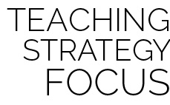

**Identify critical content:** Below-chest and above-chest passing (along with spiking) are among the most essential fundamental skills needed for successful Roundnet play. Use a video of competitive Roundnet to provide students with evidence that passing elements and cues are critical to their skill development. Then, provide students with ample time for purposeful practice.