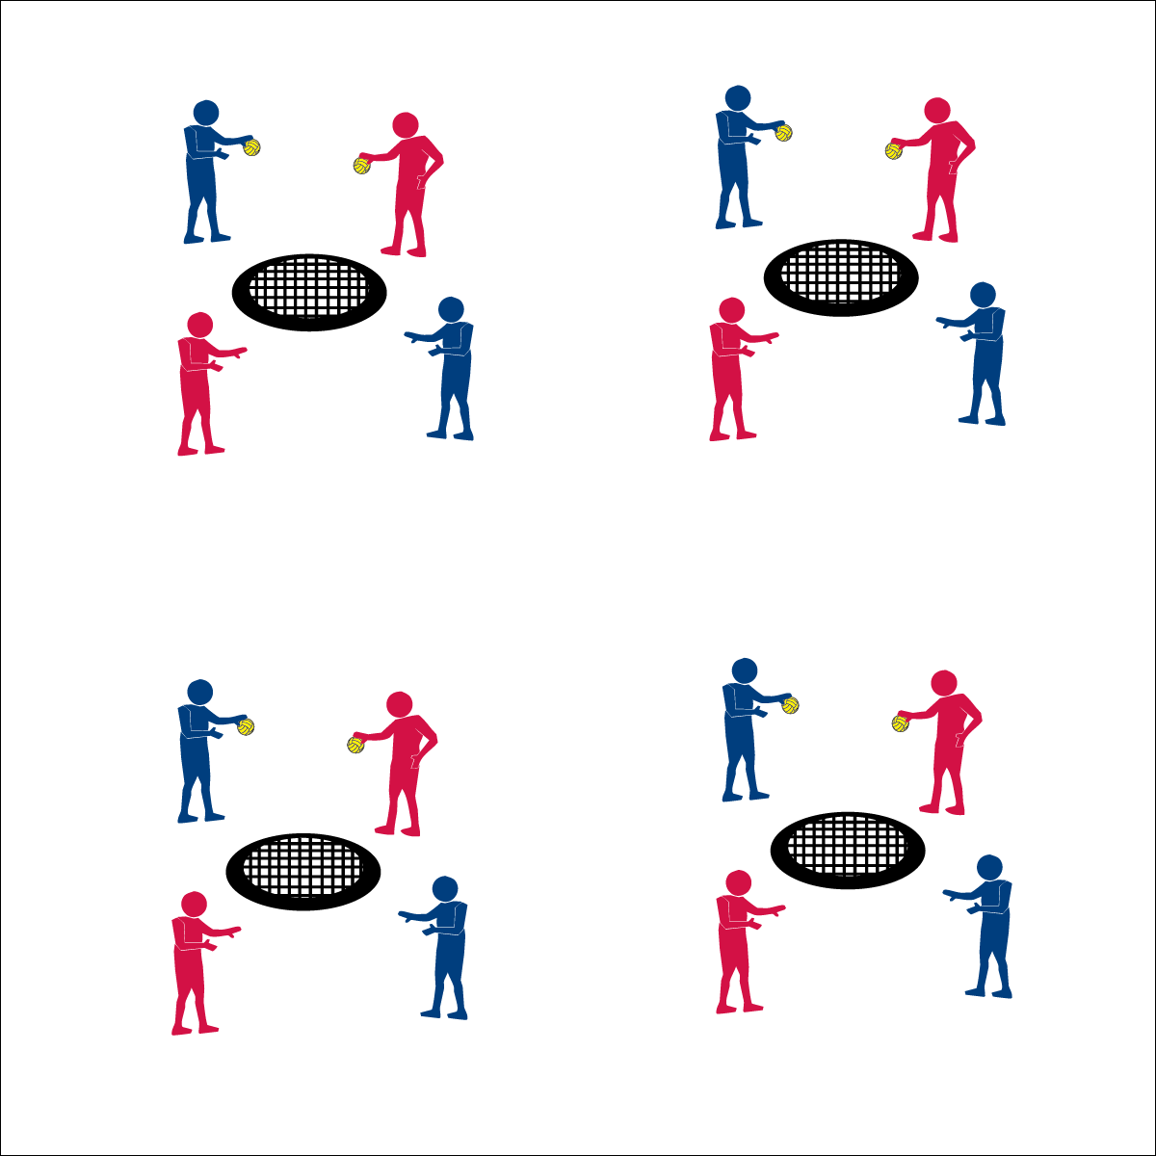­­

**Spikeball® Bounce & Catch**



* **Skill:** I will use accurate tosses with appropriate force.
* **Cognitive:** I will describe the similarities and differences between the different types of bounces used in Roundnet.
* **Fitness:** I will actively engage in all practice tasks in order to improve my skill-related fitness.
* **Personal & Social Responsibility:** I will make positive suggestions to my partner and group in order to help improve our performance.



* Accurate Bounce
* Appropriate Force
* Ready to Catch



**Equipment:**

* 1 Spikeball® net and 2 balls per group of 4 students
* 1 large cone
* 1 Task Tent per group of 4 students
* 1 Bounce & Catch Challenge Card per group of 4 students

**Set-Up:**

1. Set Spikeball® nets up in a large activity area with plenty of room for vigorous activity.
2. Place 2 Spikeballs® at each net.
3. Display 1 Bounce & Catch Challenge Card at each net using a Task Tent and a cone.
4. Pair students and then send 2 pairs to each Spikeball net.

**Activity Procedures:**

1. It’s time to get introduced to the Spikeball® Net that we’ll use to play Roundnet. This is a game of bounce and catch with 4 levels of play.
2. The object is to make different types of bounces for your partner to catch. Each level of play introduces a different type of bounce. This will teach us how the ball will react to and rebound off of the net.
3. There will be 2 sets of partners per net. Alternate bounces with the other pair at your net.
4. Complete 10 successful bounces at each level. Begin at level 1 when you hear the start signal.
5. Level 1: Basic Bounces – bounce the ball back and forth directly to your partner.
6. Level 2: High Bounce – use enough force and the correct trajectory to bounce the ball high off of the net.
7. Level 3: Low Bounce – change the trajectory so that the bounce comes low off of the net.
8. Level 4: Drop Bounce – limit the force and modify the trajectory so that the ball bounces low and drops to the floor close to the net.

**Grade Level Progression:**

**6th:** Participates with peers and demonstrates appropriate responses to self and group challenges.

**7th:** Demonstrates the ability to follow and/or lead appropriately.

**8th:** Works with partner to develop a plan of action for improving challenge performance.

* **Adaptation:** Remove the Spikeball® Net from this task. Students bounce a ball back and forth. Allow students to choose a ball that they are comfortable catching.
* **Extension:** Use this same activity format to practice spike serves.



**Organize students to interact with content:** Learning the ball’s reaction to the net will provide students with a fundamental understanding of how and why different spikes will offer different results. Students are generally excited to begin using the Spikeball® net in game play. The Bounce & Catch organization offers the opportunity to learn fundamental concepts using the net in a cooperative and collaborative manner.



* **DOK 1:** Can you name and describe each of the bounces used in this activity?
* **DOK 2:** How does the angle at which the ball is thrown affect the way it bounces off off he net?
* **DOK 3:** How is a person’s knowledge of each of these bounces related to their Roundnet performance?
* **DOK 4:** Design a practice task that will help you improve your ability to spike the ball using different bounces.



* **Standard 4 [M7.6-8]:** Uses physical activity and fitness equipment appropriately and safely, with the teacher’s guidance (6); Independently uses physical activity and exercise equipment appropriately and safely (7); Independently uses physical activity and fitness equipment appropriately, and identifies specific safety concerns associated with the activity (8).
* **Standard 5: [M3.6-8]:** Recognizes individual challenges and copes in a positive way, such as extending effort, asking for help/feedback, and/or modifying the tasks (6); Generates positive strategies such as offering suggestions/assistance, leading/following others, and/or providing possible solutions when faced with a group challenge (7); Develops a plan of action and makes appropriate decisions based on that plan when faced with an individual challenge (8).



Accuracy, Appropriate, Control, Force, Practice, Improve, Safety

**Spikeball® Bounce & Catch**