­­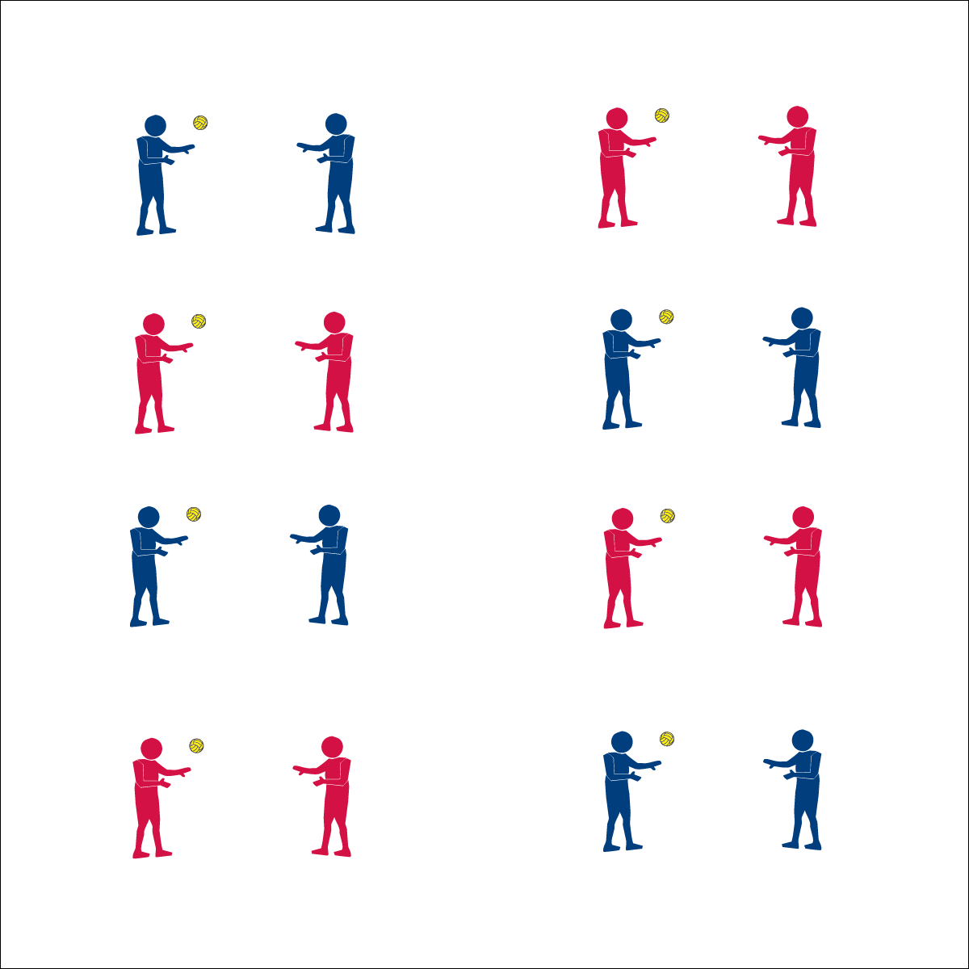

**Partner Passing Plays**



* **Skill:** I will maintain my balance while focusing on accuracy while passing.
* **Cognitive:** I will compare and contrast health-related and skill-related fitness as each relates to Roundnet.
* **Fitness:** I will identify the skill-related fitness component(s) most important for passing.
* **Personal & Social Responsibility:** I will encourage my classmates by offering positive feedback on their performance.



* Accurate Passes
* Maintain Balance
* Offer Encouragement



**Equipment:**

* 1 Spikeball® per pair
* 4-8 Partner Passing Challenge Cards

**Set-Up:**

1. Pair students, each pair with a ball.
2. Post several Partner Passing Challenges Cards throughout the activity area for students to see and reference.

**Activity Procedures:**

1. We’re going to continue our Roundnet passing drills by completing a series of partner passing challenges. This will give us more advanced practice with the below- and above-chest passes.
2. Remember, both passes require you to be ready in an athletic stance, use proper hand placement, and use a Palm Strike to hit the ball.
3. On the start signal, begin working to complete the partner passing challenges found on the Challenge Card. Reach JV level with 10 successful partner passes. Reach Varsity level with 20 successful partner passes.
4. Freeze and be ready to listen when you hear the stop signal.

**Grade Level Progression:**

**6th:** Students define and discuss the components of skill-related fitness.

**7th:** Students discuss how Roundnet can effect health- and skill-related fitness.

**8th:** Students discuss how health- and skill-related fitness components relate to Roundnet. More specifically, they discuss how each component can impact an individual’s performance.

* **Adaptation:** Use a balloon or lightweight ball.
* **Extension:** Prompt students to create their own challenges.



**Help students process content:** Students may not associate fitness components with Roundnet participation. It’s important to introduce and infuse fitness concepts whenever appropriate using student-centered dialog and not strictly lecture. Allow students to build off the ideas of their peers to summarize and elaborate on cognitive content. Use the Depth of Knowledge (DOK) questions above to start this type of content-rich discussion.



* **DOK 1:** What is health-related fitness?
* **DOK 2:** How would you compare and contrast health-related fitness with skill-related fitness?
* **DOK 3:** How do you think skill-related fitness relates to health-related fitness? How do each of these relate to Roundnet?
* **DOK 4:** As as class, let’s develop a comprehensive training plan that could improve a person’s health- and skill-related fitness in order to optimize Roundnet performances.



* **Standard 1 [M15.6]:** Transfers weight with correct timing for the striking pattern (6).
* **Standard 3 [M7.6-8]:** Identifies the components of skill-related fitness (6); Distinguishes between health-related and skill-related fitness (7); Compares and contrasts health-related fitness components (8).
* **Standard 4 [M4.6-8]:** Accepts differences among classmates in physical development, maturation, and varying skill levels by providing encouragement and positive feedback (6); Demonstrates cooperation skills by establishing rules and guidelines for resolving conflicts (7); Responds appropriately to participants’ ethical and unethical behavior during physical activity by using rules and guidelines for resolving conflicts (8).



Accuracy, Balance, Encouragement, Feedback, Transfer Weight

**Partner Passing Plays**