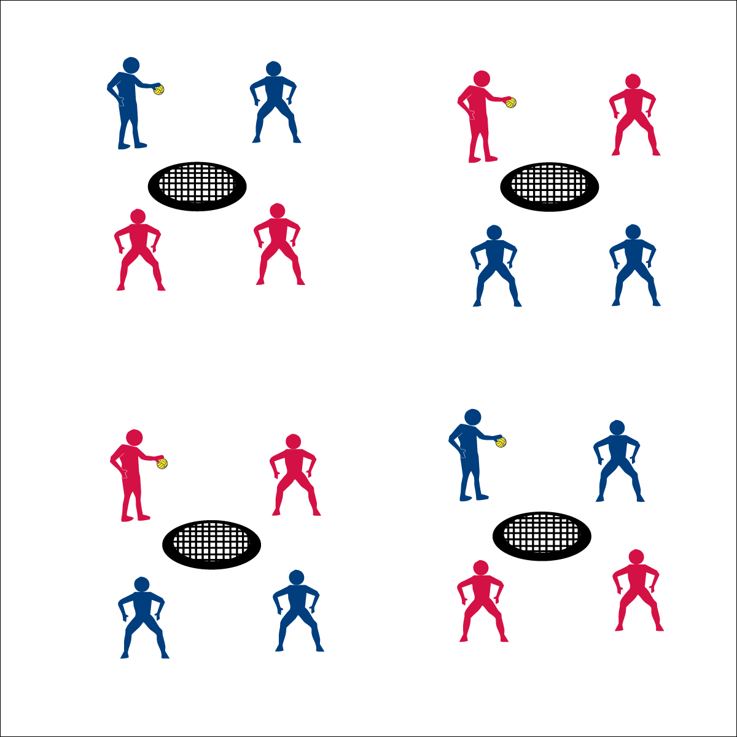­­

**Rally Time**



* **Skill:** I will pass and spike using all skill cues.
* **Cognitive:** I will list the fitness benefits of playing Roundnet.
* **Fitness:** I will distinguish between skill-related and health-related fitness benefits.
* **Personal & Social Responsibility:** I will respond appropriately to all challenges in order to promote a positive activity environment for all.



* Pass, Pass, Spike
* Spike: Palm Flat, Contact Between Heel & Fingers, Follow Through Down
* Cooperate & Encourage



**Equipment:**

* 1 Spikeball® net and 1 ball per group of 4 students

**Set-Up:**

1. Set Spikeball® nets up in the activity area, allowing space for vigorous activity.
2. Place 1 Spikeball® at each net.
3. Pair students and send 2 pairs (4 players) to each net.

**Activity Procedures:**

1. Today’s activity is a cooperative game called Rally Time.
2. The object of the activity is to to build a rally with consecutive Roundnet passes and spikes.
3. Begin each rally with a tossed serve to a member of the opposite team. Teams have a maximum of 3 hits (2 passes and 1 spike) to send the ball down to the net for a change of possession.
4. Each change of possession scores a rally point. Score 10 consecutive possession changes to achieve JV status. Score 20 to achieve Varsity status.
5. Hold the ball and be ready to listen when you hear the stop signal.

**Grade Level Progression:**

**6th:** Create a non-dynamic environment with the serving team catching the spike, then changing roles with the spiker now becoming the server. Each spike on net scores a rally point.

**7th:** Play the game as described above.

**8th:** After students achieve Varsity status, allow them to play a game of Roundnet for Rookies.

* **Adaptation:** Increase the size of the net/target or remove the net altogether.
* **Extension:** Limit teams to 2 hits (i.e., 1 pass and 1 spike).



**Help students elaborate on content:** The Rally Time activity format provides students with a controlled and cooperative Roundnet lead-up, allowing them to experience important elements of game play. Prompting students to describe and discuss their experience is an important part of building an appreciation for physical activity and movement. However, many students will offer only short descriptions of their feelings and reactions. Prompt students to elaborate using guiding follow-up questions that ask for specific examples and evidence.



* **DOK 1:** What are all of the fitness benefits of playing Roundnet?
* **DOK 2:** Which of these benefits are skill-related and which are health-related?
* **DOK 3:** How would you describe your overall reaction to your participation in Rally Time? Provide details with respect to your physical, cognitive, and emotional response? Why did you respond in these ways?
* **DOK 4:** What information can you gather from your peers to support your ideas about how and why you reacted in the ways that you did.



* **Standard 1: [M13.6-8]:** Strikes with a mature overarm pattern in a non-dynamic environment for net/wall games such as volleyball, handball, badminton, or tennis (6); Strikes with a mature overarm pattern in a dynamic environment for net/wall games such as volleyball, handball, badminton, or tennis (7); Strikes with a mature overarm pattern in a modified game for net/wall games such as volleyball, handball, badminton, or tennis (8).
* **Standard 3 [M7.6-8]:** Identifies the components of skill-related fitness (6); Distinguishes between health-related and skill-related fitness (7); Compares and contrasts health-related fitness components (8).
* **Standard 4 [M4.6-8]:** Accepts differences among classmates in physical development, maturation, and varying skill levels by providing encouragement and positive feedback (6); Demonstrates cooperation skills by establishing rules and guidelines for resolving conflicts (7); Responds appropriately to participants’ ethical and unethical behavior during physical activity by using rules and guidelines for resolving conflicts (8).



Spike, Strike, Health-Related Fitness, Skill-Related Fitness, Positive Environment, Rally

**Rally Time**