­­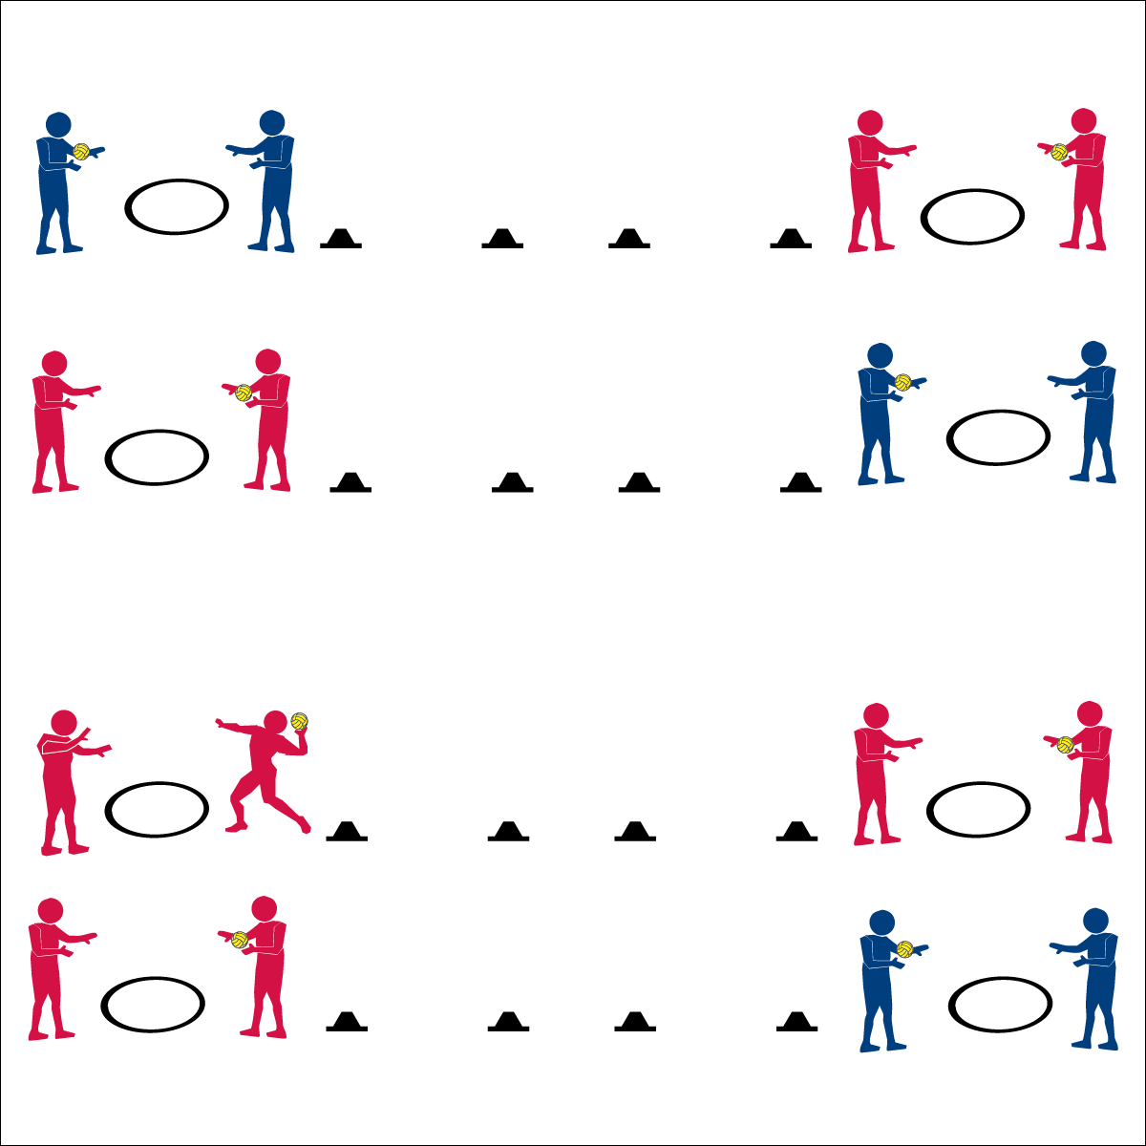

**Partner Passing Pentathlon**



* **Skill:** I will complete all passing pentathlon tasks.
* **Cognitive:** I will accurately record performance data on the Passing Pentathlon Skill Card.
* **Fitness:** I will accurately rate my overall effort on the Skill Card.
* **Personal & Social Responsibility:** I will extend my effort in order to help my partner and myself improve our passing skills.



* Attempt an Event
* Record Your Data
* Repeat for All 5 Events
* Rate Your Effort



**Equipment:**

* 1 ball per pair
* 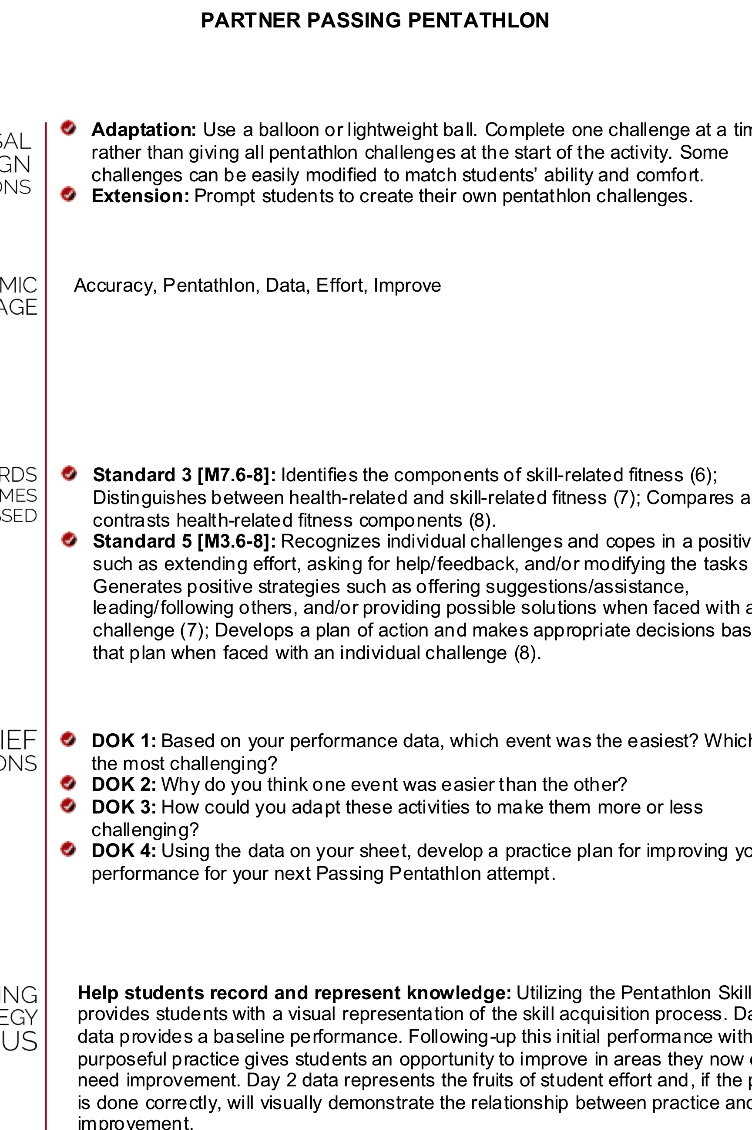1 hoop per pair
* 2 low profile cones per pair
* 1 Passing Pentathlon Skill Card and 1 pencil per pair

**Set-Up:**

1. For each pair, place a hoop and a ball 5 paces from one cone, and place another cone 10 paces from the first cone.
2. Duplicate this set-up on the opposite side of the activity area, with hoops on the outside and cones placed toward the middle of the area.
3. Pair students, sending each pair to a hoop.

**Activity Procedures:**

1. It’s time to assess your Netball passing skills with a Passing Pentathlon activity.
2. Your goal is to complete and record your score for the 5 passing challenges found on the Skill Card.
3. You’ll also rate your effort at the bottom of the Pentathlon Skill Card.
4. If you finish the pentathlon challenges early, create your own challenges to be shared with your classmates.

**Grade Level Progression:**

**6th:** Participates with peers and demonstrates appropriate responses to self and group challenges.

**7th:** Demonstrates the ability to follow and/or lead appropriately.

**8th:** Works with partner to develop a plan of action for improving challenge performance.

* **Adaptation:** Use a balloon or lightweight ball. Complete one challenge at a time rather than giving all pentathlon challenges at the start of the activity. Some challenges can be easily modified to match students’ ability and comfort.
* **Extension:** Prompt students to create their own pentathlon challenges.



**Help students record and represent knowledge:** Utilizing the Pentathlon Skill Card provides students with a visual representation of the skill acquisition process. Day 1 data provides a baseline performance. Following-up this initial performance with purposeful practice gives students an opportunity to improve in areas they now can see need improvement. Day 2 data represents the fruits of student effort and, if the process is done correctly, will visually demonstrate the relationship between practice and improvement.



* **DOK 1:** Based on your performance data, which event was the easiest? Which was the most challenging?
* **DOK 2:** Why do you think one event was easier than the other?
* **DOK 3:** How could you adapt these activities to make them more or less challenging?
* **DOK 4:** Using the data on your sheet, develop a practice plan for improving your performance for your next Passing Pentathlon attempt.



* **Standard 3 [M7.6-8]:** Identifies the components of skill-related fitness (6); Distinguishes between health-related and skill-related fitness (7); Compares and contrasts health-related fitness components (8).
* **Standard 5 [M3.6-8]:** Recognizes individual challenges and copes in a positive way, such as extending effort, asking for help/feedback, and/or modifying the tasks (6); Generates positive strategies such as offering suggestions/assistance, leading/following others, and/or providing possible solutions when faced with a group challenge (7); Develops a plan of action and makes appropriate decisions based on that plan when faced with an individual challenge (8).



Accuracy, Pentathlon, Data, Effort, Improve

**Partner Passing Pentathlon**