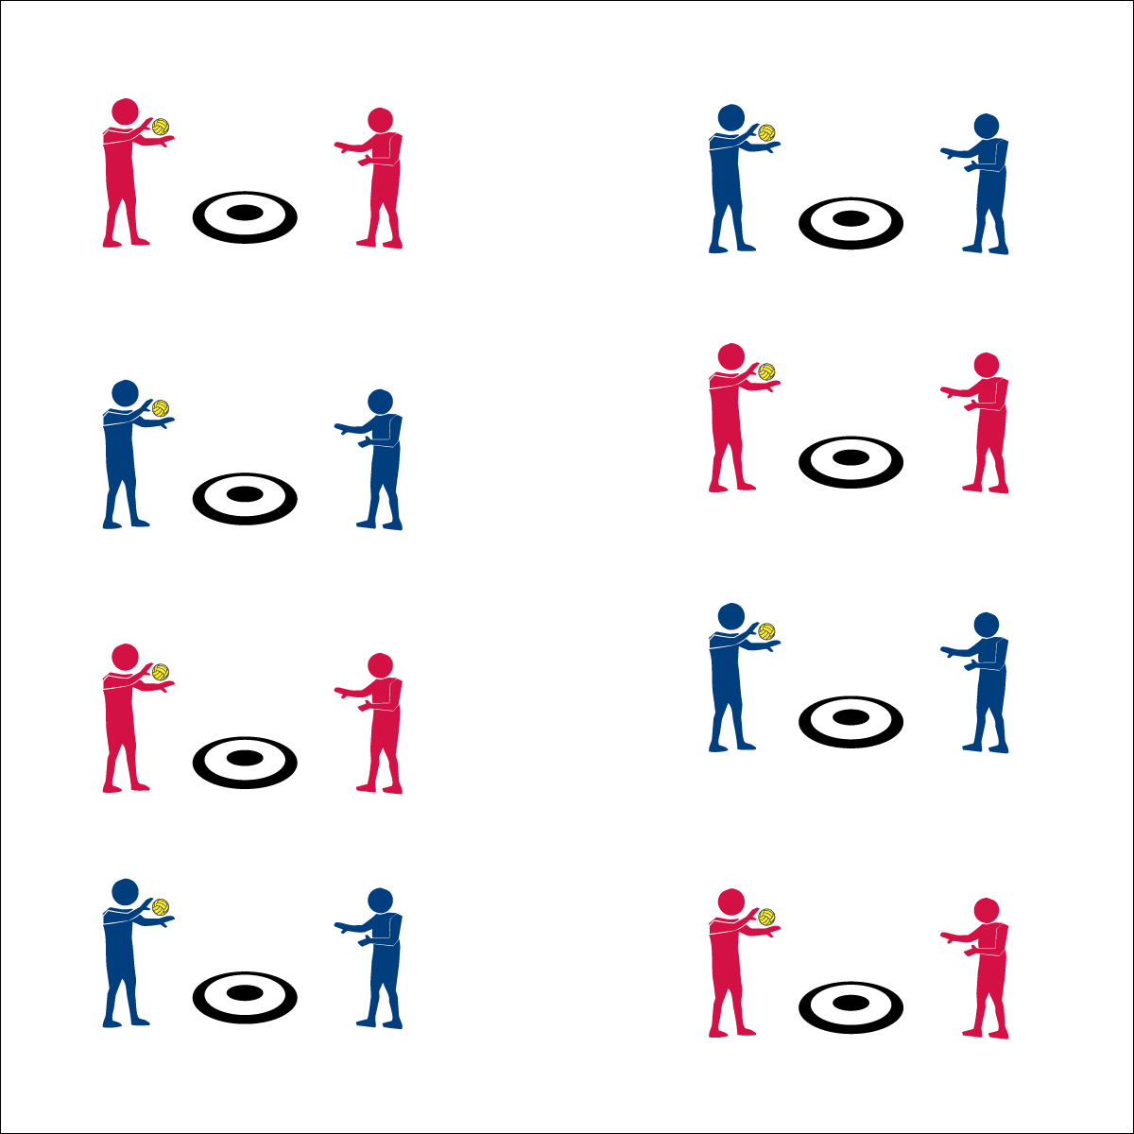­­

**Selfie Spikes**



* **Skill:** I will spike the ball with a mature striking pattern, focusing on all cues.
* **Cognitive:** I will develop a plan of action in order to help my partner and myself improve our spiking skills.
* **Fitness:** I will define coordination and explain how it relates to Roundnet.
* **Personal & Social Responsibility:** I will respond appropriately to all challenges in order to promote  
  a positive activity environment for all.



* Partner Toss
* Self Pass
* Accurate Spike



**Equipment:**

* 1 hoop per pair
* 1 spot marker per pair
* 1 ball per pair

**Set-Up:**

1. In a large activity area, place 1 spot marker and 1 ball in the center of a hoop for each pair of students.
2. Pair students and send each pair to a hoop.

**Activity Procedures:**

1. This activity is called Selfie Spikes. The object is to land your spikes inside of the hoop.
2. On the start signal, your partner will toss you the ball just above waist level. Self-pass the ball and then spike it into the hoop.
3. Complete 5 attempted spikes and then change roles.
4. When you believe that you’ve mastered the hoop at level 1, move to level 2 and attempt to hit the spot marker with each spike.
5. When you hear the stop signal, hold the ball and be ready to listen.

**Grade Level Progression:**

**6th:** Participates with peers and demonstrates appropriate responses to self and group challenges.

**7th:** Demonstrates the ability to follow and/or lead appropriately.

**8th:** Works with partner to develop a plan of action for improving personal performance.

**Selfie Spikes**



Coordination, Mature, Spike, Strike, Plan of Action, Positive Environment



* **Standard 1 [M13.6-8]:** Strikes with a mature overarm pattern in a non-dynamic environment for net/wall games such as volleyball, handball, badminton, or tennis (6); Strikes with a mature overarm pattern in a dynamic environment for net/wall games such as volleyball, handball, badminton, or tennis (7); Strikes with a mature overarm pattern in a modified game for net/wall games such as volleyball, handball, badminton, or tennis (8).
* **Standard 3 [M7.6-8]:** Identifies the components of skill-related fitness (6); Distinguishes between health-related and skill-related fitness (7); Compares and contrasts health-related fitness components (8).
* **Standard 5: [M3.6-8]:** Recognizes individual challenges and copes in a positive way, such as extending effort, asking for help/feedback, and/or modifying the tasks (6); Generates positive strategies such as offering suggestions/assistance, leading/following others, and/or providing possible solutions when faced with a group challenge (7); Develops a plan of action and makes appropriate decisions based on that plan when faced with an individual challenge (8).



* **DOK 1:** What are the cues for a mature spike?
* **DOK 2:** How did you apply these cues in the Selfie Spike activity?
* **DOK 3:** How are the cues related to successful spiking?
* **DOK 4:** Develop a plan of action that you and your partner can follow to help improve your spiking skills.

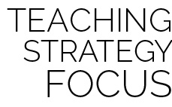

**Help students practice skills strategies, and processes:** This activity provides a fundamental practice task for developing spiking skills. Using this activity before and after the Spiking Pentathlon Challenge demonstrates a skill development process that students can utilize throughout a lifetime of activity and learning.

* **Adaptation:** Remove or increase the size of the target. Use a balloon or lightweight ball.
* **Extension:** Decrease the size of the target (e.g., place a sticker or mark on each spot).

