­­

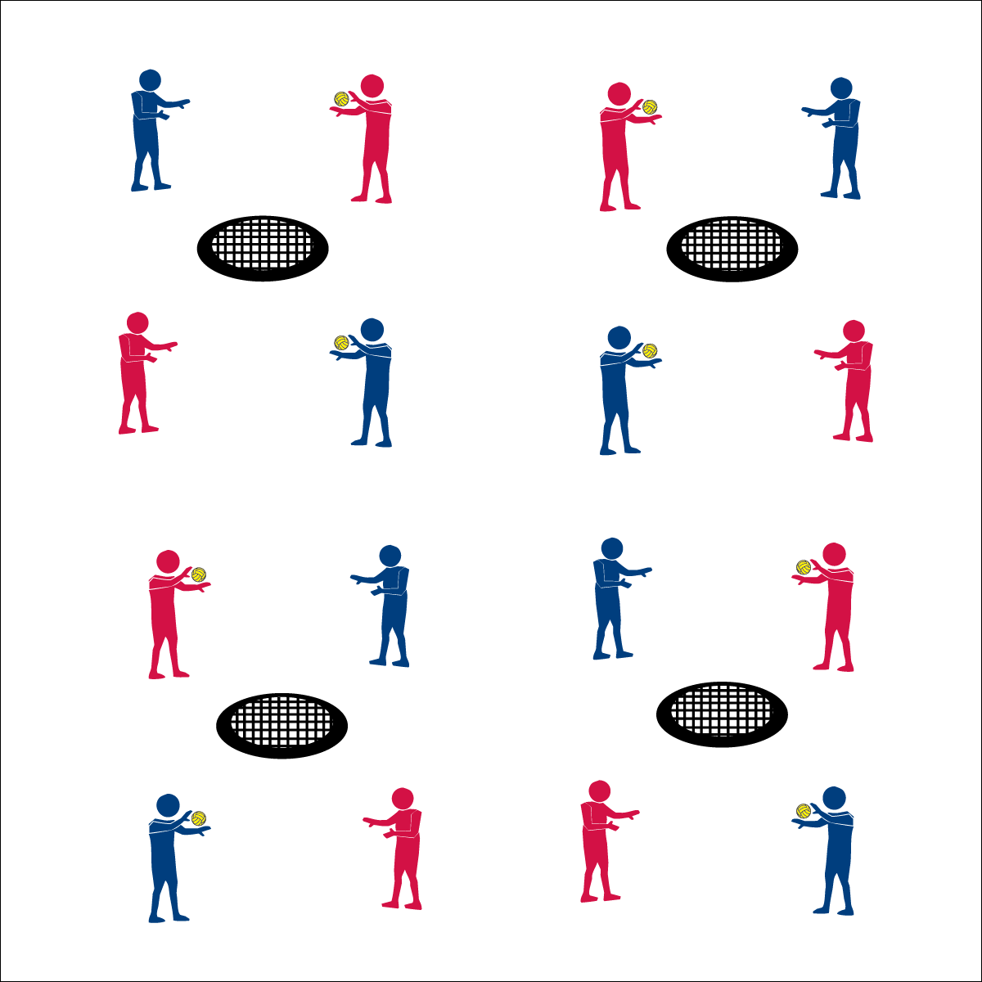

**Activity Procedures:**

1. It’s time to assess your Netball spiking skills with a Spiking Pentathlon activity.
2. Your goal is to complete and record your score for the 5 spiking challenges found on the Skill Card.
3. You’ll also rate your effort at the bottom of the card.
4. If you finish the pentathlon challenges early, create your own challenges to be shared with your classmates.

**Grade Level Progression:**

**6th:** Works to make accurate tosses to partner and also offers encouragement and positive feedback.

**7th:** Uses class strategies and communication skills to appropriately resolve any conflicts or disruptions.

**8th:** Independently manages behavior and engagement with no teacher reminders or influence.



**Equipment:**

* 1 Spikeball® net & 1 ball per group of 4 students
* 1 large cone
* 1 Spiking Pentathlon Skill Card & pencil per pair
* 1 Task Tent per group of 4 students
* 1 Spiking Cue Chart per group of 4 students

**Set-Up:**

1. Set Spikeball® nets up in a large activity area with plenty of room for vigorous activity.
2. Place 1 Spikeball® at each net.
3. Place Spiking Cue Chart in Task Tent and on large cone at each Spikeball® net.
4. Pair students and then send 2 pairs to each Spikeball® net.



* Power Stance (Sideways, Shoulder-Width, Eyes on Ball)
* Core Rotation (Rotate Hips, Hand Up/Open, Swing Down)
* Palm Strike/Follow Through (Palm Flat, Contact Between Heel & Fingers, Follow Through Down)



* **Skill:** I will spike the ball with a mature striking pattern, focusing on all cues.
* **Cognitive:** I will accurately record performance data.
* **Fitness:** I will accurately rate my overall effort.
* **Personal & Social Responsibility:** I will accept the differences between my partner and myself and use encouragement and positive feedback in our communications.

**Spiking Pentathlon**

* **Adaptation:** Remove or increase the size of the target. Use a balloon or lightweight ball. Complete one challenge at a time rather than giving all pentathlon challenges at the start of the activity. Some challenges can be easily modified to match students’ ability and comfort.
* **Extension:** Prompt students to create their own pentathlon challenges.



**Manage response rates with tiered questioning techniques:** Utilize the DOK Debrief Questions for a purposeful discussion with ascending cognitive complexity. This helps students deepen their understanding of critical concepts while contextualizing the information in a meaningful and relevant way.



* **DOK 1:** What is accurate data?
* **DOK 2:** What do you know about how data can be used?
* **DOK 3:** Using the performance data that you and your partner collected, what’s your interpretation of your overall performance? Provide details and evidence.
* **DOK 4:** Develop a performance plan that you and your partner can use to improve your next Spiking Pentathlon.



* **Standard 1 [M13.6-8]:** Strikes with a mature overarm pattern in a non-dynamic environment for net/wall games such as volleyball, handball, badminton, or tennis (6); Strikes with a mature overarm pattern in a dynamic environment for net/wall games such as volleyball, handball, badminton, or tennis (7); Strikes with a mature overarm pattern in a modified game for net/wall games such as volleyball, handball, badminton, or tennis (8).
* **Standard 3 [M7.6-8]:** Identifies the components of skill-related fitness (6); Distinguishes between health-related and skill-related fitness (7); Compares and contrasts health-related fitness components (8).
* **Standard 4 [M4.6-8]:** Accepts differences among classmates in physical development, maturation, and varying skill levels by providing encouragement and positive feedback (6); Demonstrates cooperation skills by establishing rules and guidelines for resolving conflicts (7); Responds appropriately to participants’ ethical and unethical behavior during physical activity by using rules and guidelines for resolving conflicts (8).



Spike, Mature, Data, Effort, Feedback, Communication Skills

**Spiking Pentathlon**